Table of Contents

1. Abstract 5

2. About DOIT & C, Jaipur 5

a) History 5

b) Objective 5

c) Functions 6

d) Vision 7

3. Introduction 8

a) Basic workflow mechanism of Rajasthan Sampark Portal: 8

I. Grievance registration process 9

II. Moderation of the grievance 9

III. Allocation to a departmental user 10

IV. Grievance redressal process 10

V. Feedback or reopen 10

b) Process Maps of various Grievance Redressal Mechanisms 11

I. Grievance registration through Web Portal 12

II. Grievance Allocation Process: 13

III. Grievance Redressal Process 13

IV. Feedback Process 14

V. Reopening of Grievance 15

c) System overview of the Rajasthan Sampark Portal 16

d) Scenarios of Registration 18

e) Action Tabs available for different users: 19

e) Roles and Action Rights of different users: 21

4. Technical Concepts used in developing the Rajasthan Sampark Web Application: 34

5. Aim of the project 37

6. Project Undertaken 37

About Sampark: 38

a) Help: 38

b) Feedback: 38

c) Contact Us: 38

d) Lodge Your Grievance (With/Without Citizen’s registration) 38

e) View Status of grievance 38

f) Send Reminder 39

g) Announcements 39

h) Citizen Registration 39

1) Citizen’s Dashboard 39

i) Search box. 40

j) CUG Area, For Departmental User: 40

2) Dashboard for Departmental User 40

• My Profile 40

• Edit Profile 40

• Change Password 40

• Overall Summary 40

• Outbox 40

• Grievance status, by Pendency 40

• Grievance status, by forwarding officer: 40

• Grievance status, by Category 41

• Disposal Status. 41

• Inbox: 41

• My Grievance Entries: 41

• Downloads: 41

• Reorder my widgets: 41

• Search Grievances: 41

• Analyze Report: 41

• Office Entry Form: 41

Menu Icons: 41

i. Home: 41

ii. Entry: 42

iii. Monitor: 42

iv. Utility: 42

• Officer Master Creation: 42

• User Monitoring: 42

• Grievance Management: 42

• Other Module: 42

• Corruption Irregularity: 42

• Ideas and Innovation: 42

v. Help: 43

vi. Discussion: 43

vii. Circular: 43

viii. Others: 43

1) DDG (Deduplication of Grievances) Module: 43

• Reports: 43

DDG-1 43

DDG-2 43

DDG-3 43

DDG-4 43

DDG-5 44

DDG-6 44

DDG-7 44

CRS-1 44

GRAM SABHA 44

ANNEXURE- 11 44

ANNEXURE- 12 44

• Verification: 44

Annexure VC-REC (Verification of relief cases): 44

Annexure VC-RJC(Verification of reject cases): 44

Custom reports of verification: 44

Consolidated reports of verification: 45

Performa for citizen acceptance: 45

• Help: 45

• Annexures: 45

• Home: 45

• Adopter master entry: 45

7. Results and Analysis: 45

8. Recommendations: 61

(i). Test Approach 61

A. Test Approach Description 61

B. Test Phases 62

• System Integration Testing I (SIT1) 62

• System Integration Testing II (SIT2) 62

• Parallel Testing 62

• Load Testing 62

• Model Office 63

• Infrastructure/Gateway Testing 63

C. Testing Type Descriptions 63

(ii). Status and Reporting Metrics 64

A. Defect Tracking Approach 64

B. System Test Phase Tracking Approach – Metrics to Utilize 64

C. System Test Status/Issues Meeting 65

D. Acknowledgement 65

9. Annexures: 67

10. References: 117

# Abstract

“Rajasthan Sampark” is an important step of State Government, Rajasthan in the field of services which facilitates citizens to bring their complaints in front of the authorized government officers in order to get easy and fast redressal. The title “Functionality testing for Rajasthan Sampark” deals with studying the standard workflow of “Rajasthan Sampark” and observing the actual flow, then providing corrective measures if faults are found during comparison. The corrective measures can be provided as the suggestions to the corresponding faults found. Appropriate screen shots indicating to the faults are taken for part of testing so that the issues can be indicated in an understandable manner.

1. About DOIT & C, Jaipur

## History

Department of Information Technology & Communication (DoIT&C) was initially known as Department of Computers which was established in 1987. It was functioning under the State’s Planning Department, to provide state government a strong technical foundation to better serve its citizens and to create more accountability and efficiency through computerization. Thereafter, on 1st April 1988, the Department was reconstituted as Directorate of Computers which, with the enhancement in its scope of work from computerization to IT enablement for framing policy, planning, implementation and monitoring of Information & Communication Technologies and e-Governance projects, It was further renamed as Department of Information Technology on 30th Sep 1997. Consequently, in the year 2002 the Department was rechristened as Department of Information Technology & Communication which is continued till date.

## Objective

DoIT&C is working to put technology to its highest and best use throughout Rajasthan Government Departments to improve the administration of State programs and services. Providing guidance on technical matters to Departments, vetting IT projects and taking Department on achieving IT Road Map are the basic jobs of Department of Information Technology & Communication (DoIT&C).

## Functions

​1. Formulate and Implement the Information Technology Policy in the state.

2. Appraisal of new technologies and prescribing uniform standards by promotion of investment in Information Technology Sector and related activities and creation and up gradation of Information Technology infrastructure in the State.

3. Assistance in development and implantation of software packages for monitoring of key parameters and computerization of thrust areas in different departments and semi Government organizations.

4. Standardization of hardware/software platforms for the departments/organization and to ensure dynamic monitoring of their prices and minimization of wasteful expenditure.

5. Development of Information Technology related communication infrastructure.

6. Assistance to the departments/semi government organizations in creating and updating websites.

7. Planning of different IT related programs by organizing various promotional activities like national/international conferences/seminars and participation in the same.

8. Coordinating all IT projects in the government and following up IT related projects/schemes posed to government of India and its agencies and also other players in this field in India as well as abroad.

9. Identification of laws and rules which need to be modified or enacted to enable legal validation and also to act as nodal agency/authority on behalf of the State Government for matters relating to Information Technology Act and similar other central and state legislations.

10. Maintenance of database for all Information Technology related material and human resources available in the state.

11. To organize training programs for increasing IT literacy among the officers and staff of State Government.

12. Facilitate Co-ordination between various Departments for successful implementation of Mission Mode Projects (MMPs) under National e-Governance Plan and various other e-Governance projects in the State for efficient and effective delivery of government services.

13. Set up Core and Support ICT infrastructure for Government data storage, application hosting and Voice, Video and Data transfers over secure dedicated network for Government services delivery to citizens and businesses as well as efficient functioning of Government Departments.

14. Facilitate co-ordination among Government Departments, Academic Institutions and Industry for achieving excellence in IT and related sectors.

15. Support various Departments for their Capacity Building Initiatives through skilled manpower recruitment and training with respect to implementation and use of ICT and e-Governance projects.

16. Support the State Government Departments in adopting best practices, guidelines, policies and standards with implementation and use of ICT in Government.

## Vision

The Government of Rajasthan would leverage Information & Communication Technology (ICT) not only as a tool for improving governance and employment opportunities, but also more significantly as a means to enhance the quality of life and bridging the socio-economic divide in the State. The State Government intends to make conscious efforts to see that benefits of IT in terms of employment generation and economic up-lifting percolates to all sections of the society, particularly to those living in rural and remote areas.

# Introduction

**Rajasthan Sampark** is an innovative e-Governance project conceived by the Department of Information Technology & Communication, Government of Rajasthan. The project paves the way for a common man to reach the departments of the State Government for their queries and concerns, with the help of telecommunication tools and web portal. It enables the departments to disseminate the information about various schemes and programs being run for the benefit of the citizens. It is also a centralized platform where any citizen of the state can convey his grievances, pain area, thoughts, suggestions and appreciation etc. for the respective departments. It bridges the digital divide between citizens and the government.

**Rajasthan Sampark** intends to help the government to achieve important aspects of good governance viz. Robust Delivery System, Transparency, Communication, Grievance Redressal and Sensitivity towards citizens.

**Rajasthan Sampark Portal** is developed on centralized platform to be hosted at Rajasthan State Data Centre. The State Level Grievance Redressal System is **Multichannel, Multilevel and Multi Department Call Centre** that would be a single point of contact for citizen of the State to register their g**rievances, queries and to convey any thoughts, suggestions and appreciation etc. for the respective Departments**. The State Level Grievance Redressal System enables the reach of the Government services to the common man.

The project has a very wide scope for it is available for every rural and urban area of Rajasthan. It covers each and every department that is concerned with the state government. It provides a common platform for citizen as they are eligible to make complaint related to any subject that is concerned with state government.

## Basic workflow mechanism of Rajasthan Sampark Portal:

Various Stages of the Grievance Redressal Process are mentioned in the following:-

### Grievance registration process

This process deals with the details of work flow of registration of the grievance by citizen through various means. The various means available with the citizen for grievance registration are:

* Citizen Contact center
* Through web portal
* Through letters (Hardcopy)
* Through emails
* Through SMS and
* Through kiosks/ Departmental Access Points.

This also ensures that the grievance is filled with all desired fields that are required for grievance processing by the departments. It also takes care of prioritization & segregation automatically according to the available information.

### Moderation of the grievance

To provide ease in use to the complainant, the System shall allow registering a grievance without fully qualified for processing. This imposes the requirement of a specific layer called Moderator Layer. A specific category of system role shall be implemented who shall perform the job of making a Grievance fully qualified. It shall also be possible to perform this activity in multiple phases in top down mechanism. This will be specially required when grievance are being received at highest level of hierarchy e.g. through CMO where it is not possible to qualify the Grievances by the Complainant. Features of moderation are mentioned below:

* Grievance Qualification
* Re-Qualification. For example, specific grievance is initially qualified for an incorrect area / department / type.
* Phased Moderation with Top down & Bottom up Mechanism.
* Previous Record Identification & Linking
* Prioritization & Segregation
* Initialize Disposal Process

### Allocation to a departmental user

The grievance allocation process follows the grievance moderation process. On successful registration of grievance in Raj Sampark Portal, the grievance is automatically forward to the Head of Department. Once the grievance is moderated it is eligible for allocation. The HOD undertakes necessary steps to allocate the grievance to the concerned officer of department.

### Grievance redressal process

Once the grievance is allocated to the concerned officer, concerned officer takes necessary action to resolve the grievance and uploads an action taken report for approval of the designated authority. After approval of the action taken report by the designated authority, the status is updated in Raj Sampark Portal and citizen gets notification with the various modes available.

### Feedback or reopen

Based on the satisfaction level of the citizen/ complainant regarding the action taken by the appropriate authority against the lodged grievance, citizens have the option of providing feedback on the steps taken by the concerned department.

Similar to the feedback mechanism, citizens will have the option of reopening a grievance if he is not satisfied with the action taken by the departmental user pertaining to the lodged grievance.

The components of the project are shown using the following diagram:

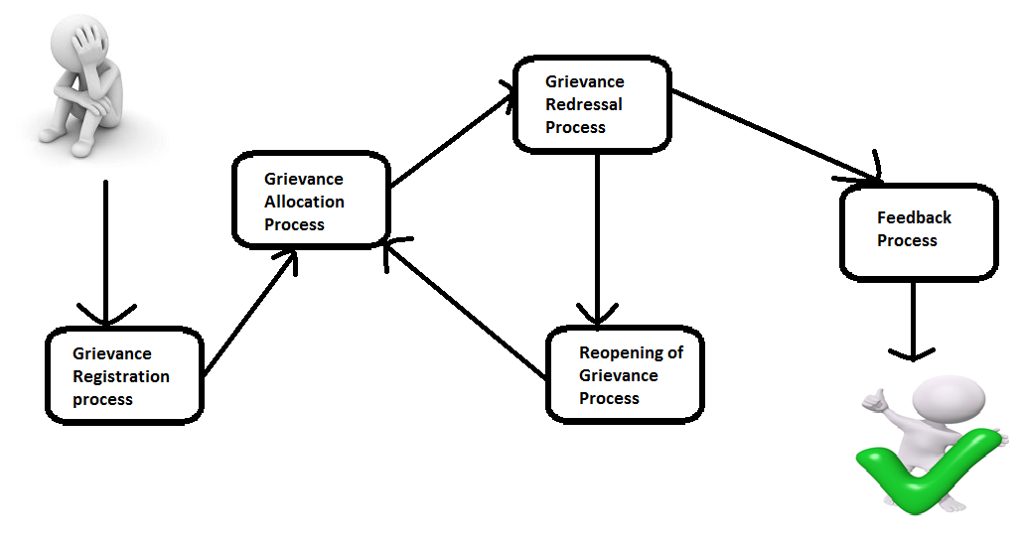

Figure 1: Grievance Redressal Mechanism

## Process Maps of various Grievance Redressal Mechanisms

In order to understand the workflow of “Rajasthan Sampark”, we have process maps with description of various Grievance Redressal Mechanisms

.

### Grievance registration through Web Portal

Flowchart:

Start

Is User Registered?

Login to the portal

Go to Lodge Grievance

Click on Lodge Grievance as a guest user

Fill Personal Details

Fill Grievance Details

Submit & note Grievance ID

End

y

N

Note: for registered user the citizen will have an option for logging in using username and password. Upon authentication the Rajas Sampark Portal will open the registered account.

### Grievance Allocation Process:

Flowchart:

Start

Officer gets Request to Reopen the Grievance

Is Request Justified?

Confirm Reopening and the grievance now appears in “Pending for allocation” head.

Further Redressal Actions are taken.

Reject the Request

End

N

Y

### Grievance Redressal Process

Flowchart:

Start

Officer gets Request to Reopen the Grievance

Is Request Justified?

Confirm Reopening and the grievance now appears in “Pending for allocation” head.

Further Redressal Actions are taken.

Reject the Request

End

N

Y

### Feedback Process

Flowchart:

Start

Citizen gets notification of Disposed Grievance

Is Citizen Satisfied with the disposal?

Click on Reopen Grievance

Provide Comments

Provide Rating and comments

End

Y

N

Provide 2 or lesser points for Rating

*Note: Citizen will also have the option of providing feedback through the kiosks / departmental access points. In this case, citizen will visit kiosks/ departmental access points and the available moderator at Departmental Access Points/ Data Entry Operator at kiosks will log on to Raj Sampark Portal and provide feedback on behalf of the citizen.*

### Reopening of Grievance

Flowchart:

Start

Officer gets Request to Reopen the Grievance

Is Request Justified?

Confirm Reopening and the grievance now appears in “Pending for allocation” head.

Further Redressal Actions are taken.

Reject the Request

End

N

Y

*Note: Citizen will also have the option of reopening of grievance through the kiosks / departmental access points. In this case, citizen will visit kiosks/ departmental access points and the available moderator at Departmental Access Points/ Data Entry Operator at kiosks will log on to Raj Sampark Portal and reopen the grievance on behalf of the citizen.*

## System overview of the Rajasthan Sampark Portal

The project “**Rajasthan Sampark**” is a web based interface that supports integration with different modes to make registration of the grievances from Citizens. The modes of the registration can be through the online registration i.e. the registration from the website of “**Rajasthan Sampark**” by citizen himself, calls to the organization, integration with social networking sites, mobile application and so on. It maintains the disposal of the grievance according to defined hierarchy of the organization. The hierarchy can be defined for different levels as demographical, office, administrative. The monitoring of the application would be maintained according to the defined workflow.

The main aim of the application is to track the process of the grievance redressal. This would include the registration of the grievance and then monitoring the grievance. Also, maintaining a record of the details of the grievance after its disposal.

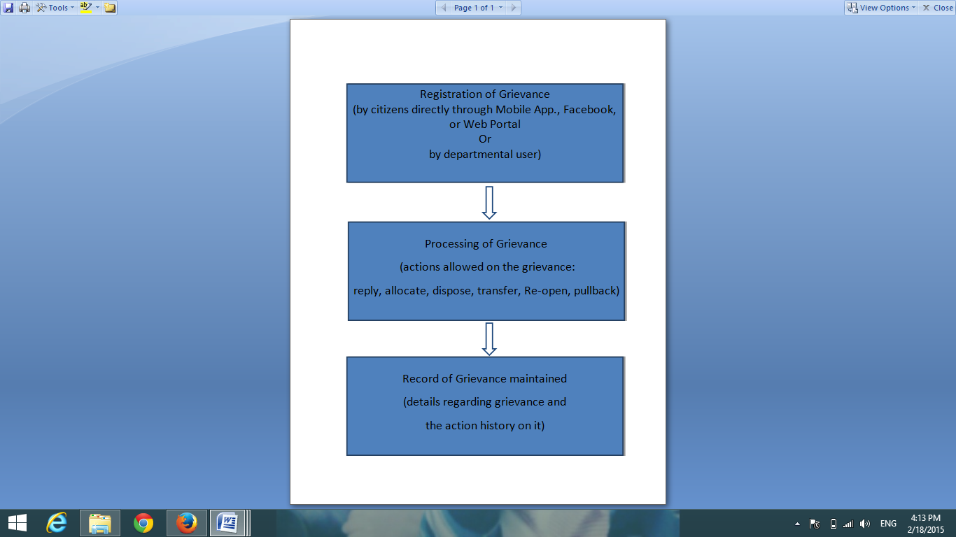

Figure 2: System Overview

## Scenarios of Registration

Diagram shows options that are available for Registration of Grievance:

**Web Portal**

**Mobile App**

**Letters**

**Kiosks**

**Departmental Login**

**SMS**

**Citizen Contact Center**

**Emails**

Figure 3: Scenario of Registration

## Action Tabs available for different users:

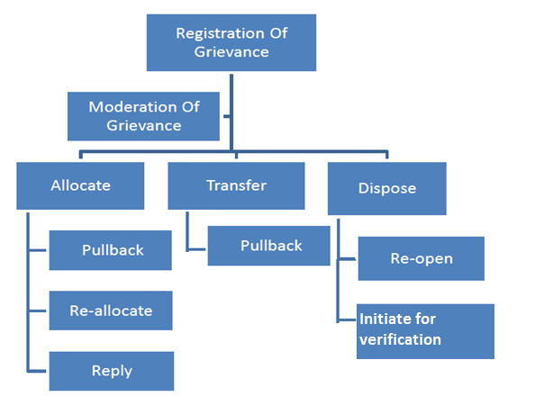

Figure 3: Work flow of the project

**Moderation Of grievance**: before any other action takes place, the moderation details should be compulsorily mentioned.

**Allocate**: to assign the grievance to a particular user (designation) along with the details and rights of allocation. Allocation rights may also include rights whether the grievance can be completely disposed or will require approval from some other user.

**Transfer**: in case the allocated department to the grievance is out of scope and some other department should be liable for the grievance.

**Dispose**: if the grievance has been taken care of and in a condition to be disposed. If the grievance is already in a condition, it can be disposed at first step also.

**Pullback**: if a grievance is already allocated and some other action is required to be taken, it should be pull backed to enable other actions.

**Re**- **Allocate:** the grievance already allocated can be re-allocated to other user if not considered in scope. This allocation is considered as re-allocation. In fact, allocation process done second time on a grievance would be considered re-allocation, no matter whatever the processes have been.

**Re**-**open:** once a grievance has been disposed, no further actions would be allowed on it. But re-open option would be available, if the grievance is not considered satisfactorily disposed and a request has been received to re-open it. After the re-open option is used, all other actions would be available.

## Roles and Action Rights of different users:

We have separate action rights for Police Department and common action rights for other all departments.

|  |  |  |  |  |  |  |  |  |  |  |  |  |  |  |  |
| --- | --- | --- | --- | --- | --- | --- | --- | --- | --- | --- | --- | --- | --- | --- | --- |
| **#** | [**Department**](javascript:__doPostBack('gvrole','Sort$DEPT_NAME')) | [**Status**](javascript:__doPostBack('gvrole','Sort$COMP_STATUS_NAME')) | [**Role**](javascript:__doPostBack('gvrole','Sort$ROLE_NAME')) | [**Allocation**](javascript:__doPostBack('gvrole','Sort$ALLOCATE')) | [**Multi. Allocation**](javascript:__doPostBack('gvrole','Sort$MULTI_ALLOCATION')) | [**Reply**](javascript:__doPostBack('gvrole','Sort$REPLY')) | [**Pullback**](javascript:__doPostBack('gvrole','Sort$PULLBACK')) | [**Reopen**](javascript:__doPostBack('gvrole','Sort$REOPEN')) | [**Send For Approval**](javascript:__doPostBack('gvrole','Sort$FORAPPROVAL')) | [**Reallocate/ Allocate**](javascript:__doPostBack('gvrole','Sort$REALLOCATED')) | [**Transfer**](javascript:__doPostBack('gvrole','Sort$TRANSFER')) | | [**Dispose**](javascript:__doPostBack('gvrole','Sort$DISPOSE')) | [**Reject**](javascript:__doPostBack('gvrole','Sort$REJECT')) | |
| **1** | Police Department | **Under Progress** | District Administrator | Yes | No | No | No | No | No | No | Yes | Yes | | No |
| Departmental Processing Office | No | No | No | No | No | No | No | No | No | | No |
| Divisional Officer | Yes | No | No | No | No | No | No | Yes | Yes | | No |
| Dept State Lvl Nodal Officer | Yes | No | No | No | No | No | No | Yes | Yes | | No |
| Block Level Nodal Officers | Yes | No | No | No | No | No | No | No | No | | No |
| District HOD – Collectors | Yes | No | No | No | No | No | No | Yes | Yes | | No |
| Project HOD | Yes | No | No | No | No | No | Yes | Yes | Yes | | No |
| District Level Nodal Officers | Yes | No | No | No | No | No | No | Yes | Yes | | No |
| Departmental HOD | Yes | No | No | No | No | No | Yes | Yes | Yes | | No |
| Super User | Yes | No | No | No | No | No | No | Yes | Yes | | No |
| **11** | Police Department | **Allocated** | Block Level Nodal Officers | No | No | Yes | Yes | No | No | Yes | No | No | | No |
| Departmental Administrator | No | No | Yes | Yes | No | No | Yes | No | No | | No |
| Dept State Lvl Nodal Officer | No | No | Yes | Yes | No | No | Yes | Yes | Yes | | No |
| Project HOD | No | No | Yes | Yes | No | No | Yes | Yes | Yes | | No |
| Departmental Processing Office | No | No | Yes | Yes | No | No | Yes | No | No | | No |
| District Administrator | No | No | Yes | Yes | No | No | Yes | Yes | Yes | | No |
| Departmental HOD | No | No | Yes | Yes | No | No | Yes | Yes | Yes | | No |
| District HOD – Collectors | No | No | Yes | Yes | No | No | Yes | Yes | Yes | | No |
| District Level Nodal Officers | No | No | Yes | Yes | No | No | Yes | Yes | Yes | | No |
| Super User | No | No | Yes | Yes | No | No | Yes | Yes | Yes | | No |
| Divisional Officer | No | No | Yes | Yes | No | No | Yes | Yes | Yes | | No |
| **22** | Police Department | **Replied** | Departmental Entry operator | No | No | No | No | No | No | No | No | No | | No |
| District Administrator | No | No | Yes | Yes | No | No | Yes | Yes | Yes | | No |
| Project HOD | Yes | No | Yes | Yes | No | Yes | Yes | Yes | Yes | | No |
| Divisional Officer | No | No | Yes | Yes | No | Yes | Yes | Yes | Yes | | No |
| Block Level Nodal Officers | No | No | Yes | Yes | No | Yes | Yes | No | No | | No |
| Super User | No | No | Yes | Yes | No | No | Yes | Yes | Yes | | No |
| District Level Nodal Officers | No | No | Yes | Yes | No | Yes | Yes | Yes | Yes | | No |
| District HOD – Collectors | Yes | No | No | Yes | No | No | Yes | Yes | Yes | | No |
| Dept State Lvl Nodal Officer | No | No | Yes | Yes | No | Yes | Yes | Yes | Yes | | No |
| Departmental Processing Office | No | No | Yes | No | No | No | Yes | No | No | | No |
| Departmental HOD | No | No | Yes | Yes | No | No | Yes | Yes | Yes | | No |
| **33** | Police Department | **Reallocated** | Dept State Lvl Nodal Officer | No | No | Yes | Yes | No | Yes | Yes | Yes | Yes | | No |
| Divisional Officer | No | No | Yes | Yes | No | No | Yes | Yes | Yes | | No |
| Super User | No | No | Yes | Yes | No | No | Yes | Yes | Yes | | No |
| District Level Nodal Officers | Yes | No | Yes | Yes | No | Yes | Yes | Yes | Yes | | No |
| District HOD – Collectors | Yes | No | No | Yes | Yes | No | Yes | Yes | Yes | | No |
| Block Level Nodal Officers | Yes | No | Yes | Yes | No | Yes | Yes | No | No | | No |
| Departmental HOD | No | No | Yes | Yes | No | No | Yes | Yes | Yes | | No |
| Project HOD | Yes | No | Yes | Yes | No | Yes | Yes | Yes | Yes | | No |
| Departmental Administrator | No | No | Yes | No | No | No | Yes | No | No | | No |
| Departmental Processing Office | Yes | No | Yes | No | No | No | Yes | No | No | | No |
| District Administrator | No | No | Yes | Yes | No | No | Yes | Yes | Yes | | No |
| **44** | Police Department | **Disposed** | Departmental Processing Office | No | No | No | No | No | No | No | No | No | | No |
| Super User | No | No | No | No | Yes | No | No | No | No | | Yes |
| Block Level Nodal Officers | No | No | No | No | No | No | No | No | No | | No |
| Project HOD | No | No | No | No | Yes | No | No | No | No | | Yes |
| District Administrator | No | No | No | No | Yes | No | No | No | No | | Yes |
| Departmental HOD | No | No | No | No | Yes | No | No | No | No | | Yes |
| Divisional Officer | No | No | No | No | Yes | No | No | No | No | | Yes |
| District HOD – Collectors | No | No | No | No | Yes | No | No | No | No | | Yes |
| **52** | Police Department | **Transferred** | Super User | No | No | No | No | No | No | Yes | Yes | Yes | | No |
| Divisional Officer | No | No | No | No | No | No | Yes | Yes | Yes | | No |
| Departmental HOD | Yes | No | No | No | No | No | Yes | Yes | Yes | | No |
| Project HOD | Yes | No | No | No | No | No | Yes | Yes | Yes | | No |
| District Level Nodal Officers | Yes | No | No | No | No | No | Yes | Yes | Yes | | No |
| District HOD – Collectors | Yes | No | No | No | No | No | Yes | Yes | Yes | | No |
| District Administrator | No | No | No | No | No | No | Yes | Yes | Yes | | No |
| Block Level Nodal Officers | No | No | No | No | No | No | No | No | No | | No |
| Dept State Lvl Nodal Officer | Yes | No | No | No | No | No | Yes | Yes | Yes | | No |
| **61** | Police Department | **Pullback** | Project HOD | Yes | No | No | No | No | No | Yes | Yes | Yes | | No |
| Dept State Lvl Nodal Officer | No | No | No | No | No | No | Yes | Yes | Yes | | No |
| District Administrator | No | No | No | No | No | No | Yes | Yes | Yes | | No |
| Departmental HOD | No | No | No | No | No | No | Yes | Yes | Yes | | No |
| District Level Nodal Officers | Yes | No | Yes | No | No | No | Yes | Yes | Yes | | No |
| Block Level Nodal Officers | No | No | No | No | No | Yes | Yes | No | No | | No |
| Departmental Processing Office | No | No | No | No | No | No | No | No | No | | No |
| District HOD – Collectors | Yes | No | No | No | No | No | Yes | Yes | Yes | | No |
| Divisional Officer | No | No | No | No | No | No | Yes | Yes | Yes | | No |
| Super User | No | No | No | No | No | No | Yes | Yes | Yes | | No |
| **71** | Police Department | **Send for Approval** | Dept State Lvl Nodal Officer | No | No | No | No | No | Yes | No | No | No | | No |
| Departmental HOD | Yes | No | No | No | No | No | Yes | Yes | Yes | | No |
| District Level Nodal Officers | No | No | No | No | No | No | No | No | No | | No |
| District HOD – Collectors | No | No | No | No | No | No | Yes | Yes | Yes | | No |
| Departmental Administrator | No | No | No | No | No | No | No | No | No | | No |
| Block Level Nodal Officers | No | No | No | No | No | No | No | No | No | | No |
| District Administrator | No | No | No | No | No | No | Yes | Yes | Yes | | No |
| Departmental Processing Office | No | No | No | No | No | No | No | No | No | | No |
| **79** | Police Department | **Reopened** | Block Level Nodal Officers | No | No | No | No | No | No | No | No | No | | No |
| Departmental HOD | No | No | No | No | No | No | Yes | Yes | Yes | | No |
| District Administrator | No | No | No | No | No | No | Yes | Yes | Yes | | No |
| Departmental Processing Office | No | No | No | No | No | No | No | No | No | | No |
| Project HOD | Yes | No | No | No | No | No | Yes | Yes | Yes | | No |
| District Level Nodal Officers | No | No | No | No | No | No | No | No | No | | No |
| Dept State Lvl Nodal Officer | No | No | No | No | No | No | No | No | No | | No |
| Technical Admin | No | Yes | No | Yes | No | No | No | No | No | | No |
| Super User | No | No | No | No | No | No | Yes | Yes | Yes | | No |
| District HOD – Collectors | No | No | No | No | No | No | Yes | Yes | Yes | | No |
| Divisional Officer | No | No | No | No | No | No | Yes | Yes | Yes | | No |
| **90** | All | **Under Progress** | Departmental Processing Office | No | No | No | No | No | No | No | No | No | | No |
| Departmental HOD | Yes | No | No | No | No | No | Yes | Yes | Yes | | No |
| Dept State Lvl Nodal Officer | Yes | No | No | No | No | No | No | Yes | Yes | | No |
| District Level Nodal Officers | Yes | No | No | No | No | No | No | Yes | Yes | | No |
| Block Level Nodal Officers | Yes | No | No | No | No | No | No | No | No | | No |
| District HOD – Collectors | Yes | No | Yes | No | No | No | No | Yes | Yes | | No |
| Super User | Yes | No | No | No | No | No | No | Yes | Yes | | No |
| Divisional Officer | Yes | No | No | No | No | No | No | Yes | Yes | | No |
| Project HOD | Yes | No | No | No | No | No | Yes | Yes | Yes | | No |
| **99** | All | **Allocated** | Divisional Officer | No | No | Yes | Yes | No | No | Yes | Yes | Yes | | No |
| Block Level Nodal Officers | No | No | Yes | Yes | No | No | Yes | No | No | | No |
| Departmental Administrator | No | No | Yes | Yes | No | No | Yes | No | No | | No |
| District Administrator | No | No | Yes | Yes | No | No | Yes | No | No | | No |
| Project HOD | No | No | Yes | Yes | No | No | Yes | Yes | Yes | | No |
| Departmental HOD | No | No | Yes | Yes | No | No | Yes | Yes | Yes | | No |
| Departmental Processing Office | No | No | Yes | Yes | No | No | Yes | No | No | | No |
| Dept State Lvl Nodal Officer | No | No | Yes | Yes | No | No | Yes | Yes | Yes | | No |
| Super User | No | No | Yes | Yes | No | No | Yes | Yes | Yes | | No |
| District Level Nodal Officers | No | No | Yes | Yes | No | No | Yes | Yes | Yes | | No |
| District HOD – Collectors | No | No | Yes | Yes | No | No | Yes | Yes | Yes | | No |
| **110** | All | **Request to Reopen has been Rejected** | Dept State Lvl Nodal Officer | No | No | No | No | Yes | No | No | No | No | | No |
| Super User | No | No | No | No | Yes | No | No | No | No | | No |
| Departmental HOD | No | No | No | No | Yes | No | No | No | No | | No |
| District HOD – Collectors | No | No | No | No | Yes | No | No | No | No | | No |
| District Level Nodal Officers | No | No | No | No | Yes | No | No | No | No | | No |
| **115** | All | **Replied** | Departmental Administrator | No | No | Yes | No | No | No | Yes | No | No | | No |
| Project HOD | Yes | No | Yes | Yes | No | Yes | Yes | Yes | Yes | | No |
| Super User | No | No | Yes | Yes | No | No | Yes | Yes | Yes | | No |
| Divisional Officer | No | No | Yes | Yes | No | Yes | Yes | Yes | Yes | | No |
| District HOD – Collectors | Yes | No | Yes | Yes | No | No | Yes | Yes | Yes | | No |
| Departmental Processing Office | No | No | Yes | No | No | No | Yes | No | No | | No |
| Dept State Lvl Nodal Officer | No | No | Yes | Yes | No | Yes | Yes | Yes | Yes | | No |
| Departmental HOD | No | No | Yes | Yes | No | No | Yes | Yes | Yes | | No |
| District Level Nodal Officers | No | No | Yes | Yes | No | Yes | Yes | Yes | Yes | | No |
| Block Level Nodal Officers | No | No | Yes | Yes | No | Yes | Yes | No | No | | No |
| Departmental Entry operator | No | No | No | No | No | No | No | No | No | | No |
| **126** | All | **Reallocated** | Departmental Processing Office | Yes | No | Yes | No | No | No | Yes | No | No | | No |
| Divisional Officer | No | No | Yes | Yes | No | No | Yes | Yes | Yes | | No |
| Dept State Lvl Nodal Officer | No | No | Yes | Yes | No | No | Yes | Yes | Yes | | No |
| Super User | No | No | Yes | Yes | No | No | Yes | Yes | Yes | | No |
| District Level Nodal Officers | Yes | No | Yes | Yes | No | No | Yes | Yes | Yes | | No |
| Project HOD | No | No | Yes | Yes | No | Yes | Yes | Yes | Yes | | No |
| Block Level Nodal Officers | Yes | No | Yes | Yes | No | No | Yes | No | No | | No |
| Departmental HOD | No | No | Yes | Yes | No | No | Yes | Yes | Yes | | No |
| District HOD – Collectors | Yes | No | Yes | Yes | Yes | No | Yes | Yes | Yes | | No |
| Departmental Administrator | No | No | Yes | No | No | No | Yes | No | No | | No |
| District Administrator | Yes | No | Yes | Yes | No | No | Yes | No | No | | No |
| **137** | All | **Return** | District HOD – Collectors | No | No | No | No | No | No | Yes | Yes | Yes | | No |
| Block Level Nodal Officers | No | No | Yes | No | No | Yes | Yes | No | No | | No |
| District Level Nodal Officers | No | No | Yes | No | No | Yes | Yes | Yes | Yes | | No |
| Departmental HOD | No | No | No | No | No | No | Yes | Yes | Yes | | No |
| Dept State Lvl Nodal Officer | No | No | Yes | No | No | Yes | Yes | Yes | Yes | | No |
| **142** | All | **Disposed** | Super User | No | No | No | No | Yes | No | No | No | No | | Yes |
| District Level Nodal Officers | No | No | No | No | Yes | No | No | No | No | | Yes |
| Dept State Lvl Nodal Officer | No | No | No | No | Yes | No | No | No | No | | Yes |
| Project HOD | No | No | No | No | Yes | No | No | No | No | | Yes |
| Departmental HOD | No | No | No | No | Yes | No | No | No | No | | Yes |
| Block Level Nodal Officers | No | No | No | No | No | No | No | No | No | | No |
| Departmental Processing Office | No | No | No | No | No | No | No | No | No | | No |
| District HOD – Collectors | No | No | No | No | Yes | No | No | No | No | | Yes |
| Divisional Officer | No | No | No | No | Yes | No | No | No | No | | Yes |
| **151** | All | **Transferred** | Block Level Nodal Officers | Yes | No | No | No | No | No | Yes | No | No | | No |
| Dept State Lvl Nodal Officer | Yes | No | No | No | No | No | Yes | Yes | Yes | | No |
| Super User | Yes | No | No | No | No | No | Yes | Yes | Yes | | No |
| District Level Nodal Officers | Yes | No | No | No | No | No | Yes | Yes | Yes | | No |
| Project HOD | Yes | No | No | No | No | No | Yes | Yes | Yes | | No |
| Departmental Processing Office | No | No | No | No | No | No | No | No | No | | No |
| Departmental HOD | Yes | No | No | No | No | No | Yes | Yes | Yes | | No |
| District HOD – Collectors | Yes | No | No | Yes | No | No | Yes | Yes | Yes | | No |
| Divisional Officer | Yes | No | No | No | No | No | Yes | Yes | Yes | | No |
| **160** | All | **Pullback** | Project HOD | Yes | No | No | No | No | No | Yes | Yes | Yes | | No |
| Departmental Processing Office | No | No | No | No | No | No | No | No | No | | No |
| Departmental HOD | Yes | No | Yes | Yes | No | No | Yes | Yes | Yes | | No |
| Dept State Lvl Nodal Officer | No | No | Yes | Yes | No | No | Yes | Yes | Yes | | No |
| Super User | No | No | Yes | Yes | No | No | Yes | Yes | Yes | | No |
| District Level Nodal Officers | Yes | No | Yes | Yes | No | Yes | Yes | Yes | Yes | | No |
| Block Level Nodal Officers | No | No | Yes | Yes | No | Yes | Yes | No | No | | No |
| Divisional Officer | No | No | No | No | No | No | Yes | Yes | Yes | | No |
| District HOD – Collectors | Yes | No | Yes | Yes | No | No | Yes | Yes | Yes | | No |
| **169** | All | **Send for Approval** | Super User | No | No | No | Yes | No | No | Yes | Yes | Yes | | No |
| Dept State Lvl Nodal Officer | No | No | No | No | No | Yes | No | No | No | | No |
| Block Level Nodal Officers | No | No | No | No | No | No | No | No | No | | No |
| District Level Nodal Officers | No | No | No | No | No | No | No | No | No | | No |
| Departmental HOD | Yes | No | No | No | No | No | Yes | Yes | Yes | | No |
| Departmental Processing Office | No | No | No | No | No | No | No | No | No | | No |
| Departmental Administrator | No | No | No | No | No | No | No | No | No | | No |
| District HOD – Collectors | No | No | No | No | No | No | Yes | Yes | Yes | | No |
| **177** | All | **Reopened** | Project HOD | Yes | No | No | No | No | No | Yes | Yes | Yes | | No |
| District Administrator | No | No | No | No | No | No | Yes | Yes | Yes | | No |
| District HOD – Collectors | No | No | No | No | No | No | Yes | Yes | Yes | | No |
| Super User | No | No | No | No | No | No | Yes | Yes | Yes | | No |
| Block Level Nodal Officers | Yes | No | No | No | No | No | No | No | No | | No |
| Departmental HOD | No | No | No | No | No | No | Yes | Yes | Yes | | No |
| District Level Nodal Officers | Yes | No | No | No | No | No | Yes | Yes | Yes | | No |
| Dept State Lvl Nodal Officer | No | No | No | No | No | No | No | No | No | | No |
| Departmental Processing Office | No | No | No | No | No | No | No | No | No | | No |
| Divisional Officer | No | No | No | No | No | No | Yes | Yes | Yes | | No |
| **187** | All | **Select One...** | Dept State Lvl Nodal Officer | No | No | Yes | No | No | Yes | Yes | Yes | Yes | | No |
| Select One... | No | No | No | No | No | No | No | No | No | | No |
| District HOD – Collectors | No | No | No | No | Yes | No | No | No | No | | No |
| Departmental HOD | No | No | No | No | No | No | Yes | Yes | Yes | | No |

# Technical Concepts used in developing the Rajasthan Sampark Web Application:

* 1. Object oriented programming is a met HOD of programming that seeks to mimic the way we form model of the world. To cope with the complexity of the life, we have evolved a wonderful capacity to generalized, classify and generate and abstraction. Almost every noun is our vocabulary represents a class of object sharing some set of attributes or behavioral traits.

The entire basis of object oriented programming, infect is defining the object in object oriented programming. Object is a unit that combined both data and code together. And an object is an instance of a class. Class is a type of data structure defined to hold data and the code function.

Object-oriented systems draw upon class definitions that are derived from the analysis model. Object oriented design establish a design group in that enables a s/w engineer to define the object oriented architecture in a manner that maximized reused, thereby improving development speed and end product quality.

* 1. RDBMS stands for Relational Database Management System. RDBMS data is structured in database tables, fields and records. Each RDBMS table consists of database table rows. Each database table row consists of one or more database table fields.

RDBMS store the data into collection of tables, which might be related by common fields (database table columns). RDBMS also provide relational operators to manipulate the data stored into the database tables. Most RDBMS use SQL as database query language.

The goal of a relational database design is to generate a set of relation schema that allows us to store information without unnecessary redundancy and also to retrieve information easily.

* 1. Software testing Software testing is the process of evaluation a software item to detect differences between given input and expected output also to assess the feature of a software item. Testing assesses the quality of the product. Software testing is a process that should be done during the development process. In other words software testing is a verification and validation process.

1. **Verification** is the process to make sure the product satisfies the conditions imposed at the start of the development phase. In other words, to make sure the product behaves the way we want it to
2. **Validation** is the process to make sure the product satisfies the specified requirements at the end of the development phase. In other words, to make sure the product is built as per customer requirements.

There are two basics of software testing: black box testing and white box testing.

Between which we have used the concept of black box testing in our project.

1. **Black box** testing is a testing technique that ignores the internal mechanism of the system and focuses on the output generated against any input and execution of the system. It is also called functional testing.

Some kinds of testing are used in the project, and belong to the category of black box testing, they are: -

* **Integration testing** is testing in which a group of components are combined to produce output. Also, the interaction between software and hardware is tested in integration testing if software and hardware components have any relation.
* **Functional testing** is the testing to ensure that the specified functionality required in the system requirements works.
* **System testing** is the testing to ensure that by putting the software in different environments (e.g., Operating Systems) it still works. System testing is done with full system implementation and environment.
* **Stress Testing** is the testing to evaluate how system behaves under unfavorable conditions. Testing is conducted at beyond limits of the specifications.
* **Performance Testing** is the testing to assess the speed and effectiveness of the system and to make sure it is generating results within a specified time as in performance requirements.
* **Usability Testing** is performed to the perspective of the client, to evaluate how the GUI is user-friendly? How easily can the client learn? After learning how to use, how proficiently can the client perform? How pleasing is it to use its design?
* **Acceptance Testing** is often done by the customer to ensure that the delivered product meets the requirements and works as the customer expected.
* **Regression Testing** is the testing after modification of a system, component, or a group of related units to ensure that the modification is working correctly and is not damaging or imposing other modules to produce unexpected results.
* **Beta Testing** is the testing which is done by end users, a team outside development, or publicly releasing full pre-version of the product which is known as beta version. The aim of beta testing is to cover unexpected errors.
  1. Tools and Platforms
* Tool : Microsoft Visual Studio 2010 Ultimate
* Front end : ASP.NET Framework with C#, XML, HTML
* Back end : Oracle 12c.
* **Visual Studio** is a complete set of development tools for building ASP.NET Web applications, XML Web Services, desktop applications, and mobile applications. Visual Basic, Visual C#, and Visual C++ all use the same integrated development environment (IDE), which enables tool sharing and eases the creation of mixed-language solutions. In addition, these languages use the functionality of the .NET Framework, which provides access to key technologies that simplify the development of ASP Web applications and XML Web Services.
* **ASP.NET** is a web application framework developed by Microsoft that allows developers to build dynamic web sites, web applications and XML web services. ASP.NET can be used to create anything from small, personal websites through to large, enterprise-class web applications.
* Visual **C#** is modern, high-level, multi-paradigm, general-purpose programming language for building apps using Visual Studio and the .NET Framework. C# is designed to be simple, powerful, type-safe, and object-oriented. The many innovations in C# enable rapid application development while retaining the expressiveness and elegance of C-style languages.
  1. System Requirements
* **Software**: -
  + **Server Side:** 
    - OS: Microsoft Windows Server 2003 or onwards
    - Web Server: IIS 6.0 or onwards with asp.net runtime
  + **Client Side:**
    - OS: Any GUI OS.
    - Web Browser: Any browser compatible with IE 5.0 or onwards
* **Hardware**: -
  + **Server Side:**
    - RAM : 128 GB and above
    - HDD : 500 GB and above (Free space excluding data size)
    - Processor : 1.6-2 GHz or onwards
  + **Client Side:**
    - RAM : 2 GB and above
    - HDD : 250 GB and above (Free Memory)
    - Processor : 450MHz or onward
    - CPU : 32 cores

# Aim of the project

The primary aim of our project is to conduct a functionality testing of the workflow of the Rajasthan Sampark Portal with respect to the defined process and to suggest/ design user friendly “User Interfaces” for both citizens and departmental users.

# Project Undertaken

These are the modules that were covered during the period:

**Home Screen:**

Home screen of the portal provides all the basic features through which a user can understand the functionality of grievance registration system. Also it helps the user to know more about Rajasthan Sampark. Following are the features available on home screen:

## About Sampark:

On clicking the link “About Sampark” user is directed to the interface shown in the image below. It provides a small description regarding how Rajasthan Government is striving for excellent citizen service by ensuring transparency and timeliness in grievance redressal. User gets an overview of what the portal is all about.

## Help:

It consists of some frequently asked questions to help the user in case of any queries.

## Feedback:

User is provided with a feature to send a feedback or suggestion to the Government regarding the grievances. On clicking this link, user will be directed to Feedback/suggestion form.

## Contact Us:

This page contains the toll free number and Email Id of Rajasthan Sampark portal through which a citizen can lodge a grievance or contact the government in case of any discrepancies.

## Lodge Your Grievance (With/Without Citizen’s registration)

To register a grievance user may click on this link. User will be directed to grievance registration form.

## View Status of grievance

User can keep a track on the actions taken on registered grievances and check its status.

## Send Reminder

Once a grievance is lodged, user can not only check its status but also send reminder to the government to take necessary action to speed up the redressal process.

## Announcements

Latest updates and announcements made by the government are shown in this section of the portal. User can download relevant documents from here(As a User Manual).

## Citizen Registration

Features for citizens like downloading application form, registering and Logging into the portal are available in this section of the homepage. Only registered citizen can login to lodge grievances. Citizen has facility to download application form in Hindi or English language.

### Citizen’s Dashboard

#### Edit Profile

In this module we can edit citizen profile information like Name, Father’s Name, mobile no, phone no, type pin code, country, district, city, street, email-id, ID Proof and ID number.

#### Change Password

We can change password in this section.

#### Lodge grievance

To register a grievance user may click on this link.

* View status**.**

User can see his entered grievance status like it is moderated, allocated or disposed.

#### Feedback.

User can give feedback/suggestions to department for which grievances are released.

#### Reminder.

User can send reminder after 15 or 30 days of grievances entered in case of no response.

## Search box.

It takes grievance id to find detailed information and status for grievance.

## CUG Area, For Departmental User:

This section is for the departmental users to register and login to the system. Then a dashboard will open as explained below:

### Dashboard for Departmental User

It contains following widgets:

### My Profile

It includes departmental user’s profile information like Name, Father’s Name, mobile no, phone no, type pin code, country, district, city, street, email-id, ID Proof and ID number.

|  |
| --- |
|  |
|  |
|  |
|  |
|  |
|  |
|  |
|  |

### Edit Profile

He can update his profile information.

### Change Password

Provides facility to change password for security purpose or protection.

### Overall Summary

In this widget, timely updated information like today, this week, this month, this year and total received and disposed grievances.

|  |  |  |
| --- | --- | --- |
|  |  |  |
|  |  |  |
|  |  |  |
|  |  |  |
|  |  |  |
|  |  |  |

### Outbox

Outbox shows function performed by departmental user.

### Grievance status, by Pendency

It shows grievances status like number of grievances for which action has been started or no action.

### Grievance status, by forwarding officer:

Shows link of grievances received from forwarding officer to departmental users.

### Grievance status, by Category

Shows links of category wise grievances like personal, public or service matters.

### Disposal Status.

Shows disposal status of grievances like relief, reject, partial action or abeyance.

### Inbox:

Shows grievances send to me.

### My Grievance Entries:

Shows links of grievances entered by me in a timely manner.

### Downloads:

Departmental user can download pdf file of Guidelines for mpark Portal, User Manual for Departmental Users, and User Manual for Super admin/Technical admin User.

### Reorder my widgets:

Departmental user can reorder widgets according to his choice displayed on dashboard.

### Search Grievances:

Can directly get details of grievances with a particular grievance id related to a department.

### Analyze Report:

We can analyze report wise grievances with a time duration.

### Office Entry Form:

User can download application form in English or Hindi as per his choice.

## Menu Icons:

## Home:

Click on this icon navigate to dashboard.

## Entry:

Departmental user can registered his own grievances including details like Complainant's Detail, Grievance Area Details, Registration Details, Receive mode details and Grievance Detail, Receive mode details. Then department which enter grievance is called concern department and receiver department is called owner department.

## Monitor:

Monitor contains a sub module User Log Report which shows details of all departmental users registered on Rajasthan Sampark portal takes filter as district, department and designation and a time duration.

## Utility:

Utility module is used to managing following sub modules:

### Officer Master Creation:

It includes further sub modules for office level, Functional Reporting hierarchy, Designation hierarchy, User profile management, department hierarchy and demographic hierarchy.

### User Monitoring:

It includes further sub module User Log Report which gives information details about all the users registered to Rajasthan Sampark Portal.

### Grievance Management:

It includes grievance reminder, Reminder management, Grievance linking, complain linking and Address book.

### Other Module:

It includes Sampark visits, tours and DDG module.

### Corruption Irregularity:

It provides formation about citizen who has entered grievances related to corruption/ irregularity department.

### Ideas and Innovation:

It includes further sub modules ideas and innovation master, ideas on rating and ideas and innovation entry.

## Help:

It contains frequently asked questions, which may help to solve the queries of departmental users.

## Discussion:

Departmental user can create new discussion and view discussion of others.

## Circular:

In this field departmental user can view current and updated notifications.

## Others:

It contains submenus as visits and DDG. District collector is not authorized to access the visit module. DDG module is defined as follows:

## DDG (Deduplication of Grievances) Module:

This module shows only to District collector, Adaptors and Administrative reforms department and those Grievances are running for Future Processing ETC. This module contains following information:

### Reports:

### DDG-1

DDG1 is consulate latest entered data from DDG Master Entry form to combination of DDG2 and DDG5) on district level (AR particular department analysis the data)

### DDG-2

This DDG2 is all about the combination of DDG2 and DDG5. Adopter This DDG-2 is all about the combination of DDG2 and DDG5. Adopter level entry form (DDG2 report can be showed AR level/Adopter and district).

### DDG-3

This Report show for single Adopter is allocated to Gram panchayat details.

### DDG-4

DDG4 is summary of Grievances action taken by the single Adopters of the District wise Gram panchayat.

### DDG-5

In this Report adopter wise action taken report for adopted Separate statement for each Gram Panchayat is to prepared.

### DDG-6

This Report is List of registered Adopters on Rajsampark portal and allocated gram panchayat details.

### DDG-7

Details of Weekly meetings with Adopters taken by District Collector and mention also reason for pendency Reports.

### CRS-1

In this Report details of Applications/grievances referred to State Government.

### GRAM SABHA

Monitoring of Gram Sabha is organized in Districts wise after "Sarkar Apke Dwar" campaign and Number of grievances count and video clips/Photos counts of gram sabhas sent to ACS,AR .

### ANNEXURE- 11

Details of Division wise Application/Complaints/Grievances received during visits of Hon'ble Chief Minister and Hon'ble Ministers registered on Rajasthan Sampark Portal.

### ANNEXURE- 12

Details of District wise Application/Complaints/Grievances received during visits of Hon'ble Chief Minister and Hon'ble Ministers registered on Rajasthan Sampark Portal.

## Verification:

### Annexure VC-REC (Verification of relief cases):

It includes list of grievances, those disposal status is relief. Filter is provided as Adopter name and Gram panchayat/Municipal Body.

### Annexure VC-RJC(Verification of reject cases):

It includes list of grievances, those disposal status is reject. Filter is provided as Adopter name and Gram panchayat/Municipal Body.

### Custom reports of verification:

It includes custom reports of grievances. Filter is provided on Adopter Name and Disposal status.

### Consolidated reports of verification:

It includes consolidated report as Total Grievance Verified Under Relief Section, Total Grievances verified Under Rejected, Total Grievances Verified in both Section.

### Performa for citizen acceptance:

It includes a Performa for citizen acceptance which includes Department name, Complainant number, Complainant Details, Complainant satisfaction/dissatisfaction, Complainant’s signature.

## Help:

It contains pdf file of user manuals as User manual adopter, User manual collector, Verification adopter user manual. User has facility to download pdf.

## Annexures:

It includes annexures for Adopter master entry, CRS1 entry and DDG7 Entry.

## Home:

It includes direct image button of Adopter master entry, CRS1entry, View all reports, Help.

## Adopter master entry:

It includes list of department wise Adopters. And District Collector has facility to add adopter, delete already made adopter and edit information of related to any department.

|  |  |
| --- | --- |
|  |  |
|  |  |
|  |  |

# Results and Analysis:

|  |  |  |  |
| --- | --- | --- | --- |
| Sr No | Page Navigated | Remarks | Annexures |
| 1 | Admin login | A field called department type was blocked, because of which, other compulsory entries also were not available | Screenshot 1 |
| 2 | Admin Login->Dashboard | process button on the grievance for process is taking it to the dashboard of admin | Screenshot 2 |
| 3 | Admin Login->Dashboard->User Log Report | It is not updating the last logged in for the user | Screenshot 3 |
| 4 | Departmental login->User Profile | Employee number is taking special characters also | Screenshot 4 |
| 5 | Admin login->Admin menu->Others->visit | |  |  | | --- | --- | |  |  |   Not accessible by admin | Screenshot 5 |
| 6 | Admin Login->Dashboard->User Log Report->User Details report | It should be subdivided into pages, Getting hang with lots of data, Make subdivision of data if they are in large amount | Screenshot 6 |
| 7 | Departmental login ->departmental user dashboard | Disposal status must contain all status, all tools must work, Only two status are in the category, form download is not working | Screenshot 7 |
| 8 | Admin Login-> Demographic hierarchy->Inspection event by SMS | Must give proper actions and information,  The column names are clickable and giving unexpected result | Screenshot 8 |
| 9 | Admin login-> Demographic hierarchy-> user profile management | It has an option to select department where selecting "ALL" is asking to select a department,  Either replace "ALL" with "Select one" Or give result for all on selection | Screenshot 9 |
| 10 | Admin login->Utility->Grievance Management->Address book | For Collectorate department, there should be a provision to add all departmental users for their jurisdiction area, | Screenshot 10 |
| 11 | Admin login->Utility->Grievance Management->Address book | While allocation Only those officers should flow in address book which is added in address book. | Screenshot 11 |
| 12 | Admin login->Utility->Grievance Management->Grievance Detail form | On 28 evening, it is found that interface to update open grievances is not provided. Provided on 29 in which no effect of updation is there bug also reported in sees. Moderation category and priority missing in editing form. point reported on 30-04 at 4.05 pm. | Screenshot 12 |
| 13 | Home->Lodge your grievance->Register your grievance | Each field should take appropriate entry,  Name fields must not take other than alphabets, Id fields , Address should be more specified into the categories like house no., street name etc. | Screenshot 13 |
| 14 | Home->Lodge your grievance->Register your grievance->  Save your grievance | Save action should give proper message,  On saving found an exception, Except showing an exception to the user there must be an error message for user | Screenshot 14 |
| 15 | Home->Departmental Login->View status | After entering grievance Id or mobile no. it must show the result if they are registered ,  Yet the mobile no. was registered it didn't show the result | Screenshot 15 |
| 16 | Departmental Login->Grievance status, by pendency->pending for allocation->Allocate | All the drop downs must contain appropriate entries,  Designation not mentioned for all the departments | Screenshot 16 |
| 17 | Register your grievance-> Linking, complain linking | Drop down list is not showing any suggestions, no suggestions for the grievance on selecting any of the filter yet there are common entries,  A message must be shown on successful linking | Screenshot17 |
| 18 | Register your grievance-> Multiple linking | mulltiple linking should be done,  once linked grievance was not able to be linked with another | Screenshot 18 |
| 19 | Departmental login->Grievance status by pendency->Pullback, reopen, action | Only appropriate format file should be uploaded,  uploading .exe ,.dll,.ini also, but not showing that document in action history,  File format should be mention near to BROWSE button ,a message alert should be generated | Screenshot 19 |
| 20 | Departmental login->Grievance status by pendency ->Reopen grievance | Appropriate file formats must be acceptable,  On uploading a .jpg file it gave an exception,  Exceptions should be replaced with appropriate message | Screenshot 20 |
| 21 | Registration, Pullback, reopen uploading action | After selection for uploading, there mu  st be an option to select again,  Option got freezed after first selection | Screenshot 21 |
| 22 | Departmental login->Reordering widgets | Sequencing work must be done properly,  Direct clicking on update was successful even when number of widgets < highest order of widget | Screenshot 22 |
| 23 | Admin login->Grievance processing | Should provide the appropriate record,  Its not showing records for particular mobile number | Screenshot 23 |
| 24 | Departmental login->Monitor | Date option should contain legal date,  Its taking from date after to date,  Freeze the to date so that it must not come before from date | Screenshot 24 |
| 25 | Admin login->utility->Grievance mgmt. ->Grievance processing rights | It must open a page to proceed for complaint processing,  It's throwing an exception for page is missing,  Instead of exception we can show a message | Screenshot 25 |
| 26 | Admin login->utility->Grievance mgmt. ->grievance remainder grievance details | while uploading exe file, the remainder was sent without upload, and on next trial it was immediately sent with pdf file, We can put a gap between the remainder send and resend and can freeze resend action button too | Screenshot 26 |
| 27 | Admin login->utility->Grievance mgmt. ->Grievance remainder user interface | Must show a remainder list as per the selection of department,  All departments option is asking to select a department,  Can show a message if remainder is sent without selection | Screenshot 27 |
| 28 | Admin login->utility->Grievance mgmt. ->Grievance remainder user interface | Grievances must be shown s per the filtering options,  user wise pendency is not giving proper result,  Can use date wise filtering also | Screenshot 28 |
| 29 | Admin login->utility->Grievance mgmt. ->Complaint linking | Give details of particular grievance with link details an suggestion of linking,  Result of suggestion is not proper,  Hide the suggestion option till the grievance id is entered | Screenshot 29 |
| 30 | Admin login->utility->Grievance mgmt. ->Address book | address book creation for forwarding grievances,  drop down not refreshed on radio button selection, no data present for collectorate option, Give a message if process is done without selecting anything | Screenshot 30 |
| 31 | Help | User can take help for any query,  FAQ should also be in English, there should be one more option to ask any other query except these 15 queries. | Screenshot 31 |
| 32 | Analyze Report->Consolidation report | concerned department, office source detail page should show all the record, no data found | Screenshot 32 |
| 33 | Analyze Report->Customized report | after ticking select all option if any of the options are unchecked then it still showing select all ticked in full data on next page,  If we select all the options individually then SELECT ALL should also be mark as checked | Screenshot 33 |
| 34 | Analyze Report->Customized report-> come back option | once proceeding, while coming back the page must get freeze/reset,  while going to the next page & come back to the same page the sub fields are getting empty with fields are still ticked | Screenshot 34 |
| 35 | Analyze Report->customized report | filter should generate the customized view of grievances,  filter is not working properly, count of the total grievance is shown but not the grievance details | Screenshot 35 |
| 36 | Analyze Report->Reminder sent Report | Fields should have proper messages,  view type has an option to select all, but on viewing its giving a message to select one | Screenshot 36 |
| 37 | Analyze Report->Annexure 7 Report | Should generate an annexure report with proper functionality of its tools,  Back button is not worrying at the lower half of the page | Screenshot 37 |
| 38 | Analyze Report->Annexure 8 Report | Should generate an annexure report with proper functionality of its tools,  It's showing records in count, but not in details of that count | Screenshot 38 |
| 39 | Analyze Report->Grievance disposal and feasibility Report | Records must be shown according to filled details,  View button is not working on getting back from the detail page | Screenshot 39 |
| 40 | Admin login-> SSDG pending application | Records must be shown according to filled details,  No result is shown, rather an error is shown | Screenshot 40 |
| 41 | Admin login-> Grievance details under outbox- moderated by me | In grievance link details, its showing the grievance itself under parent grievance, It must show the child grievance/s | Screenshot 41 |
| 42 | Departmental login-> Transferred by me | while filtering on department view, the list of selected grievances must be shown,  Its showing the list of department instead of list of grievances | Screenshot 42 |
| 43 | Departmental login->My Profile | All fields must take proper values regarding the information of the departmental user,  GPF number & employee number is taking symbols also, updating with empty fields must give a message | Screenshot 43 |
| 44 | Departmental login->Dashboard->Grievance status, by pendency | Total of the outer link must match the inside total,  within 30 days: No action has 27 outside but 28 inside & the total of action taken and not taken is mismatching, same issue with other headings too | Screenshot 44 |
| 45 | Departmental login->Dashboard->Grievance status, by pendency | Inside particular period, the grievances of that period must be shown,  Its showing duration from 1 Jan 2014 to 12 Feb 2015, in within 30 days period | Screenshot 45 |
| 46 | Departmental login->Dashboard->My grievance entries:this week, this month, grievance status by pendency, Grievance status by forwarding officer | the total count of grievance must be match with the grievance status page, district received count is less than block wise received count, no action count is not matched, district view or department view button is not present | Screenshot 46 |
| 47 | |  | | --- | | Departmental login->Dashboard-> | | My grievance entries | | In this week must have pendency days lesser or equals to 7 days,  some of the grievances related but not included under the heading | Screenshot 47 |
| 48 | Departmental login->Dashboard->My grievance entries | the proper count increment on new entries ,  recently added a grievance to Ajmer increased the count by 2 | Screenshot 48 |
| 49 | Departmental login->Dashboard->My grievance entries, Forwarding officer | page navigation must be proper, district view is not shown, it is showing grievance detail page directly | Screenshot 49 |
| 50 | Departmental login->Dashboard->My grievance status by pendency | filter department drop down must show all the available departments,  filter is not showing all the departments | Screenshot 50 |
| 51 | Departmental login->Dashboard->Grievance status,by category | total count must be shown on each status page,  the total count should be mention on the category page also. | Screenshot 51 |
| 52 | Departmental login->Dashboard->Grievance status, by category | reopen option is hidden after the disposal of the grievance,  Export options should also be shown on the grievance detail page, and grievance list page should also have printing option | Screenshot 52 |
| 53 | Departmental login->Dashboard->Grievance status,by category | filter must show the records only according to selected crieteria,  filter I s not showing the appropriate result,department selection is blocked | Screenshot 53 |
| 54 | Departmental login->Dashboard->Grievance status,by category | switching to department view/district view from the grievance list page is not showing relavent result, switch to option is hidden on block wise status page | Screenshot 54 |
| 55 | Departmental login->Dashboard->Grievance status,by category | grievance detail page must show the action buttons if the grievance is under progress, there can be a button to moderate the grievance | Screenshot 55 |
| 56 | Departmental login->Dashboard->Grievance status,by category | all given buttons must be clickable, OTHERS option is useless, if it is not clickable then it should not show to the user. | Screenshot 56 |
| 57 | Departmental login->Dashboard->Grievance status, by category: general facilities/repair new section. | all fields must have appropriate instructions, mandatory fields and uploading instructions should be mention | Screenshot 57 |
| 58 | Departmental login->Dashboard->Grievance status,by category | On the grievance detail page all the attached documents must also be shown in action history columns, attached document missing in document field | Screenshot 58 |
| 59 | Citizen Registration | Must give appropriate message when there is improper entry,  Yet the file upload is empty, its giving a message, of invalid upload | Screenshot 59 |
| 60 | Citizen Registration | ID Field is taking symbols also , Either invalid id notification can be provided on register page, so that it must not accept the same or edit id must be an option in the grievance entry page. | Screenshot 60 |
| 61 | Citizen Registration | Password field must take proper conditions applied, Password length must be defined for at least 8 characters. | Screenshot 61 |
| 62 | Citizen Registration | Password conditions must be specified properly, Can Provide a hyperlink to navigate to the terms and conditions for the passwords that can be taken | Screenshot 62 |
| 63 | Citizen Registration | Email id updation, under edit profile,  It's asking for confirm the email id, when it was not even re-entered,  Can take a separate link to change the email id | Screenshot63 |
| 64 | Citizen profile | change password should generate appropriate message,  A message must be sent either on email id, or mobile number to notify about the change in password | Screenshot 64 |
| 65 | Grievance registration-> file upload | second chance must be given to the citizen if he forgets anything,  While file upload, an error occurred, the file uploaded was removed, grievance was submitted without upload | Screenshot 65 |
| 66 | Search->Expend grievance list on Word | It should directly open the relevant document , format is not proper on excel and was unable to be opened at PDF | Screenshot 66 |
| 67 | Home ->feedback | feedback from citizen must be submitted with message,  Giving no response on click on submit button, just message for under progress, Can fide the feedback option till it under progress, or can say cant submit for its under progress | Screenshot 67 |
| 68 | Citizen login->Suggestion | The suggestion or the feedback must be submitted with proper message and conditions, Suggestion is not getting submitted rather it's getting reset | Screenshot 68 |
| 69 | Citizen login-> feedback / suggestion report | It must export on word, pdf or excel and print, and proper export on pdf, Excel and print | Screenshot 69 |
| 70 | Admin login->dashboard->grievance mgmt.->grievance list | district or department view of grievances must show full list of districts and departments, It's not showing the full view while choosing any one and going back to the mentioned view | Screenshot 70 |
| 71 | Admin login->dashboard-> overall summary | Must give option to select a district, then show the list,  Directly giving the list of grievance, without option to select | Screenshot 71 |
| 72 | Citizen log in->Profile | Log in must be done on correct id and password, on wrong id or password must empty the fields of password and captcha,  The captcha field is not getting empty on such occurance | Screenshot 72 |
| 73 | Citizen login->grievance entry | All the compulsory fields must be available,  Drop down for gram panchayat for beawer block was not available | Screenshot 73 |
| 74 | Admin login->dashboard-> filter on grievance list | functioning of filter and department/district view must be different,  There is default selection in filter when switching is done | Screenshot 74 |
| 75 | Admin login->dashboard-> Filter under grievance list, for disposed status | It must show a list of grievances on filter selection, It's not showing the list, but showing the section to select | Screenshot 75 |
| 76 | Admin login->dashboard-> Overall summary District Details | Title must Not be Clickable, if there is no click event ,  Title is Clickable When user click Appropriate Title, but there is no action | Screenshot 76 |
| 77 | Adaptor login-> Dashboard ->My Profile | Each field should take appropriate entry,  Uploading Photo Not Show File IMG Format JPEG OR PNG | Screenshot 77 |
| 78 | Adaptor login-> Dashboard ->My Profile | Employee Number Only Support Numeric Value, Emp No Can Measured String Value | Screenshot 78 |
| 79 | Adaptor login-> Dashboard ->DDG Module | Module Concern All Functionality Related To Grievance, Some Technical Reason Module Not Working Correctly | Screenshot 79 |
| 80 | Adaptor login-> Dashboard ->DDG Module-> Verification | Verification For Citizen Acceptance, Form Can Be Download User Click Module | Screenshot 80 |
| 81 | Adaptor login-> Dashboard ->DDG Module-> Verification->  Verification Of Relief Cases | GP Municipal Body Working All Gram Panchyat, Spelling Mistake for Drop Down Label. | Screenshot 81 |
| 82 | Adaptor login-> Dashboard ->DDG Module-> Verification->  Verification Of Relief Cases | Grievance ID Not Show In A List, Grievance Not Clickable When user Open | Screenshot 82 |
| 83 | Adaptor login-> Dashboard ->DDG Module-> Help->User Manual Adaptor | Show Necessary Information Related To DDG Module, Directory Not Found | Screenshot 83 |
| 84 | Hanumangarh district collector login->DDG module->reports->  Annexure-DDG6 | Adaptor Master Entry Perform All Action, Page Size Not Be Changeable | Screenshot 84 |
| 85 | district collector login->DDG module->reports->Annexure-VC-REC: | All Field Work Correctly In A Module, Filter Action Is Mandatory For User Friendly | Screenshot 85 |
| 86 | district collector login->DDG module->DDG 6 ADD Adaptor | Add Adaptor Work Correctly , Add Adaptor Working Slow | Screenshot 86 |
| 87 | Departmental login(District collector)-> Others->DDG->Verification | For marked text area, maximum word limit is not specified. | Screenshot 87 |
| 88 | Departmental login(District collector)-> Others->DDG->Verification | Without entering was rejection justified field, grievance can be verified. So it should be declared as non-mandatory. And also taking reason for justification entry. | Screenshot 88 |
| 89 | Departmental login(District collector)-> Others->DDG->Verification | File upload field is also taking "text" file as it is not prespecified. | Screenshot 89 |
| 90 | Admin login->dashboard->grievance entry | All the fields must be available for admin,  A field called department type was blocked, because of which, other compulsory entries also were not available | Screenshot 90 |
| 91 | Admin login-> dashboard | process button on the grievance for process must open the grievance to process, process button on the grievance for process is taking it to the dashboard of admin | Screenshot 91 |
| 92 | Admin login-> dashboard->monitor->  User log report | When a user log in, it must update the last logged in, It is not updating the last logged in for the user | Screenshot 92 |
| 93 | Department login->dashboard-> My profile | All fields must have proper validations, Employee number is taking special characters also | Screenshot 93 |
| 94 | Gram panchayat wise report | It must have all relevant records with proper alignment, Alignment problem is there | Screenshot 94 |
| 95 | Admin login dashboard->others->Visit | Must be accessible by all authorized users,  Not accessible by admin | Screenshot 95 |
| 96 | Admin login dashboard->others-RAAS module | Not working at all | Screenshot 96 |
| 97 | Admin login-> dashboard->monitor-> User log report | It should be subdivided into pages, Getting hang with lots of data,  Make subdivision of data if they are in large amount | Screenshot 97 |
| 98 | departmental login->dashboard | Disposal status must contain all status, all tools must work,  Only two status are in the category, form download is not working | Screenshot 98 |
| 99 | Admin login->Dashboard, utility section(Event By SMS) | This section takes all information and gives view as an event report,  To enter event, a drop down list is open that is freezed | Screenshot 99 |
| 100 | Departmental login->dashboard-> Utility Section(Grievance Reminder User interface) | It provide user interaction to remind pending grievances to departmental user,  Back button is not linked to back web page | Screenshot 100 |

# 

# Recommendations:

To improve functionality of testing, we apply following test approaches:

## Test Approach

## Test Approach Description

The general methodology/approach will involve the following steps:

1. Both a minor and major upgrade will test all the critical business functions at least once.
2. Confirm the key contact list (lead matrix) is updated.
3. Review reports needed for tracking System Testing, update if necessary.
4. Review the issue management process, update if necessary.
5. Confirm the test conditions, cycles, and plans based on functional requirements are updated. Plans should include conditions for testing users’ security access.
6. Ensure test conditions are grouped by business process. There should be a separate test plan that follows a transaction through the entire system versus just at the entry or exit point. (End-to-end test plan).
7. Confirm the interface listing worksheet is updated. This should include all database links and the access granted (i.e. Read Only, Read/Write).
8. Confirm the critical path business processes are updated.
9. Identify any risks that may jeopardize the schedule completion.
10. Review with Central Offices; obtain Acknowledgment of System Test Plan(s).

For each Phase of System Testing:

1. Execute the test condition.
2. Check the output against the expected results.
3. Evaluate and document any unexpected results. Utilize testing incidents database.
4. Make sure that any required corrections are migrated and re-tested.
5. Make sure that final testing components (conditions, input, and expected results) are accurate, complete and documented in such a way to make them repeatable and reusable.
6. Review and obtain Acknowledgment of System Test results where appropriate (i.e. new functionality).

## B. Test Phases

There are separate phases of testing which are designated on the timeline within the overall System Test phase. Each phase may include several types of testing. The level of testing for an upgrade is more condensed and may not be as time-consuming as for an implementation. When possible, some of these phases may be done concurrently.

The following is a list of the test phases included in the overall System Test timeframe. However, some of these phases are not covered in detail in this document. There are separate Approach documents for those noted. The types of testing listed in SIT1 and SIT2 are described in the table in the following section.

### System Integration Testing I (SIT1)

This phase includes integration, system, user testing, and security, some end-to-end, and regression test types. The testers may include Developers, CPU Business Analysts, ITS Help Desk, Business Process Owners and End Users.

### System Integration Testing II (SIT2)

This phase includes regression testing (all failed SIT1 conditions), end to end, batch, system, integration, and user testing. The testers may include Developers, CPU Business Analysts, ITS Help Desk, Business Process Owners, and End-Users. Note: There is a separate Approach document for Batch testing.

### Parallel Testing

This phase validates all processes work together to support the business functions to ensure successful payroll runs. There is a separate Approach document for this testing effort.

### Load Testing

This phase validates that critical functions will meet production performance requirements during peak transaction volumes.

There is a separate Approach document for this testing effort.

### Model Office

This phase enables end-users an opportunity to log into the system, perform their typical tasks on the new system, verify their security access, validate their procedures and get comfortable with the new system.

### Infrastructure/Gateway Testing

There is a separate Approach document for this testing effort.

### C. Testing Type Descriptions

The following is a list of test types that will be performed during SIT1 and SIT2:

|  |  |  |
| --- | --- | --- |
| Test Type | Focus | System Test Phase |
| Integration Testing | Testing to find errors in complete functions and processes within and between units. Ensure everything has been linked together correctly. | SIT1 & SIT2 |
| System Testing | Validate that the system functionality performs as specified. Functional requirements define how the system should perform. | SIT1 & SIT2 |
| End-to-End Testing | Validate a transaction through the entire system, not just at entry and exit points. This means a transaction is followed throughout the various modules it may touch. Must be coordinated. | SIT1 & SIT2 |
| Regression Testing | Ensures that the application doesn’t negatively impact previously migrated objects/modules. Re-tests the application to ensure that a fix did not cause another portion to break that was previously working. *This is done as objects are migrated to fix errors.* | SIT1 & SIT2 |
| Security Testing | Eliminates security accessibility errors. | SIT1 & SIT2 |
| User Testing | Same focus as Integration and System Testing (executing RTP conditions), performed by Users. Also, validates production-ready and data integrity. | SIT1 &/or SIT2 – per module discretion |

### Status and Reporting Metrics

### A. Defect Tracking Approach

During all phases of system testing, defects will be logged into the Lotus Notes Testing Incidents database, including performance tuning needs. The database will provide the necessary information for developers, as well as provide management with reports. The developers need the name of the reviewer, date discovered, the requirements, test case id, severity code, and any other relevant information. All high and medium priority issues must be resolved or have a work-around in place to go-live.

### B. System Test Phase Tracking Approach – Metrics to Utilize

System test will be tracked by phase and within each phase the business processes by module. The format of the status reports being utilized for design and development will be used for system testing, as well as the reusable test plan reports. There may be additional reporting requirements, as well as, the CPUs may have additional detailed reports.

Metrics that will be tracked include but are not limited to:

1. Number of conditions, by priority (ABC), that are in progress, in error, passed, deferred, or not started.
2. Percentage of conditions tested.
3. Percentage of conditions passed.
4. Percentage of A, B, and C conditions. (Including % of each priority that has been tested and passed.)
5. What cycle/sub-cycle the conditions are in.
6. Total number of conditions per cycle/sub-cycle.
7. Total number of conditions per priority.
8. Percentage of Effort Complete
9. Percentage of Effort Earned.
10. Percentage of Effort Remaining.
11. Number of Open Testing Incidents – by priority.

### C. System Test Status/Issues Meeting

During system testing, it is recommended that a weekly status meeting be held at the same scheduled time on the same day each week. This meeting will support a communication process to inform the project team on the testing status, problems or issues, and changes. The agenda will include a review of open high and medium issues, the overall system test plan, and any action items from the previous week.

### D. Acknowledgement

Where deliverables require “acknowledgement”, this means that the responsible party has reviewed the documentation, feels that the documentation and/or testing was sufficient. Prior to system testing, test plans will require acknowledgement. During system testing, test conditions will require acknowledgement if requested. Reports will be available to provide to the users regarding status of system testing.

# Annexures:

**Screenshot 1**

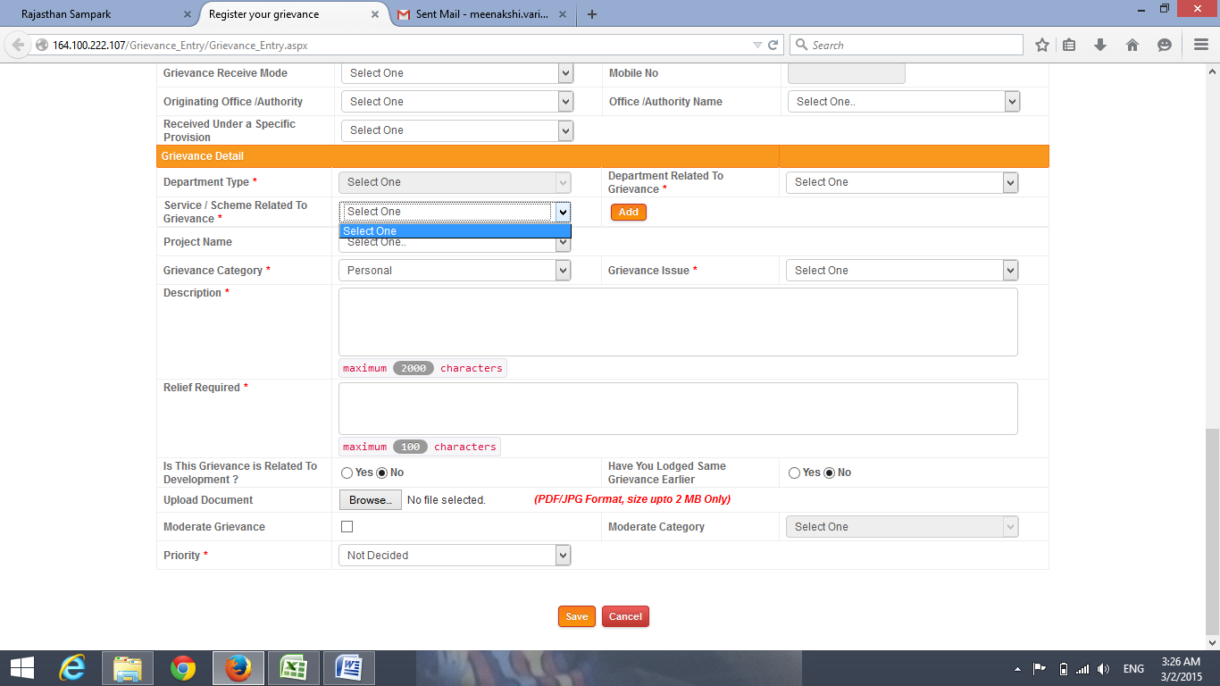

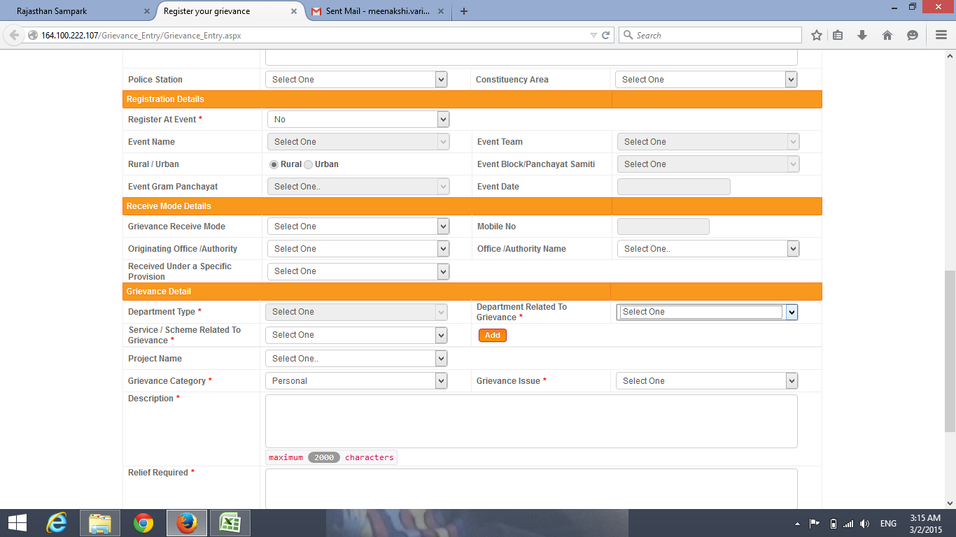

**Screenshot2**

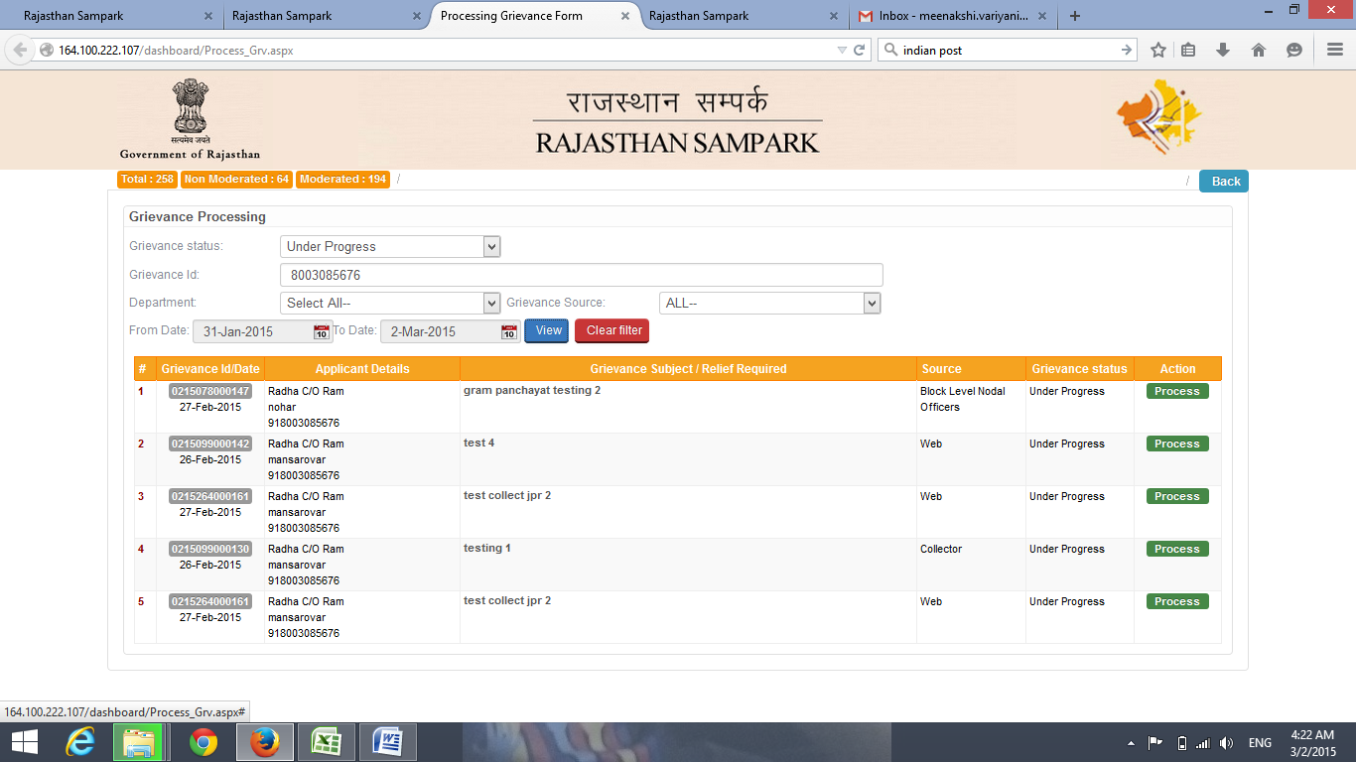

**Screenshot3**

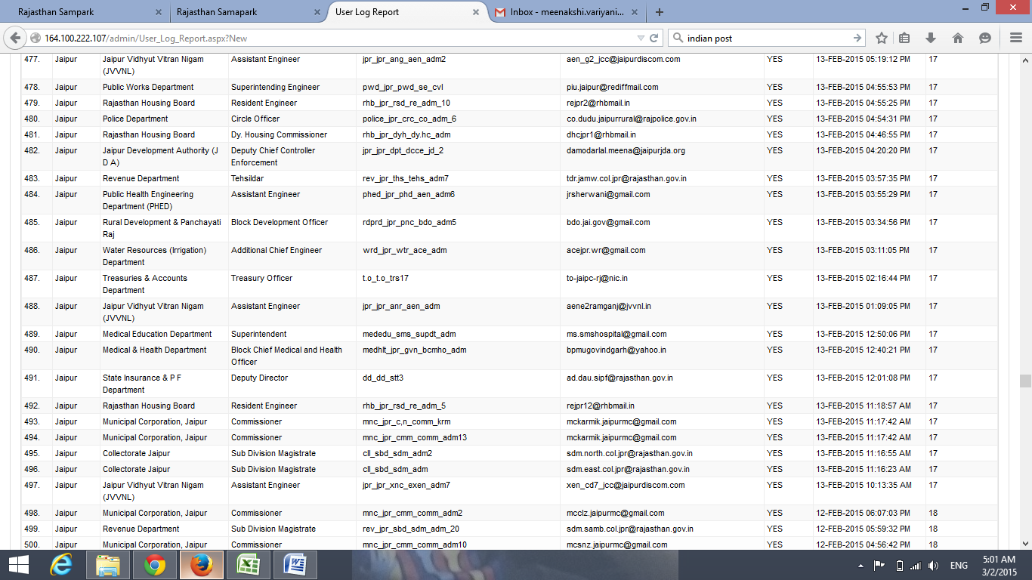

**Screenshot4**

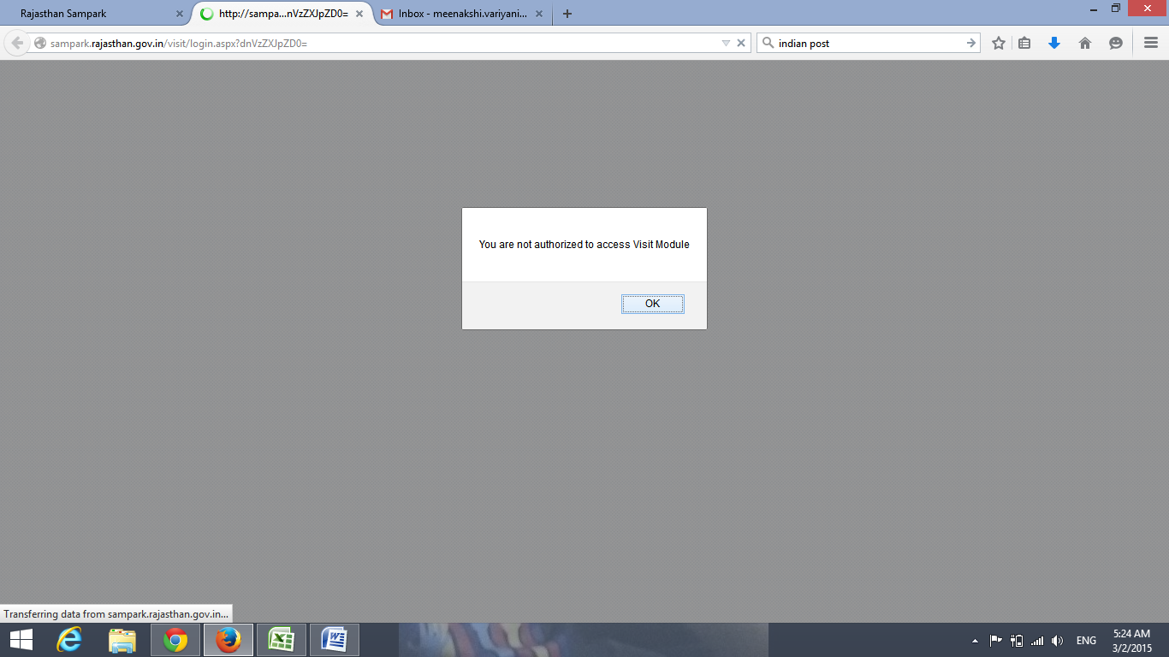

**Screenshot5**

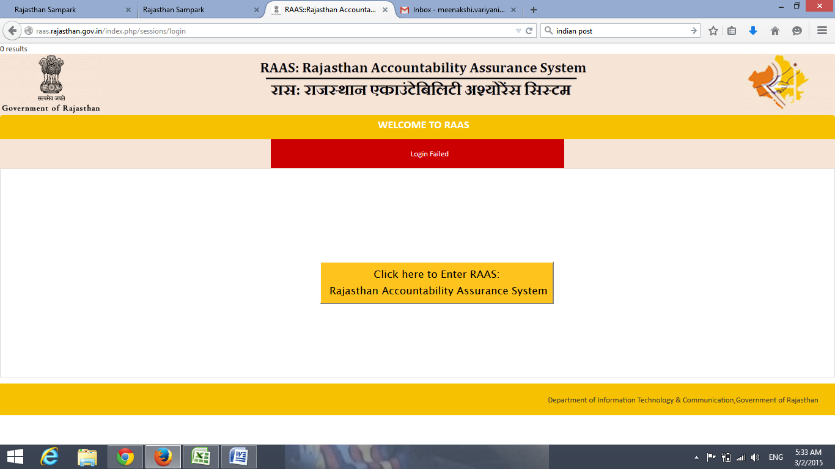

**Screenshot6**

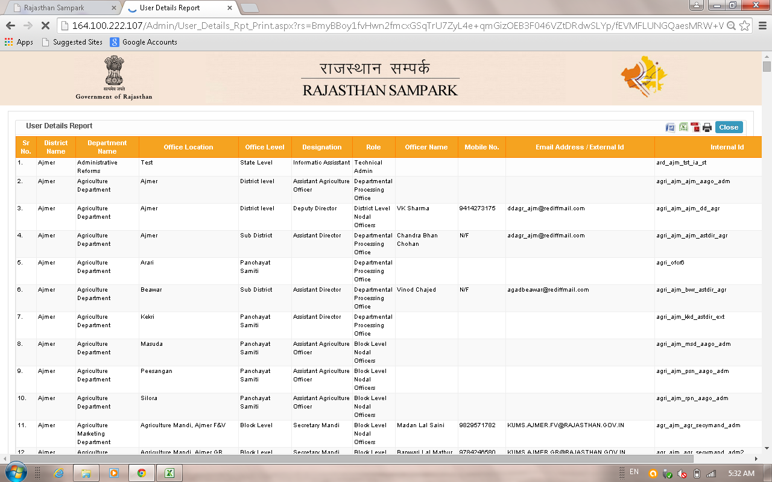

**Screenshot7**

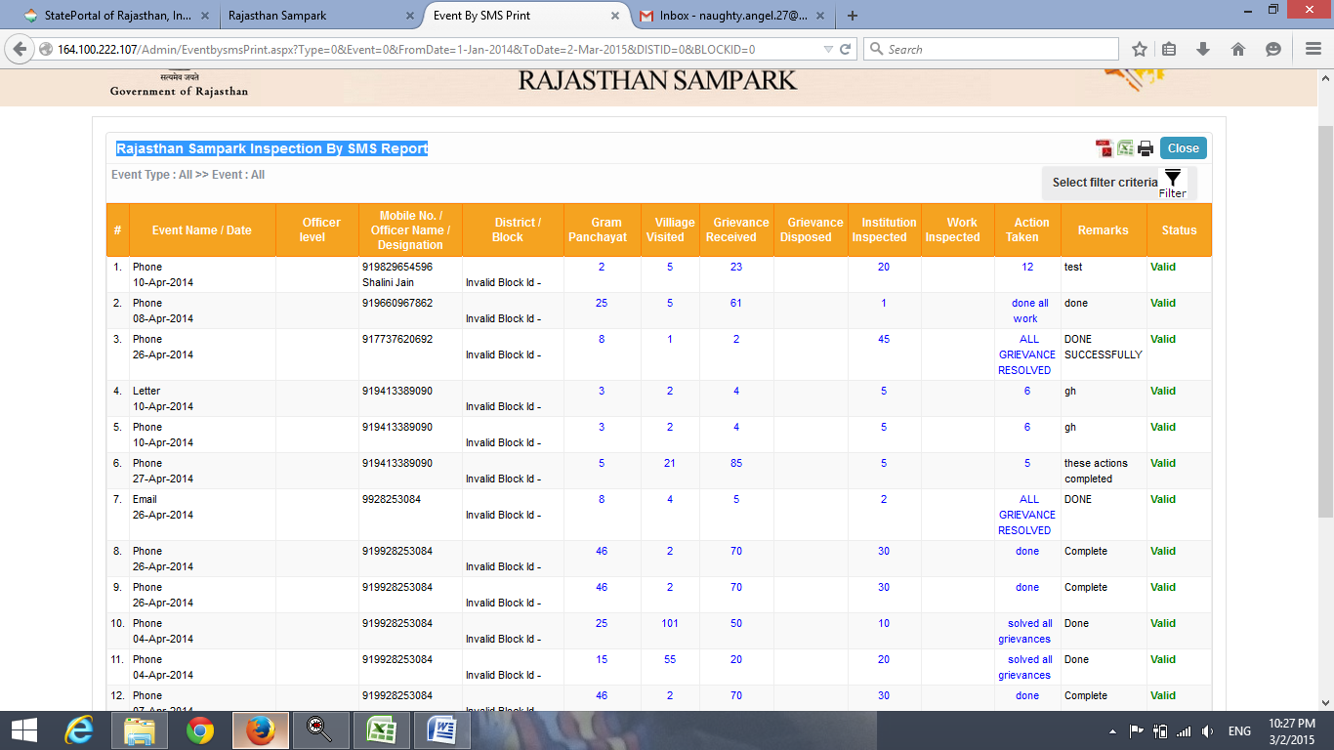

**Screenshot8**

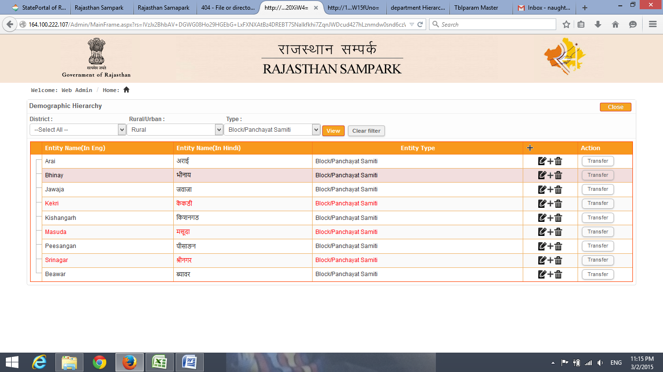

**Screenshot9**

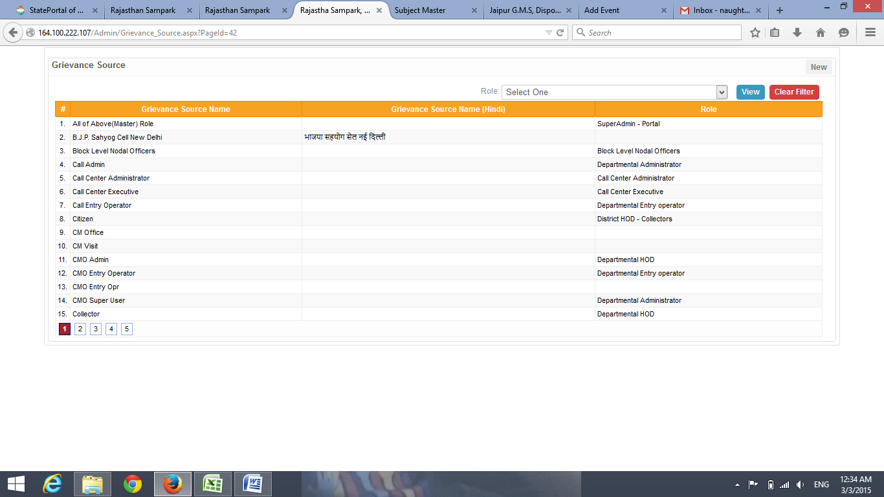

**Screenshot10**

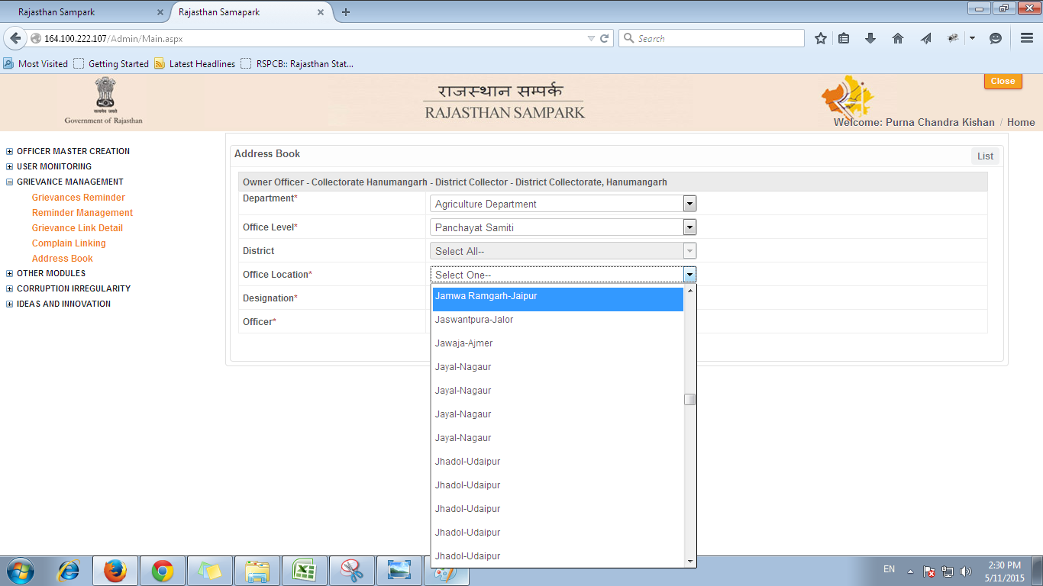

**Screenshot11**

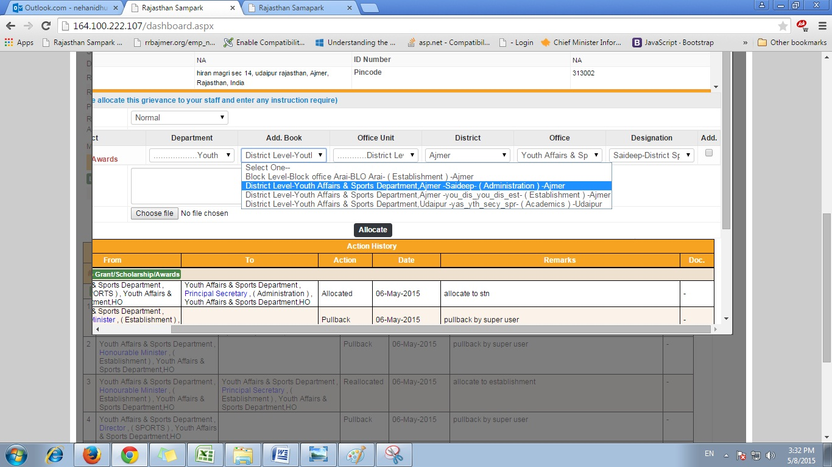

**Screenshot12**

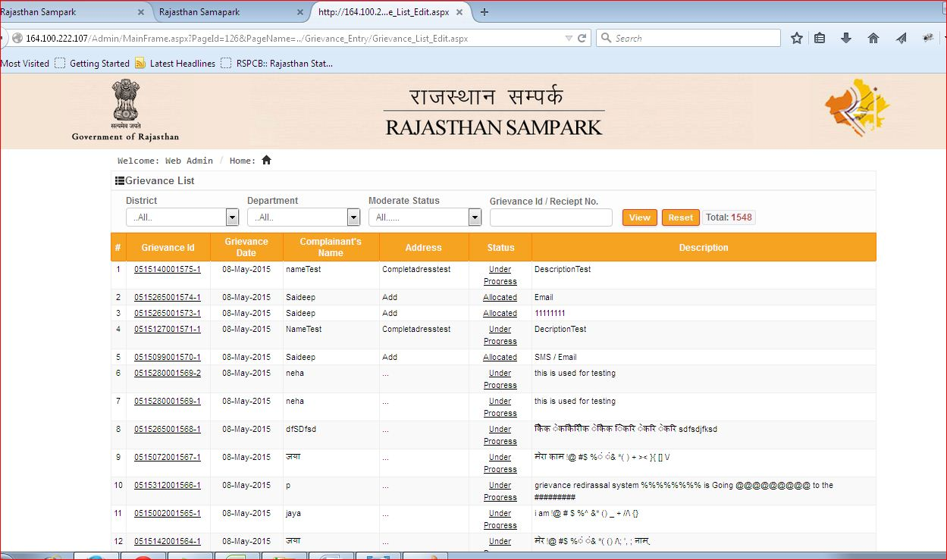

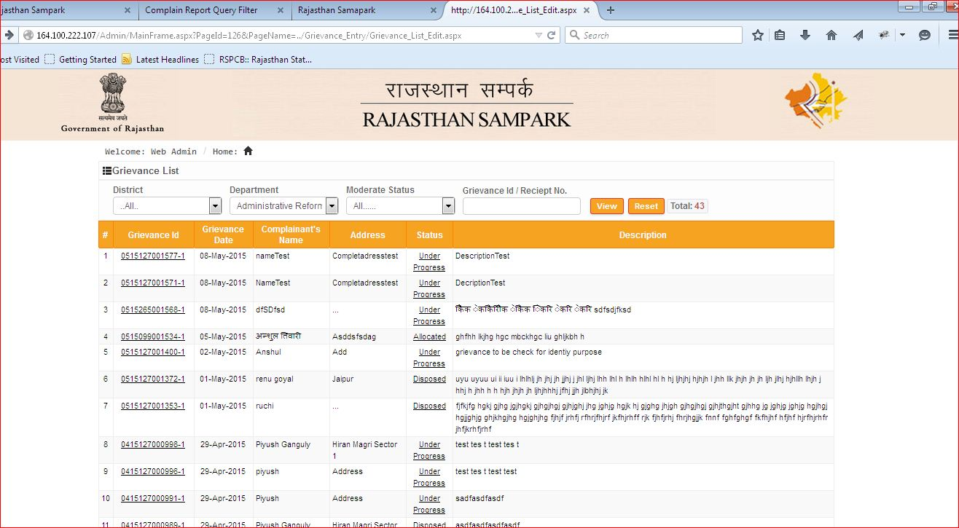

**Screenshot13**

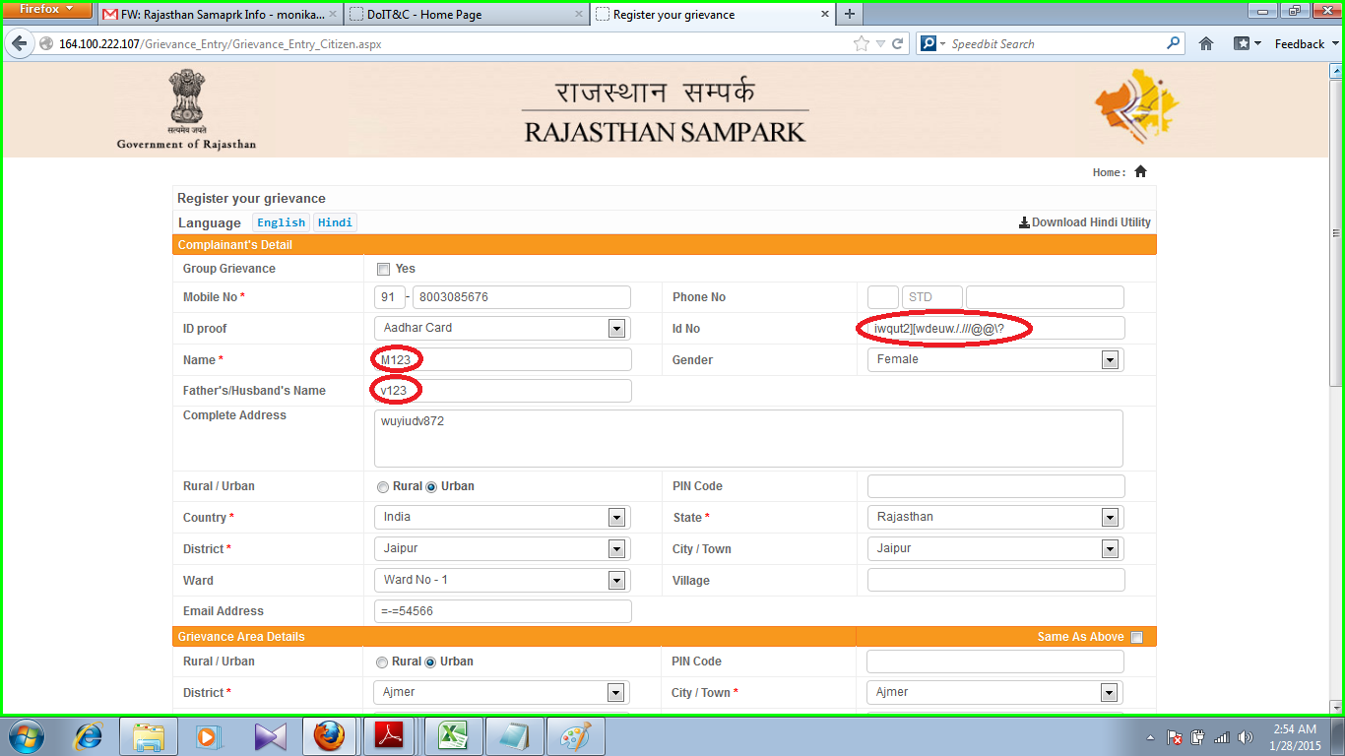

**Screenshot14**

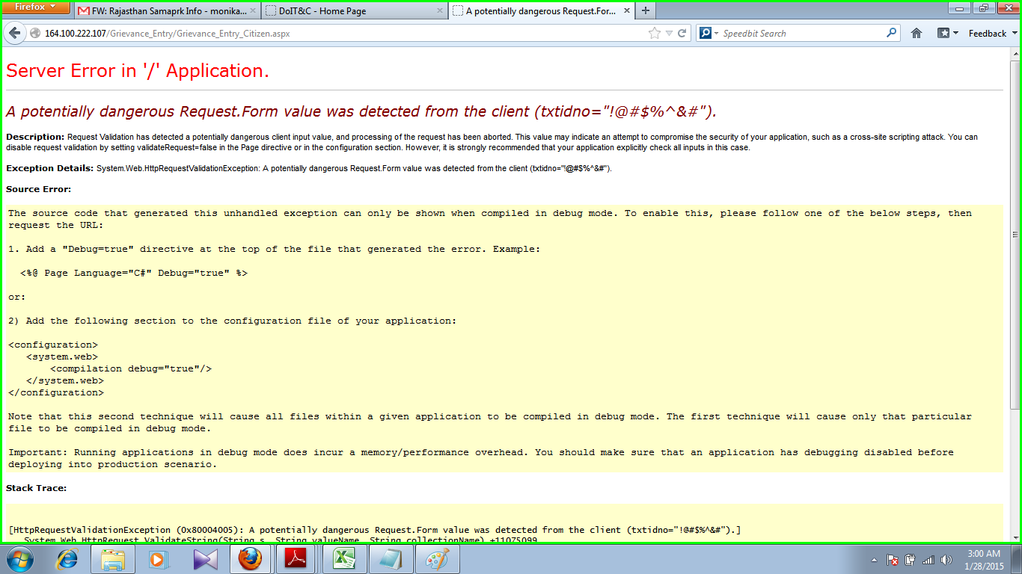

**Screenshot 15**

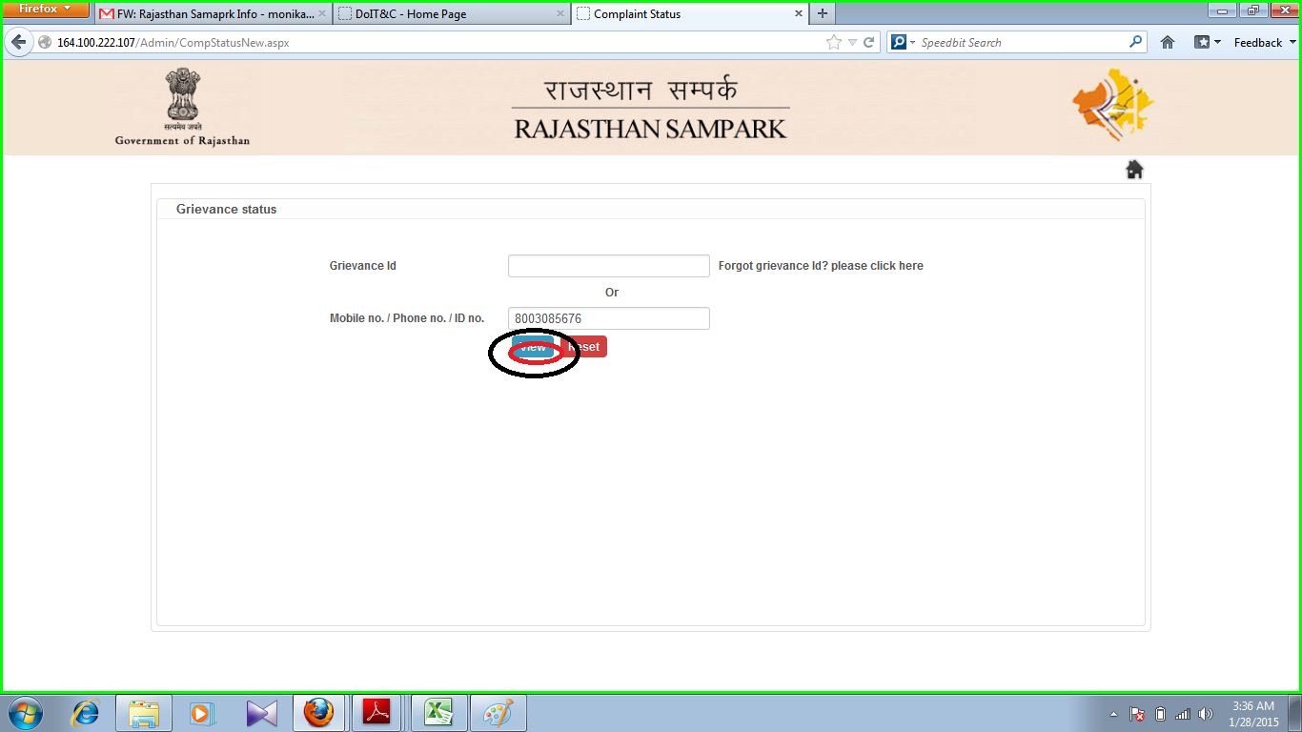

**Screenshot 16**



**Screenshot 17**

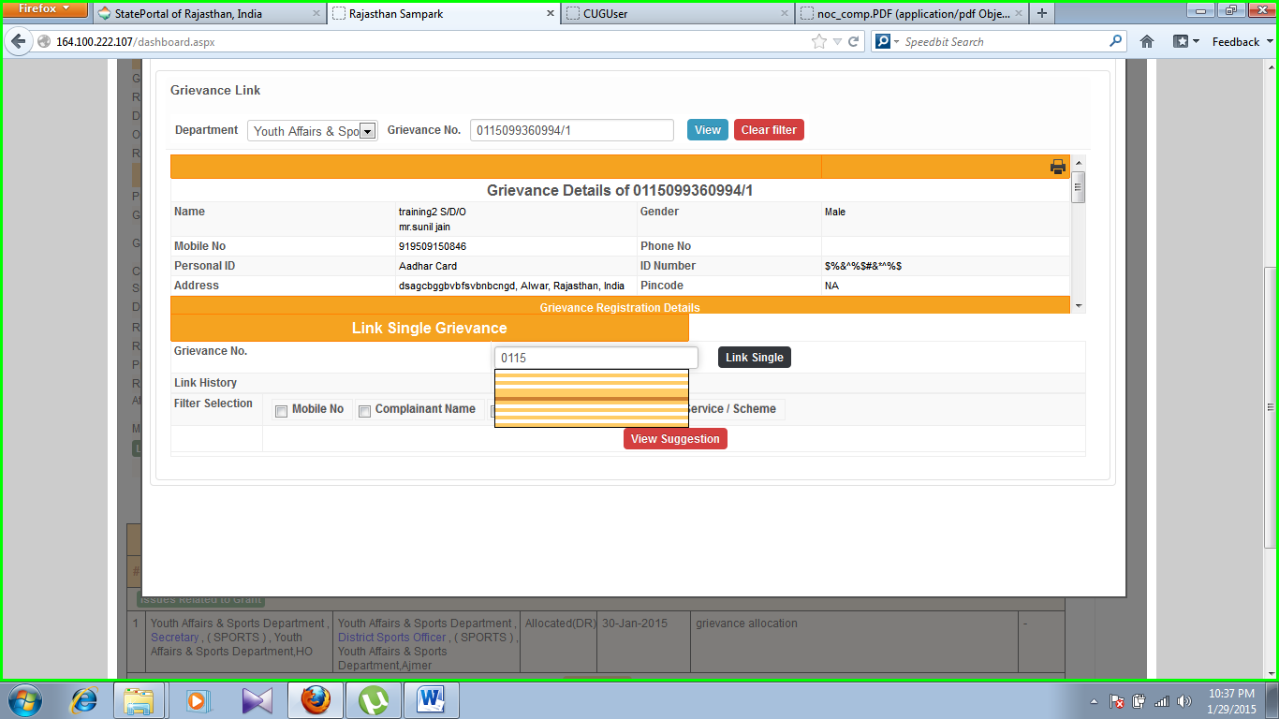

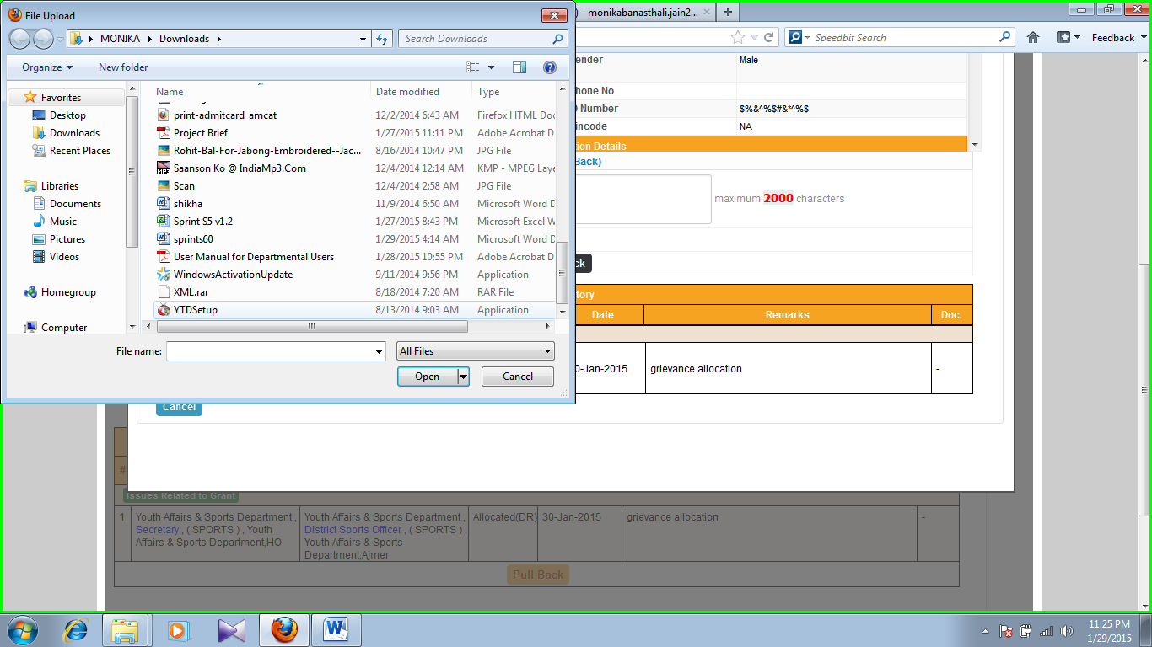

**Screenshot 16**

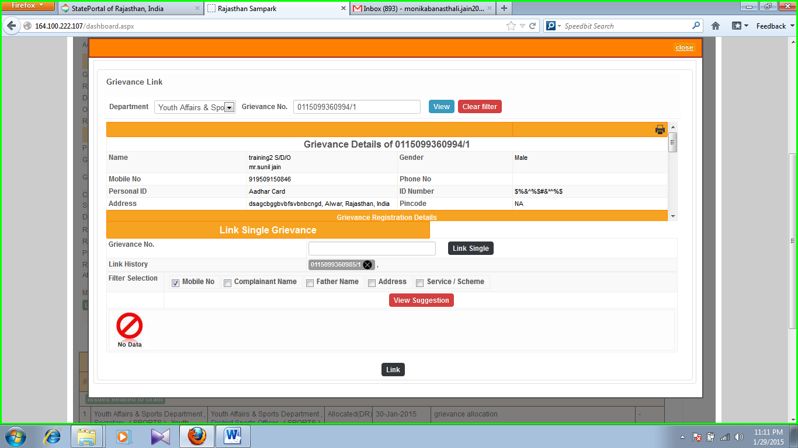**Screenshot 18**

**Screenshot 19**



**Screenshot 20**



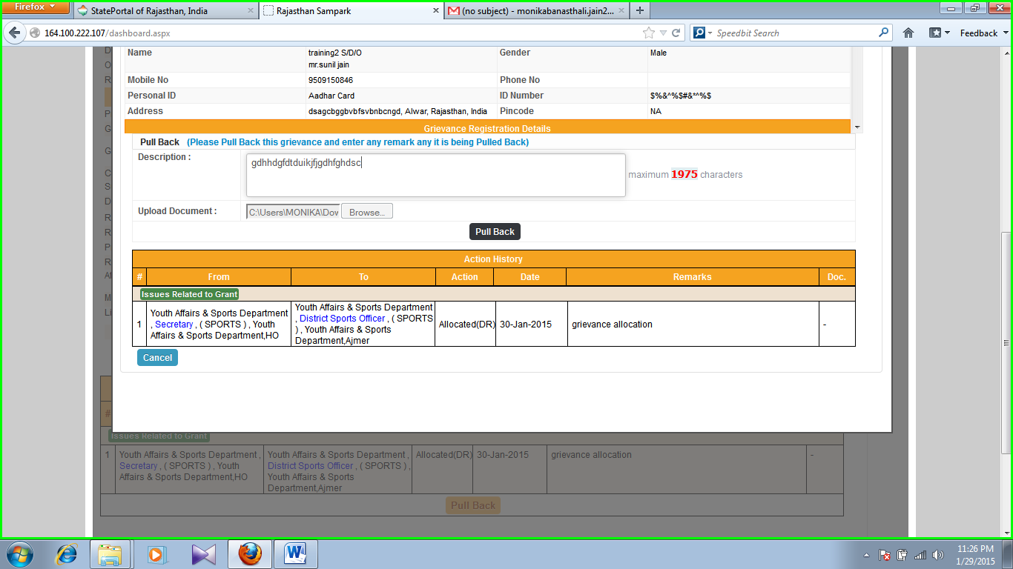

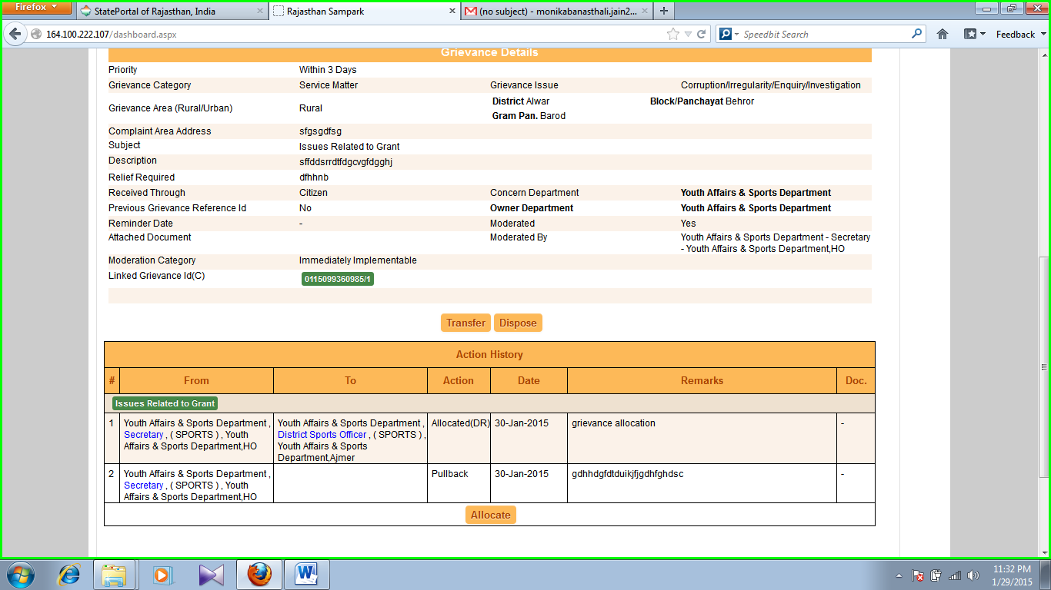**Screenshot 21**

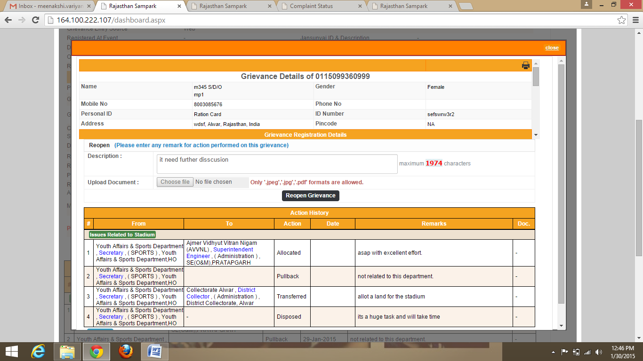**Screenshot 22**

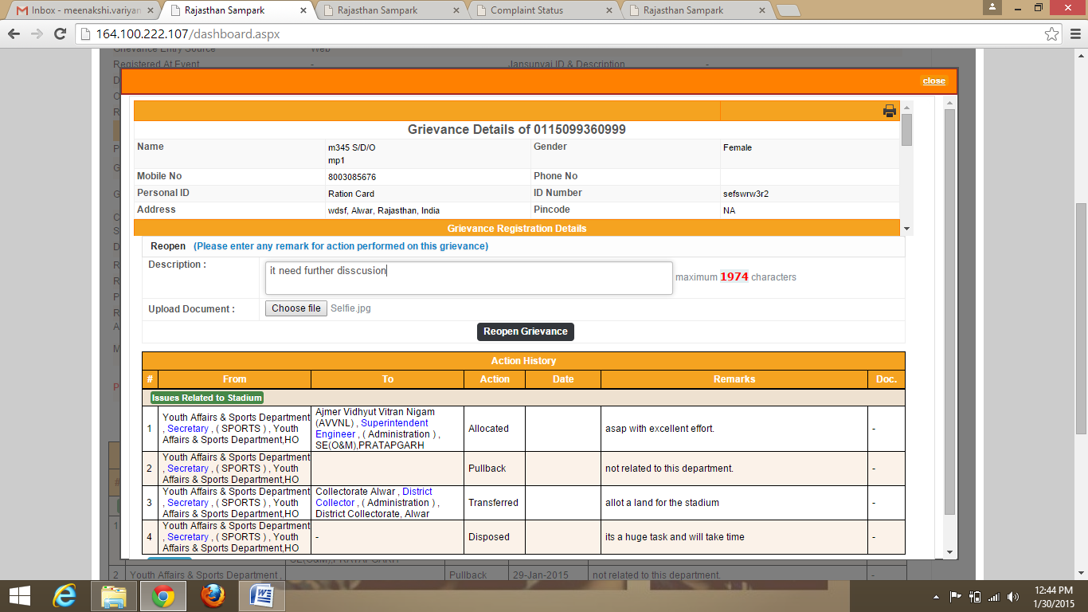

**Screenshot 23**

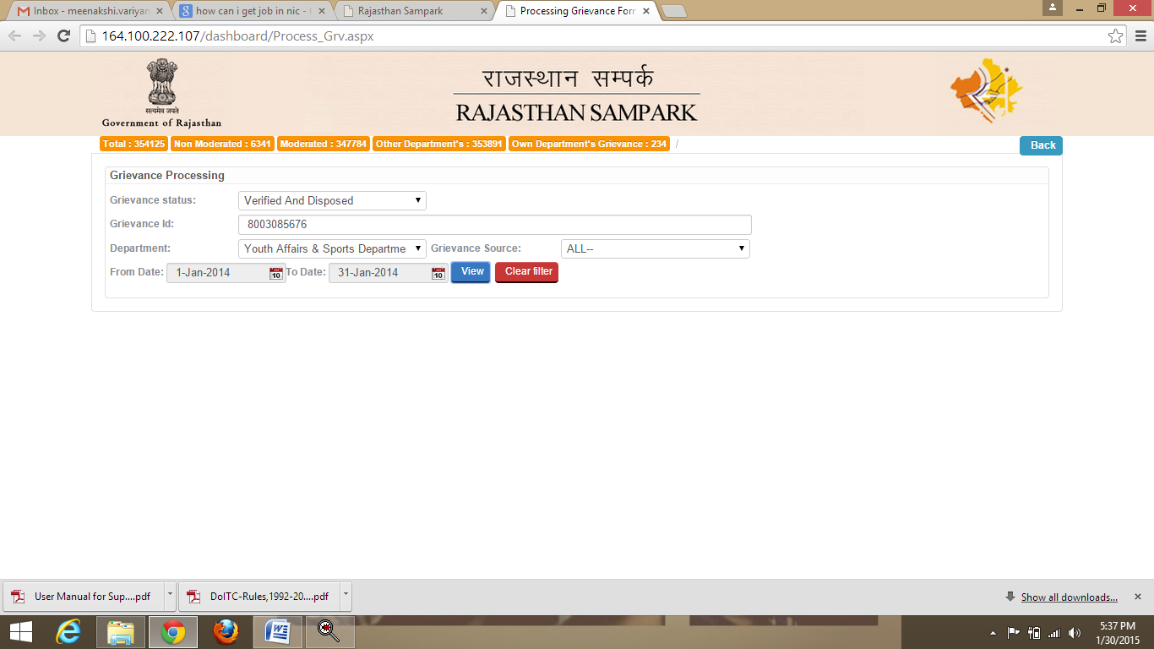

**Screenshot 24**

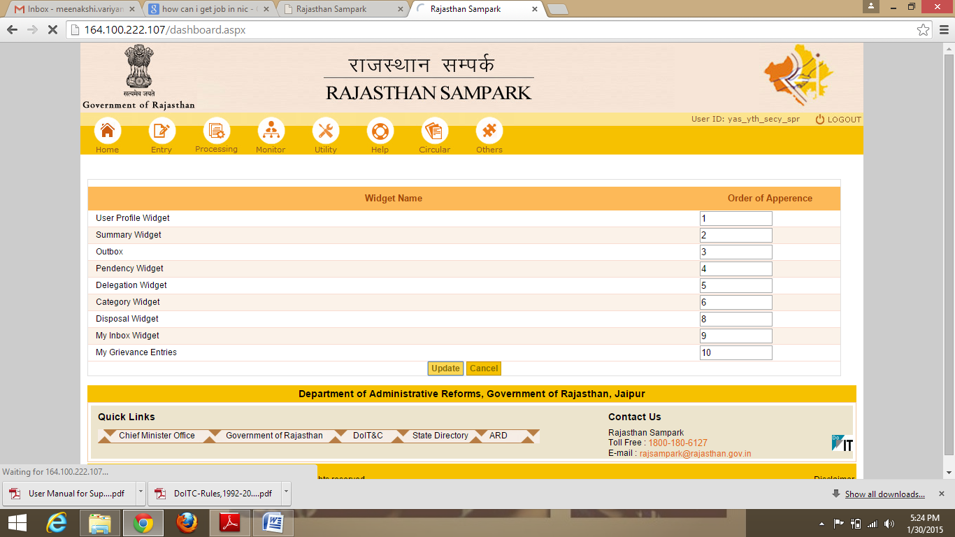**Screenshot 25**

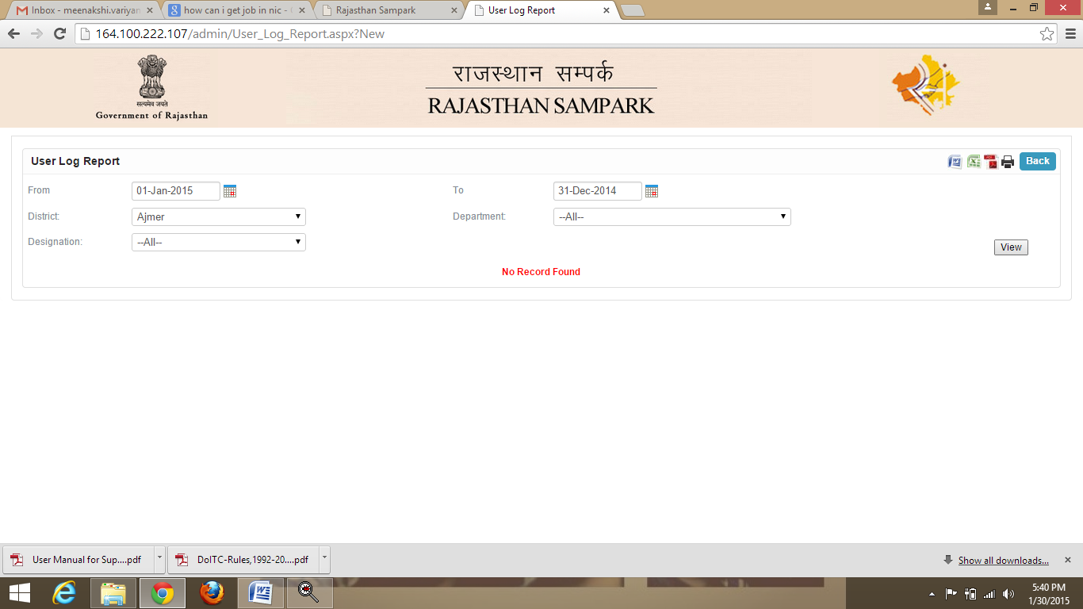

**Screenshot 26**

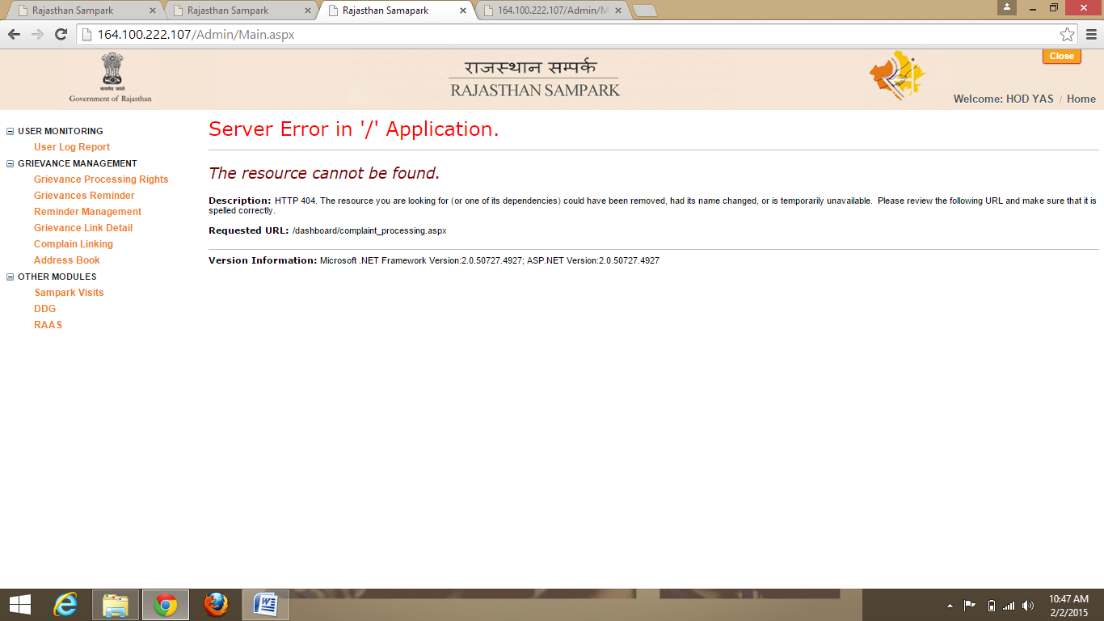

**Screenshot 27**

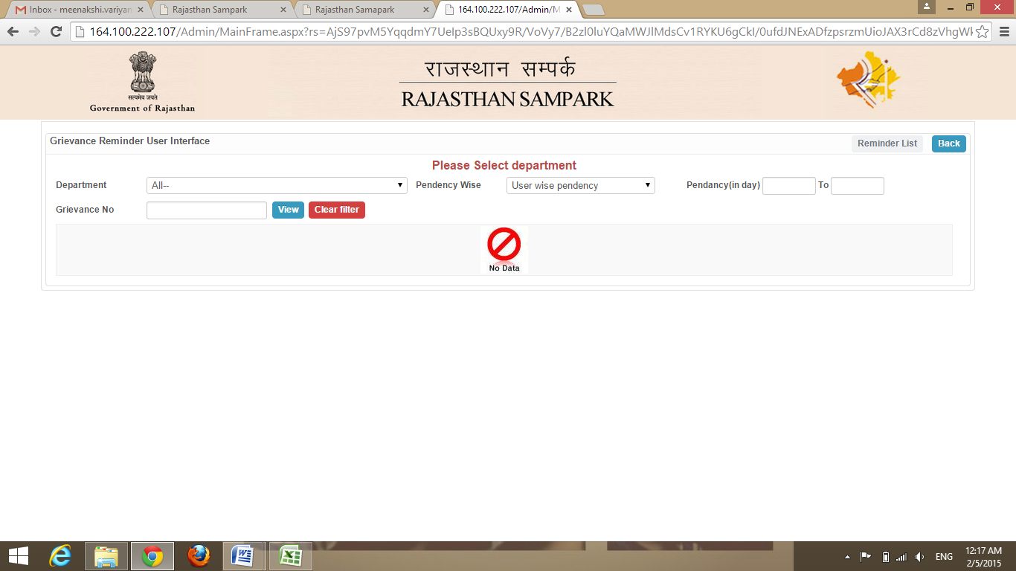

**Screenshot 28:**

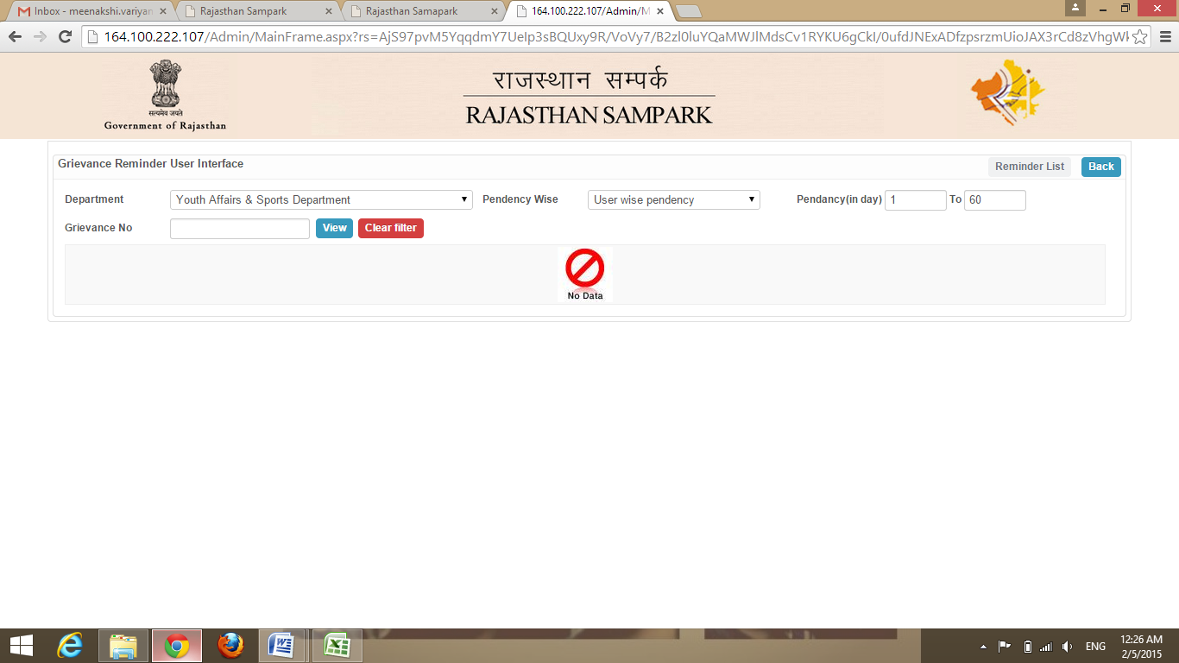

**Screenshot 29**



**Screenshot 30**

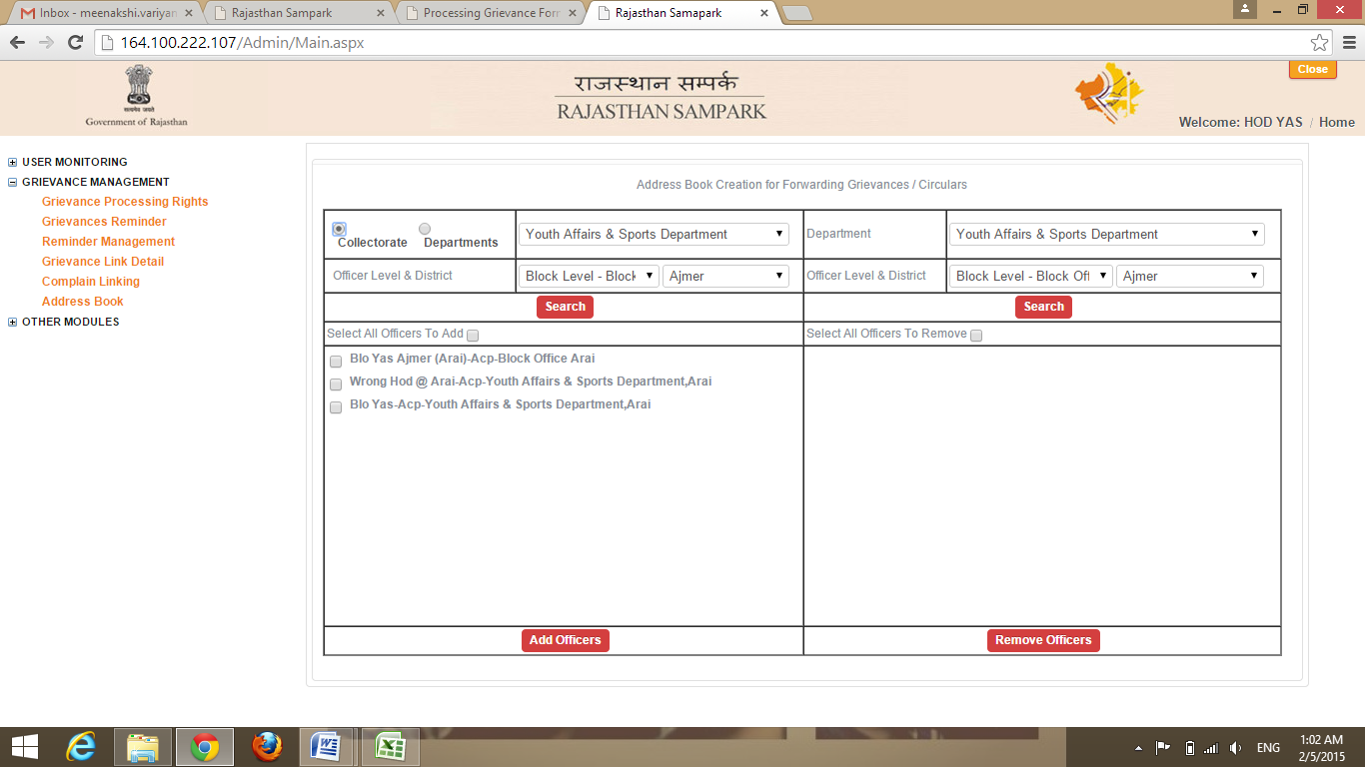

**Screenshot 31**

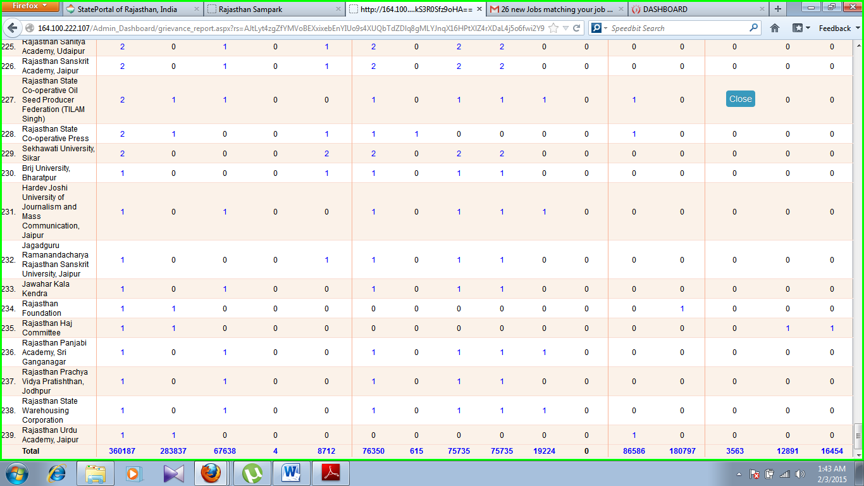

**Screenshot 32**

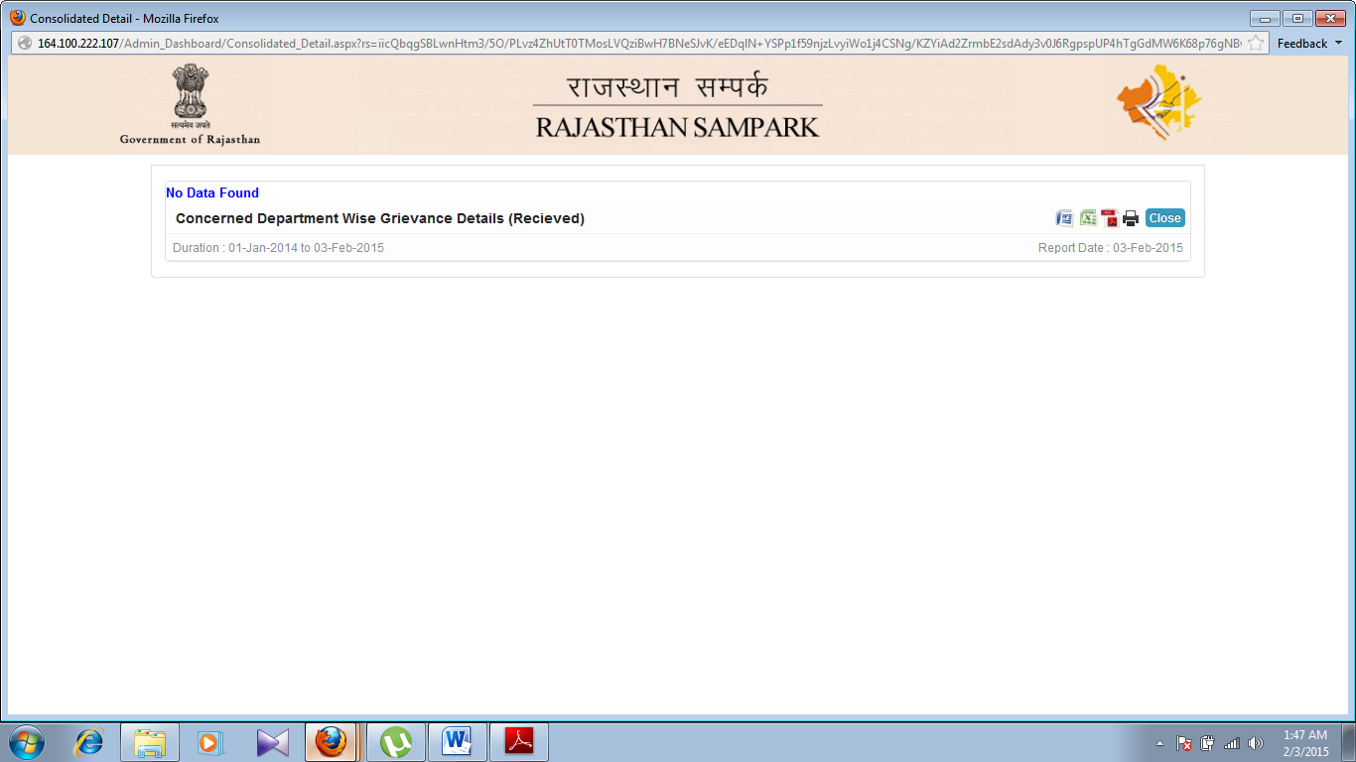

**Screenshot 33**

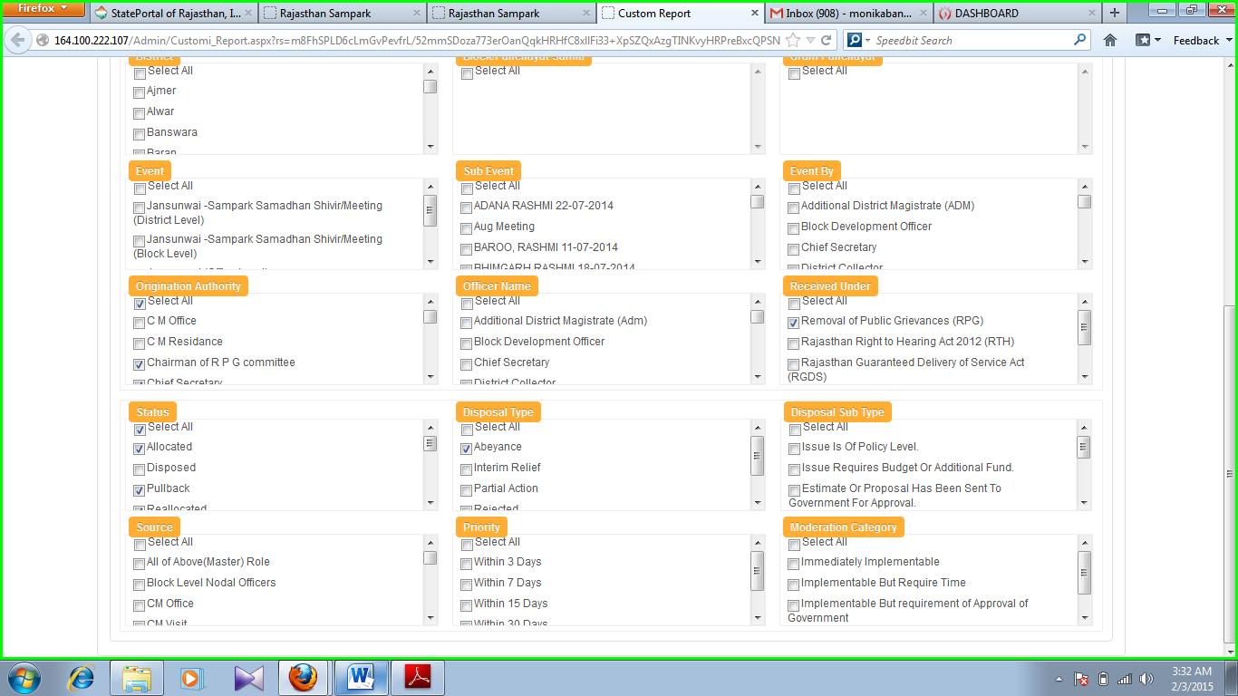

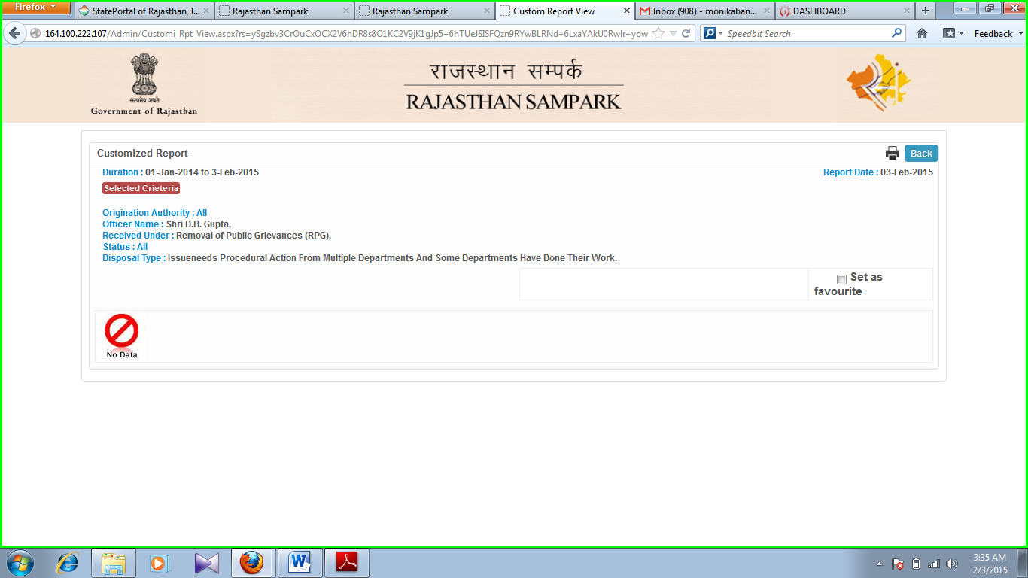



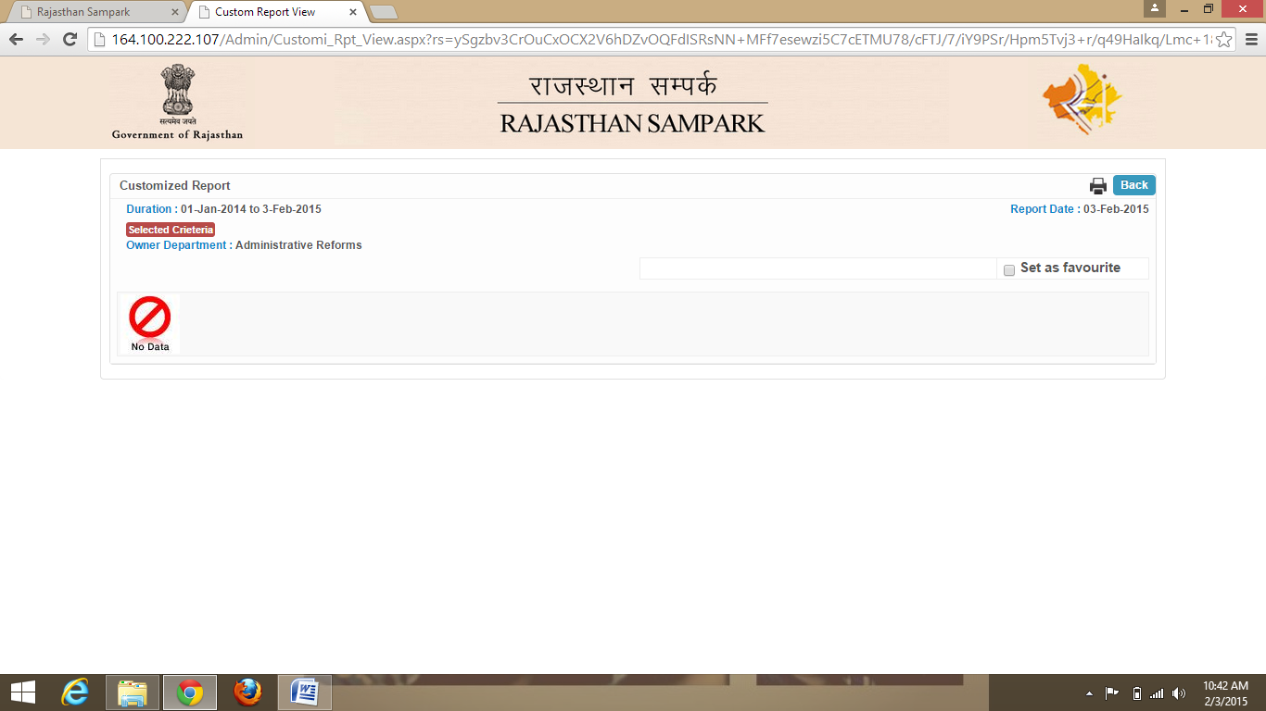 **Screenshot 34**

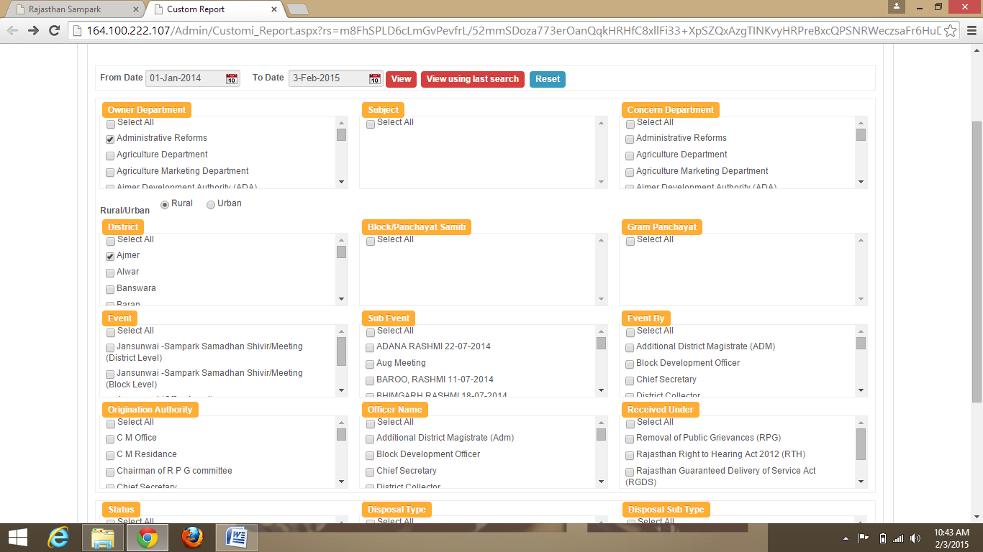

**Screenshot 35**

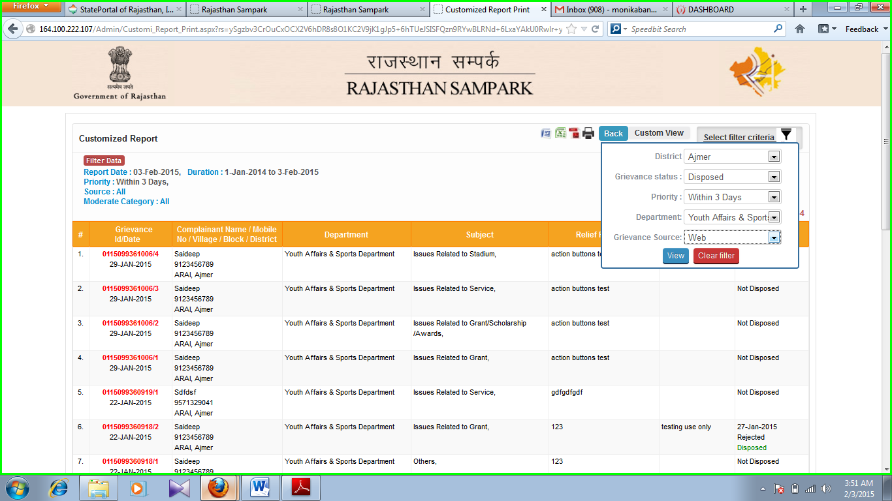

**Screenshot 36**

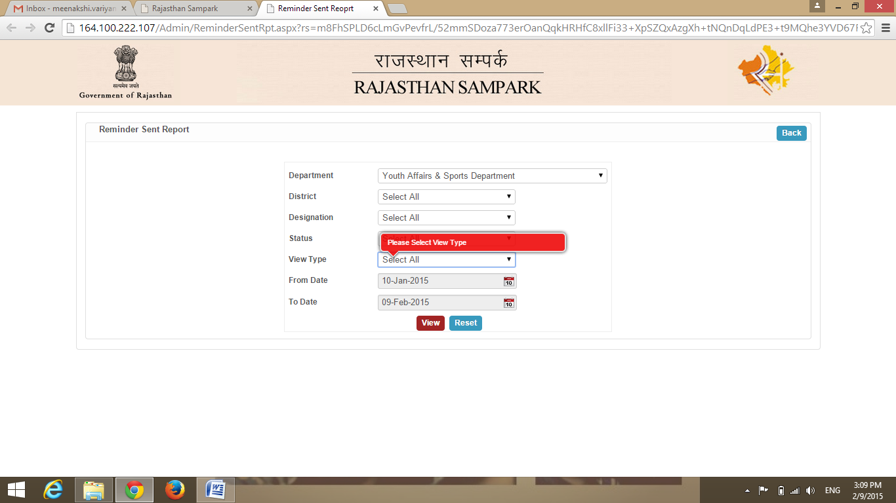

**Screenshot 37**

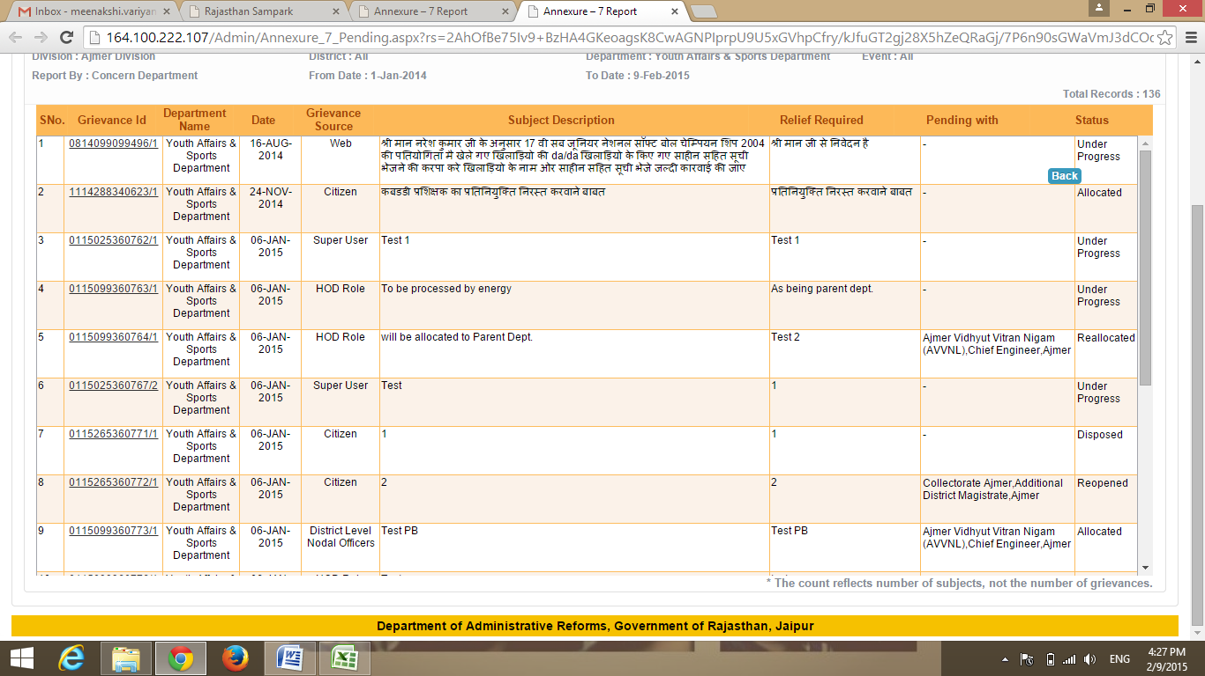

**Screenshot 38**

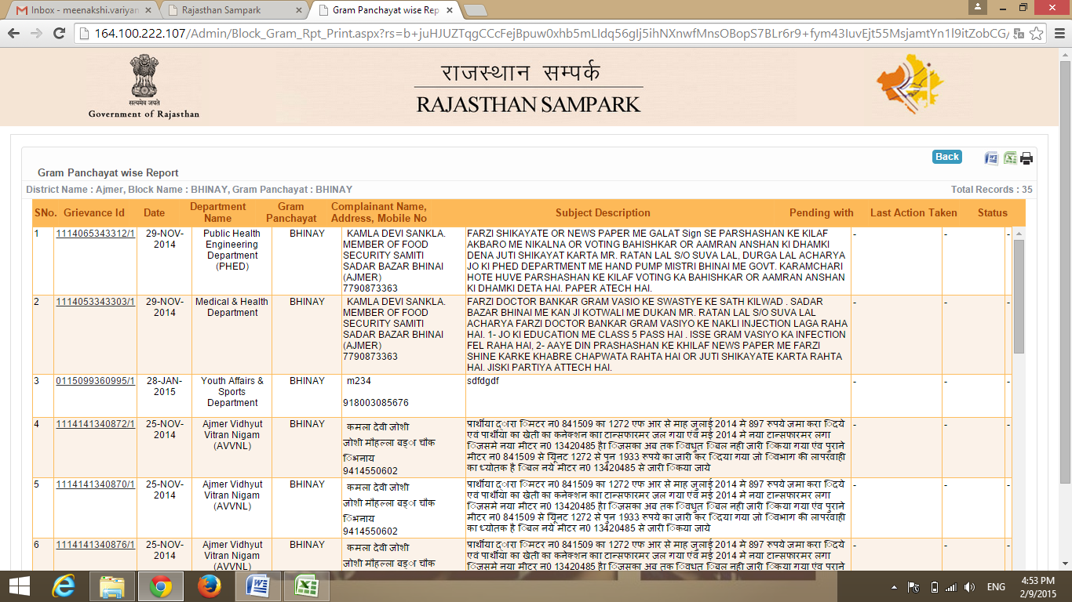

**Screenshot 39**

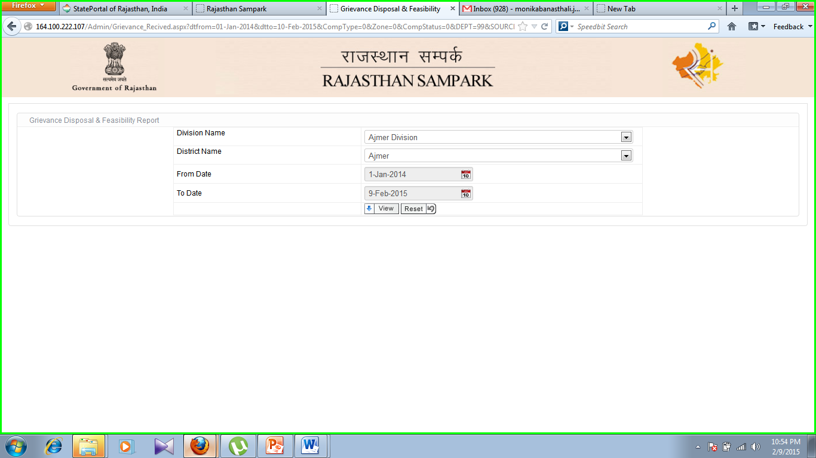

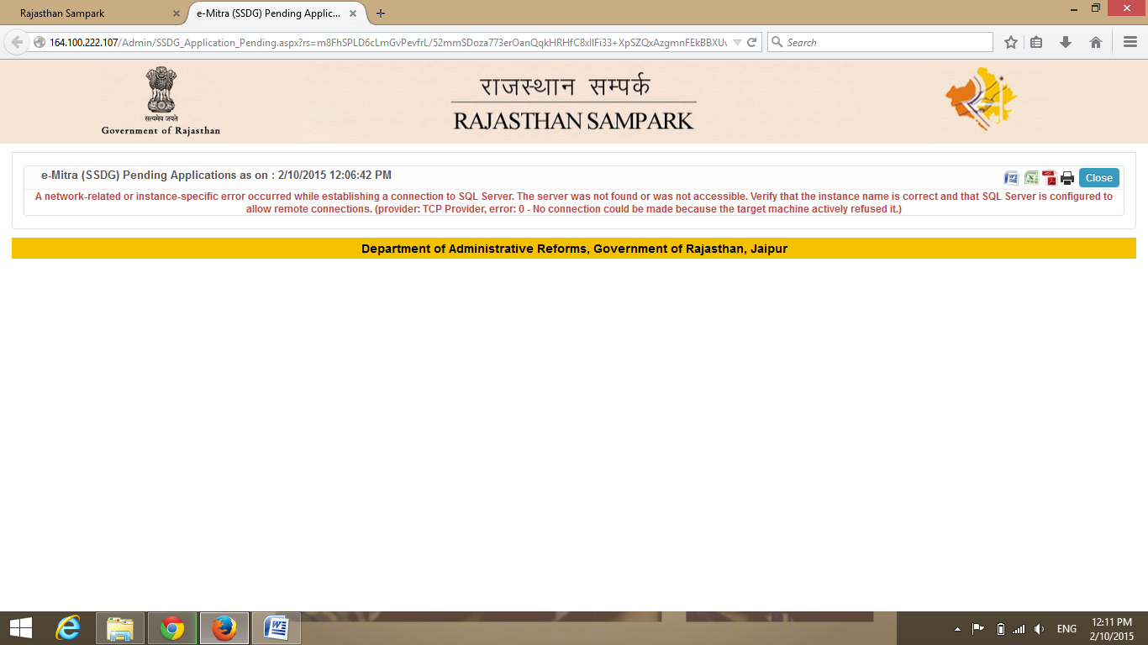**Screenshot 40**

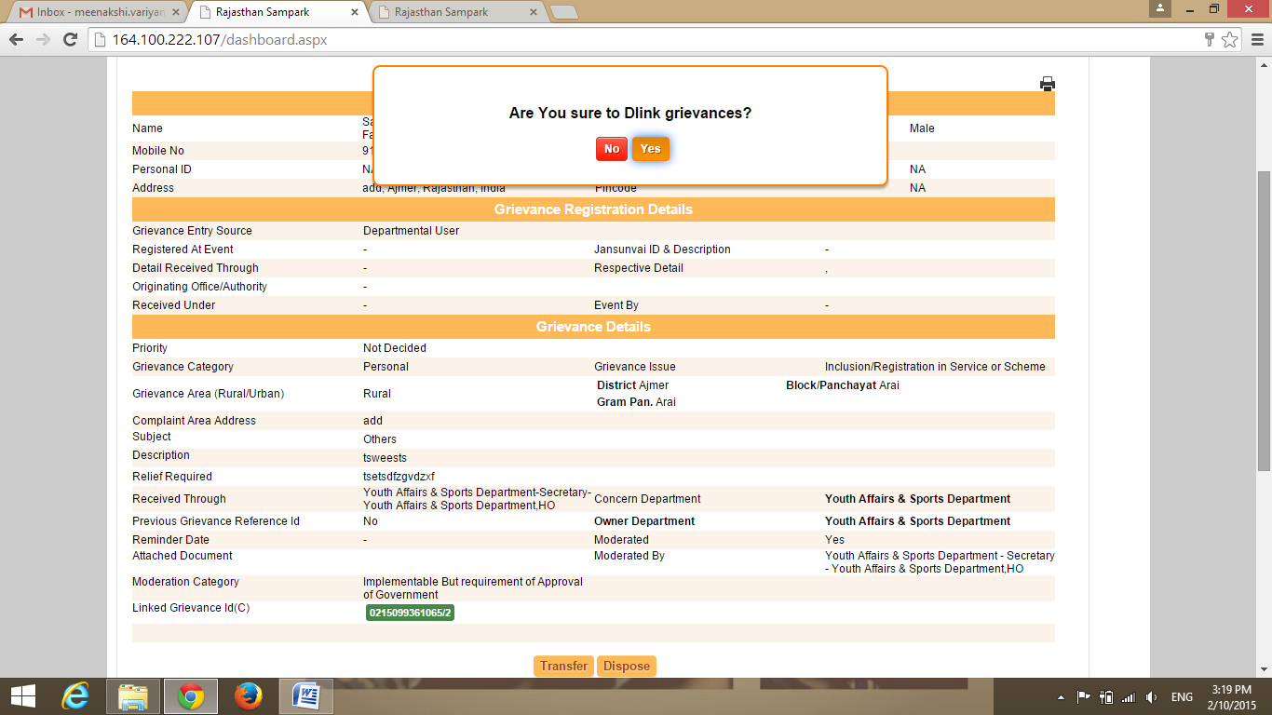

**Screenshot 41**



**Screenshot 42**

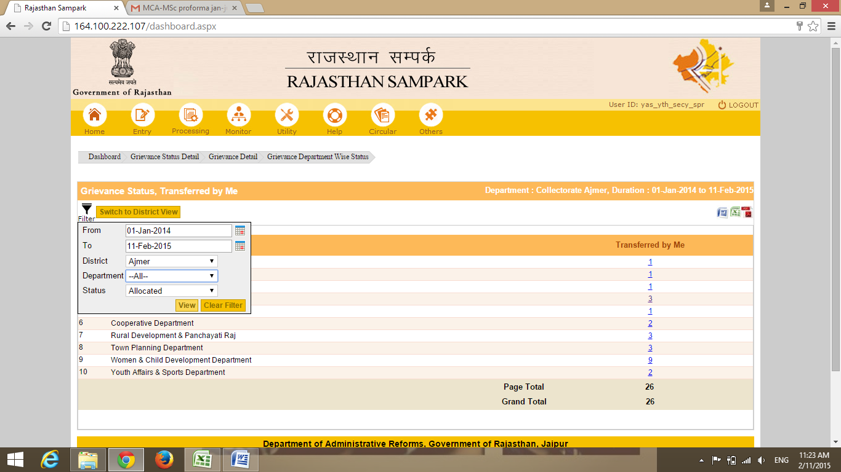

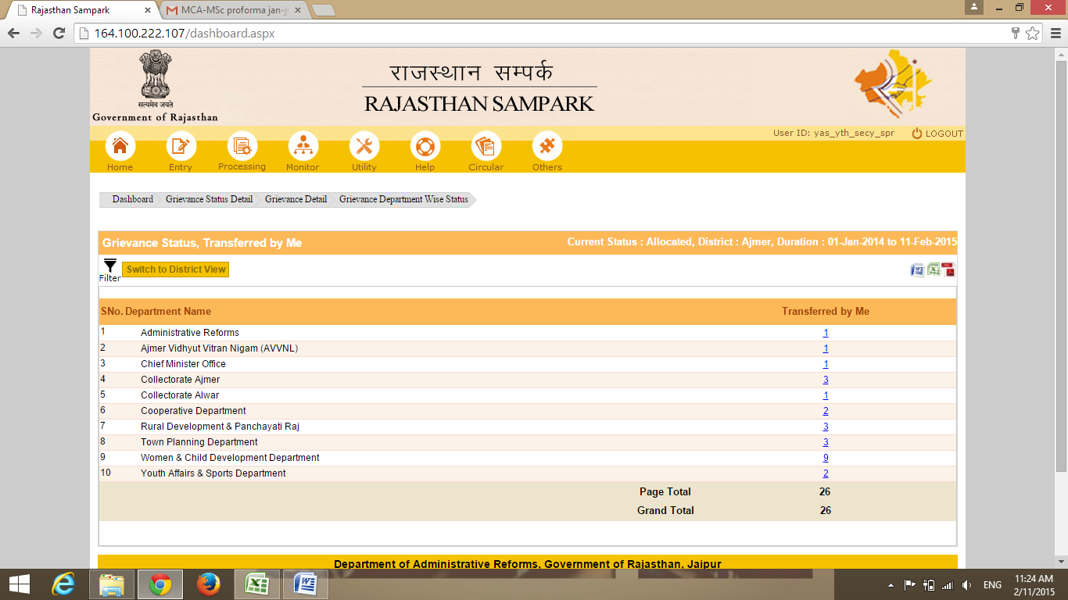

**Screenshot 43**

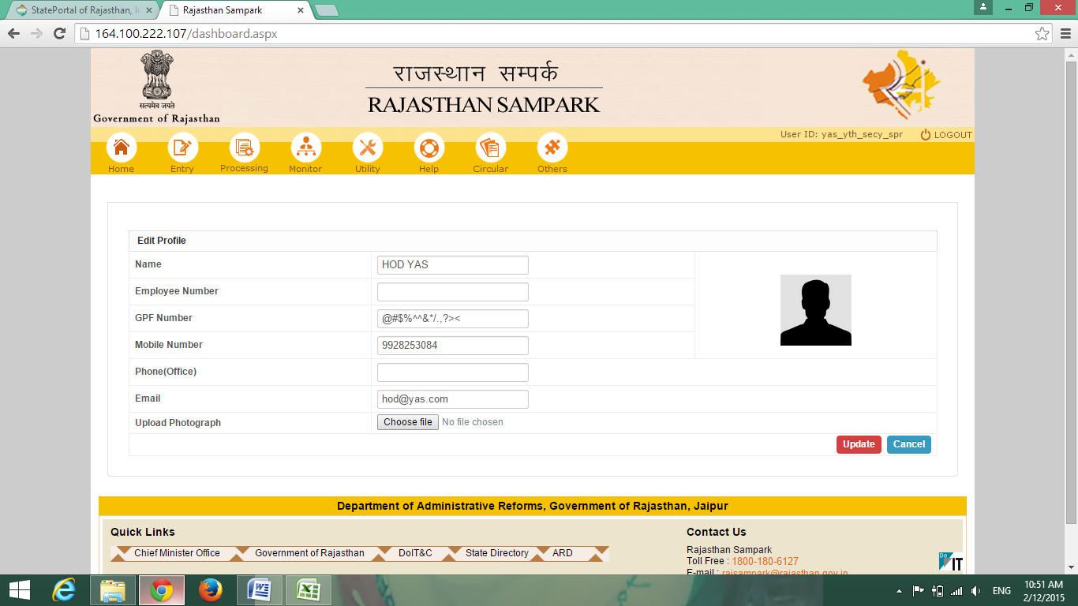

**Screenshot 44**

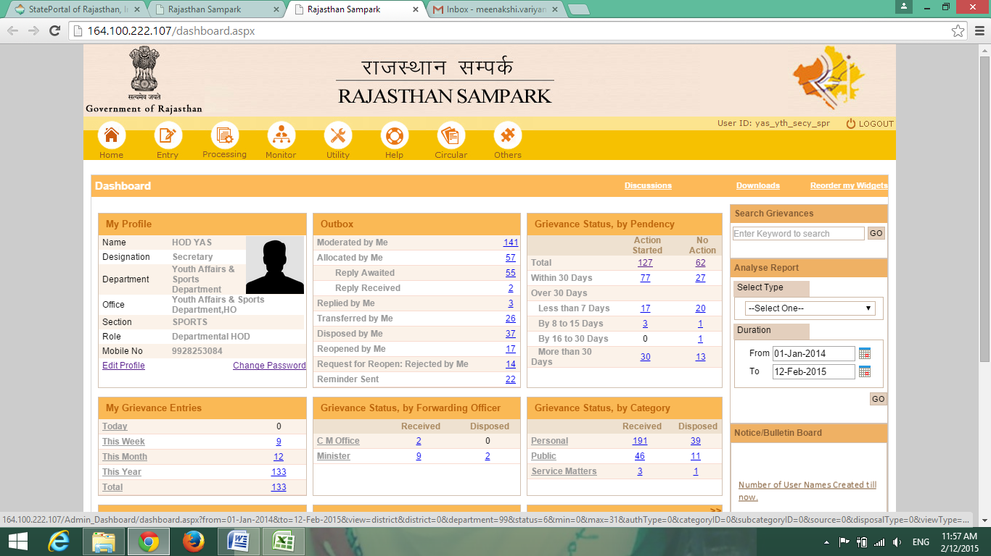

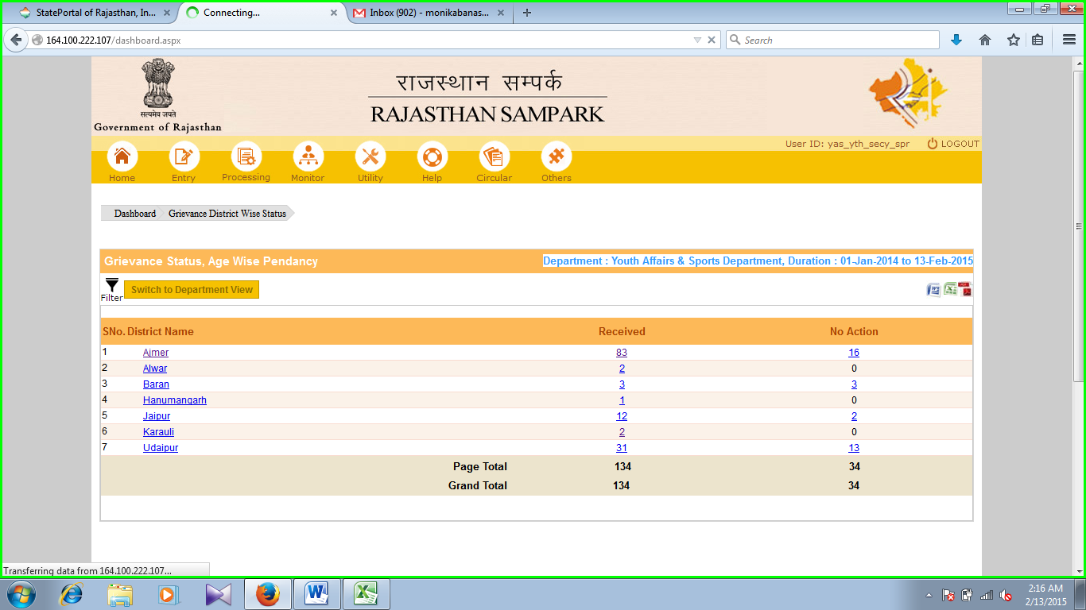

**Screenshot 45**

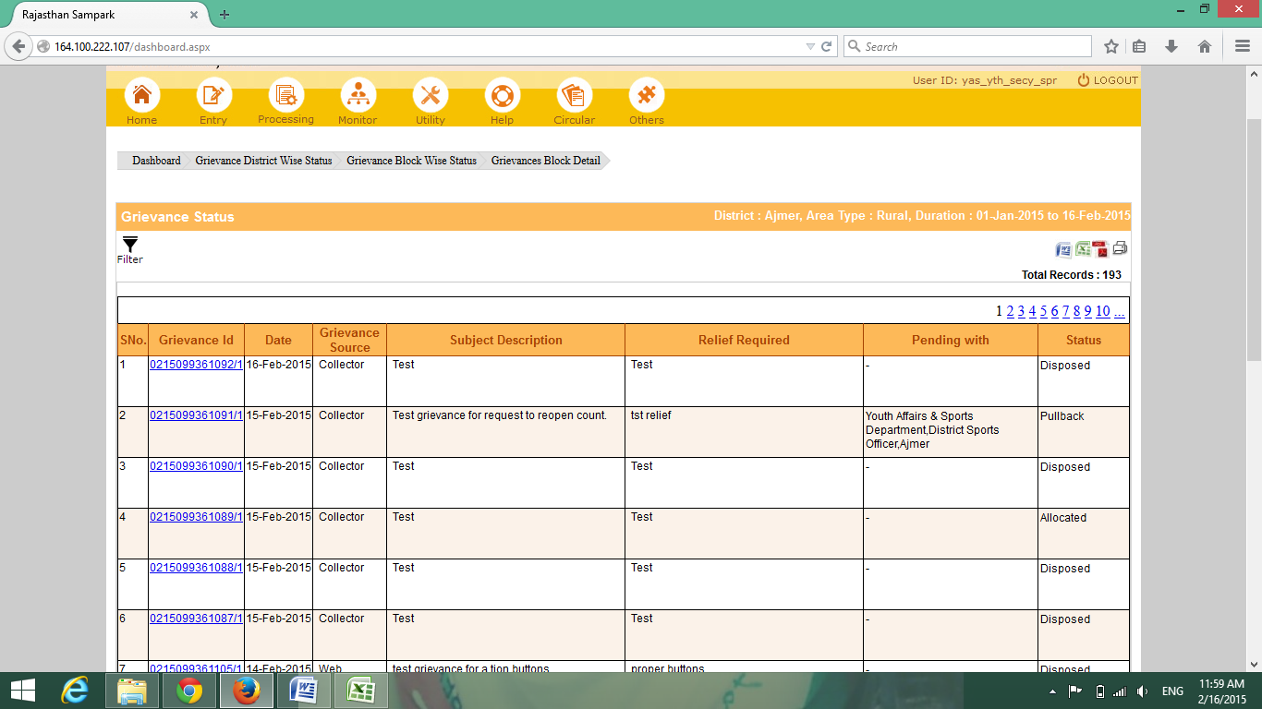

**Screenshot 46**

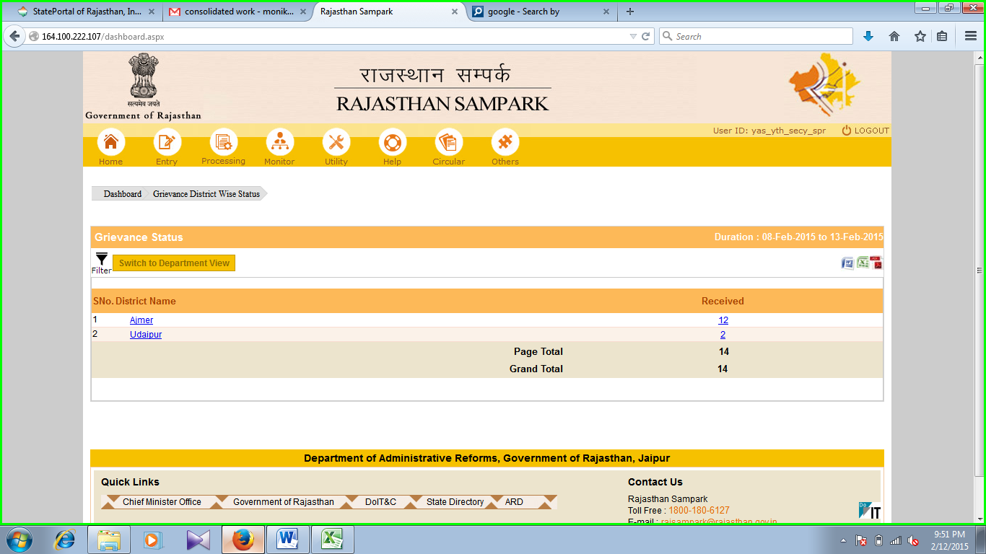

**Screenshot 47**

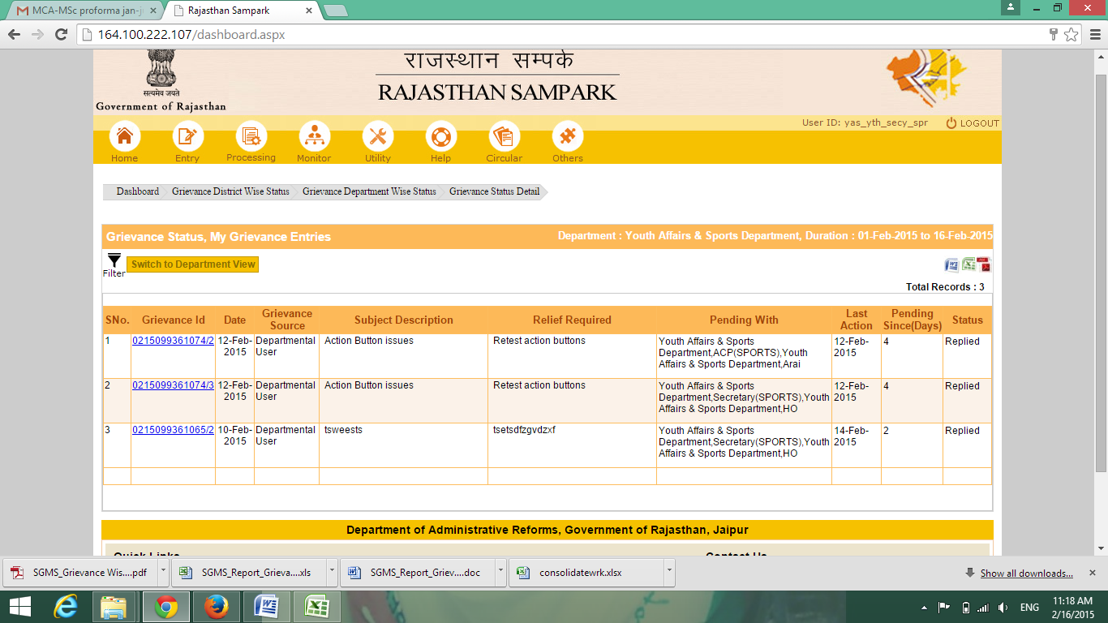

**Screenshot 48**

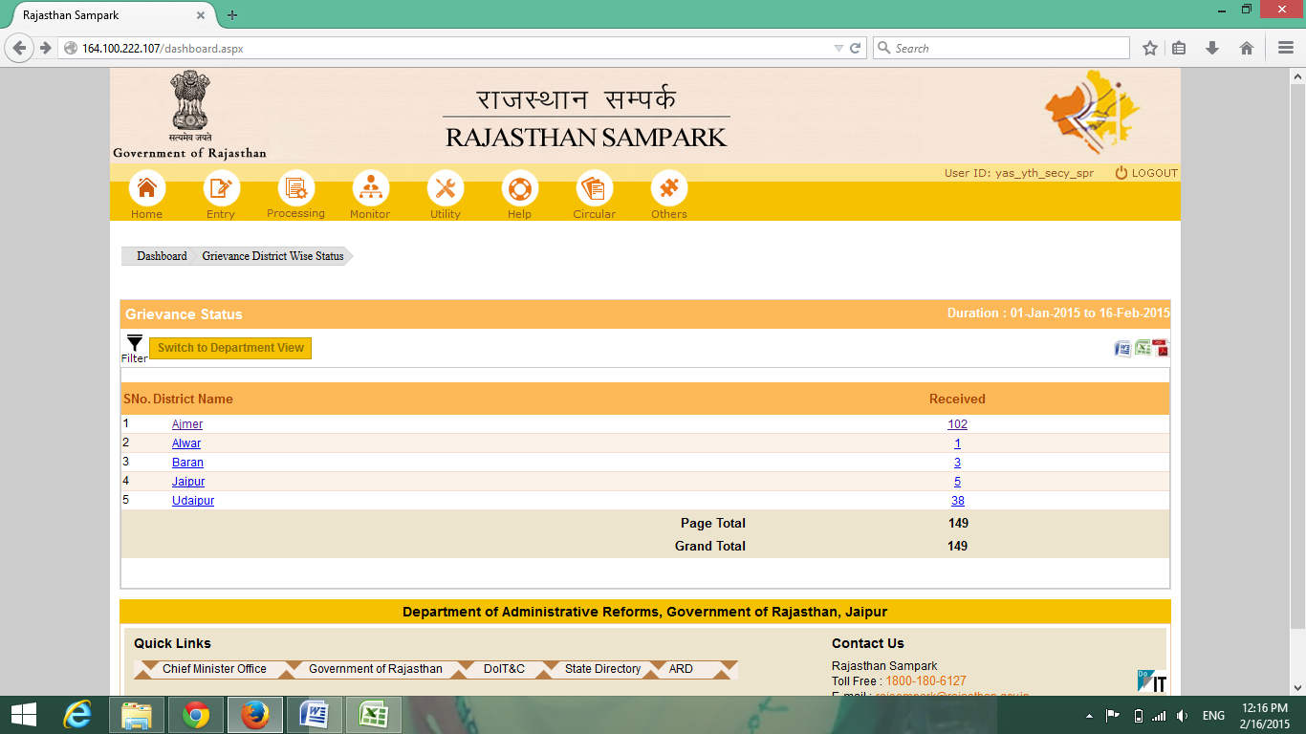

**Screenshot 49**

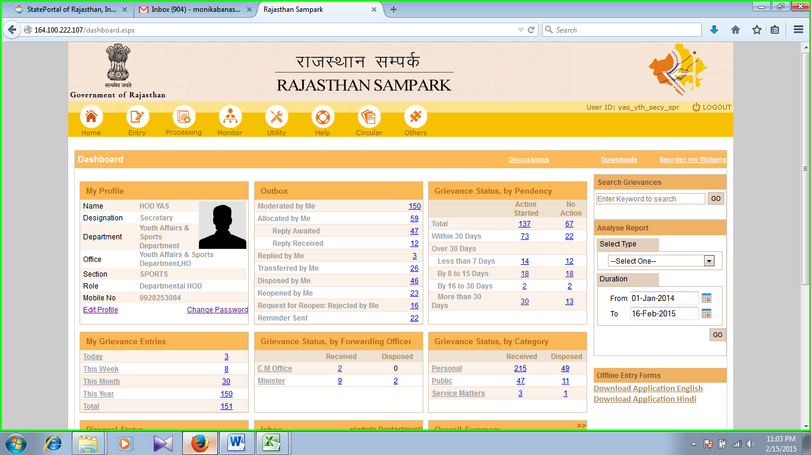

**Screenshot 50**

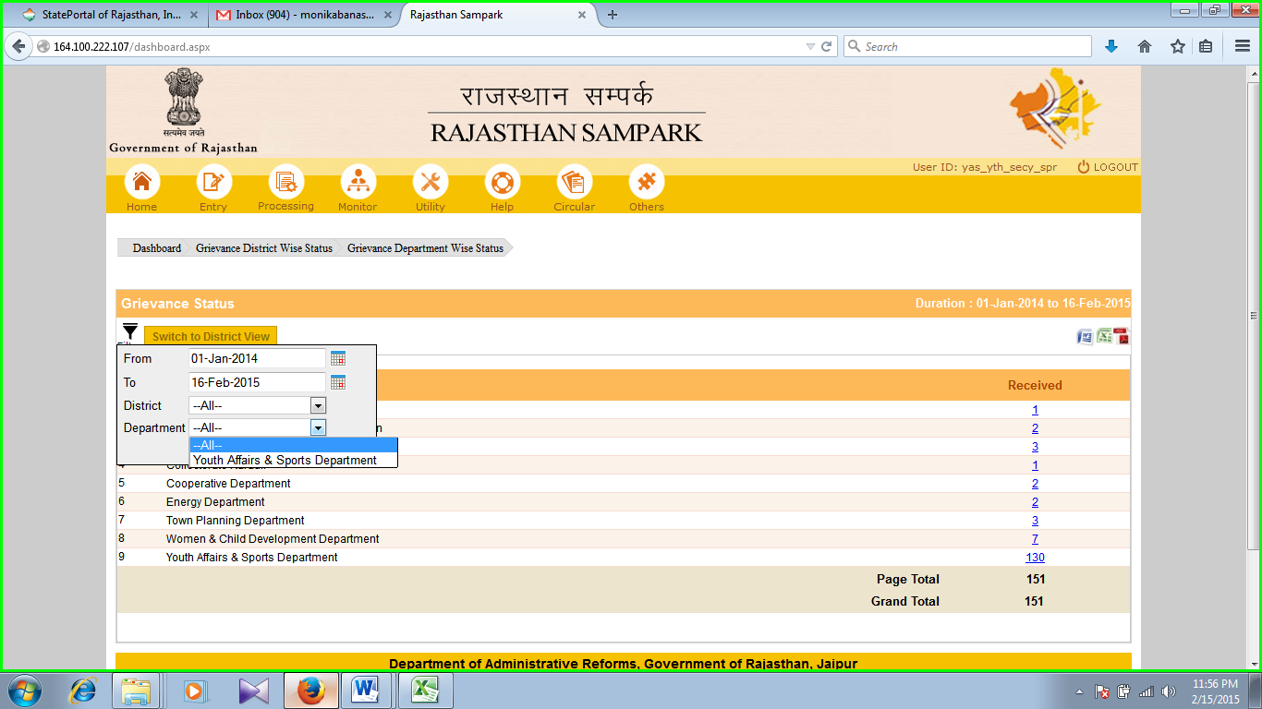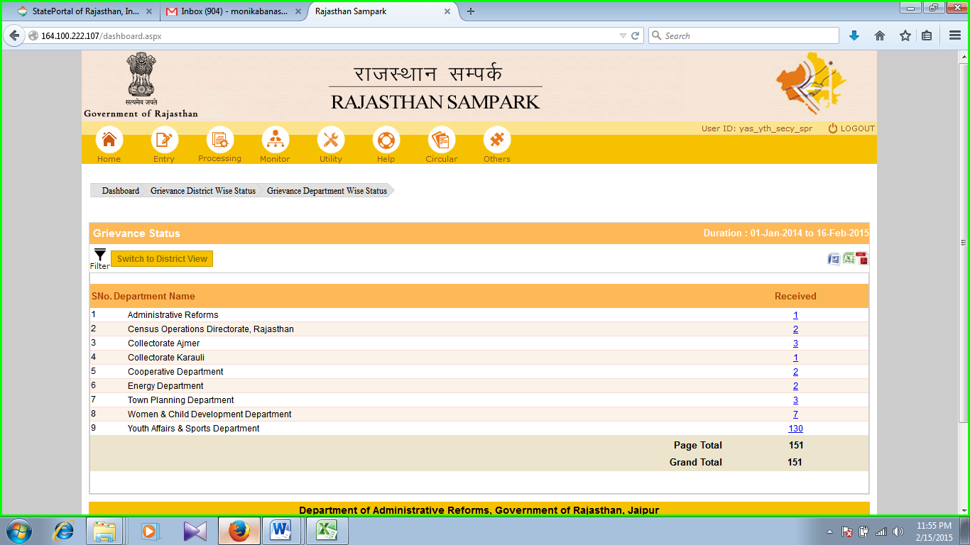  

**Screenshot 51**

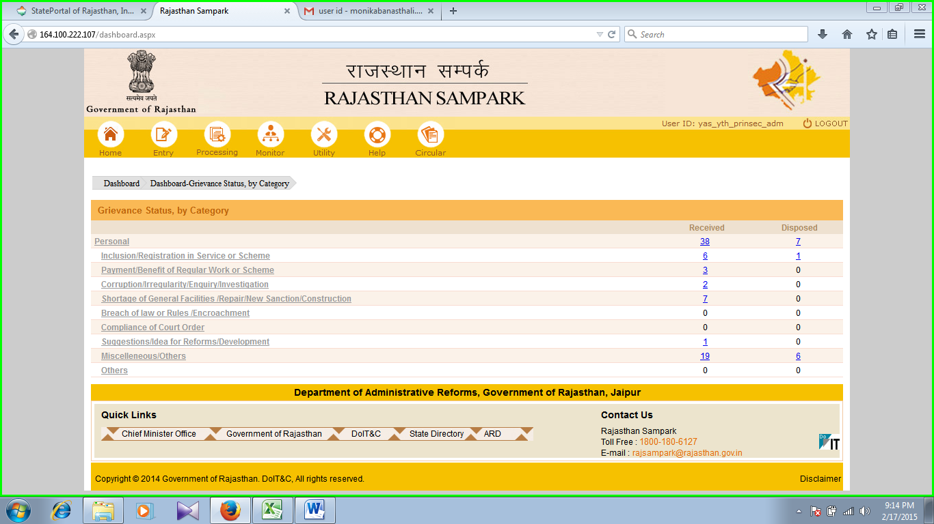

**Screenshot 52**

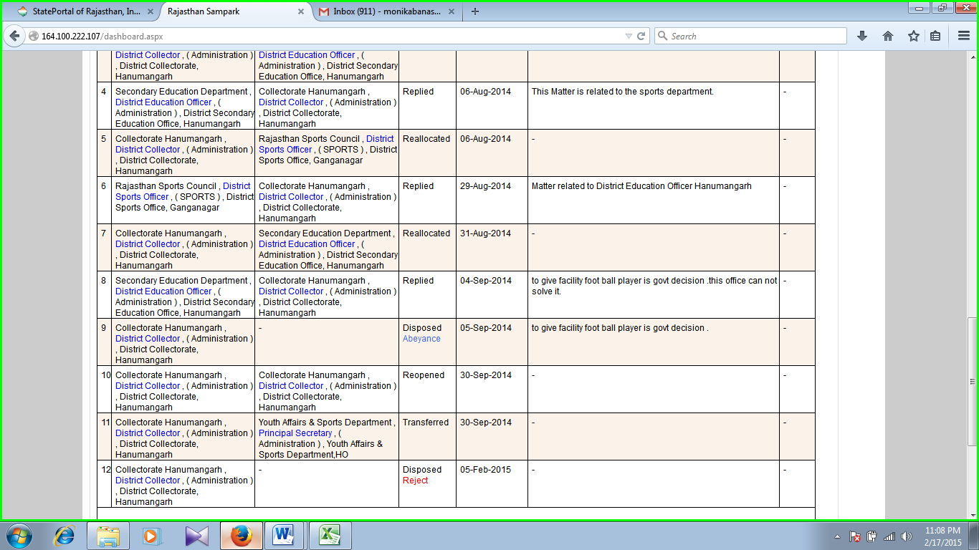

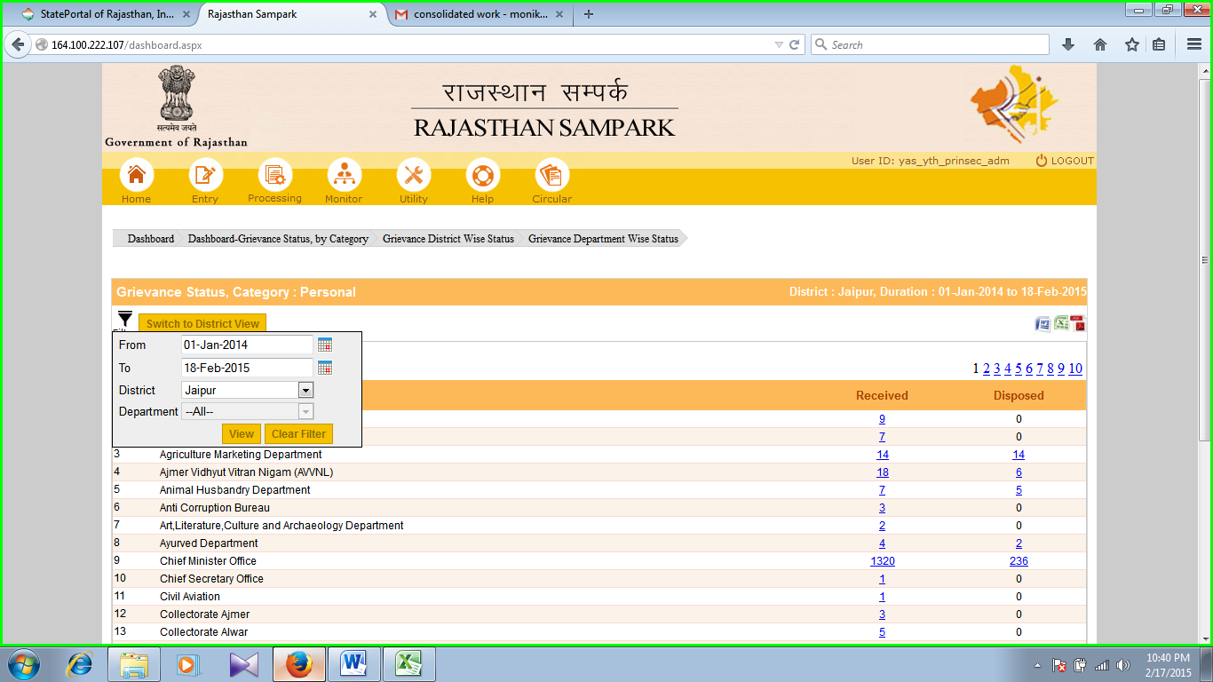**Screenshot 53**

**Screenshot 54**

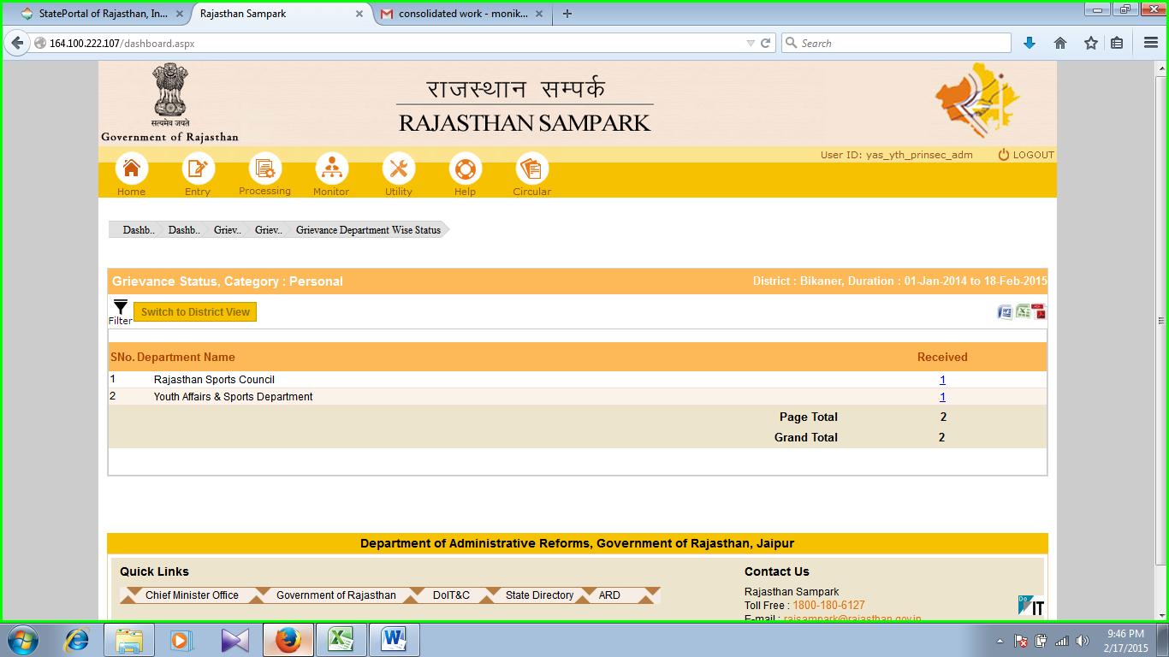

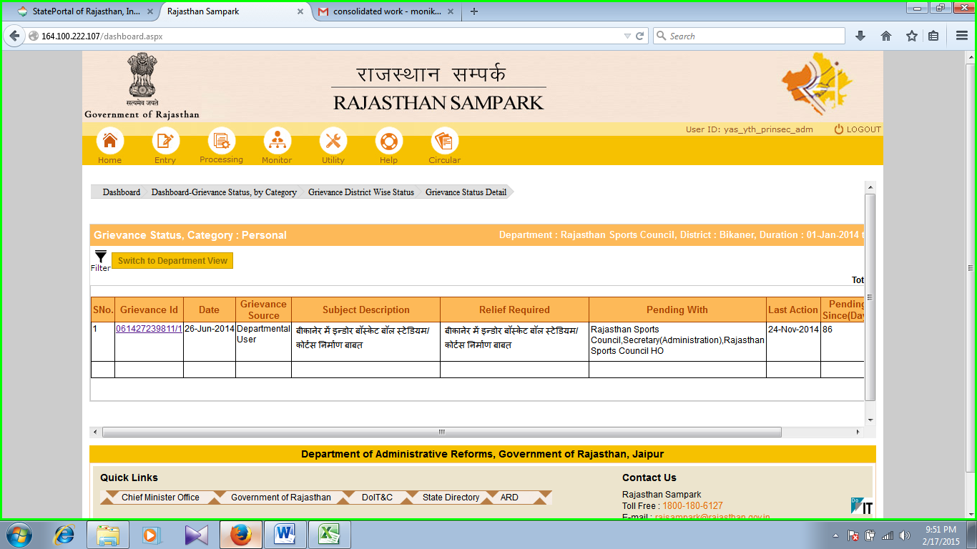

**Screenshot 55**

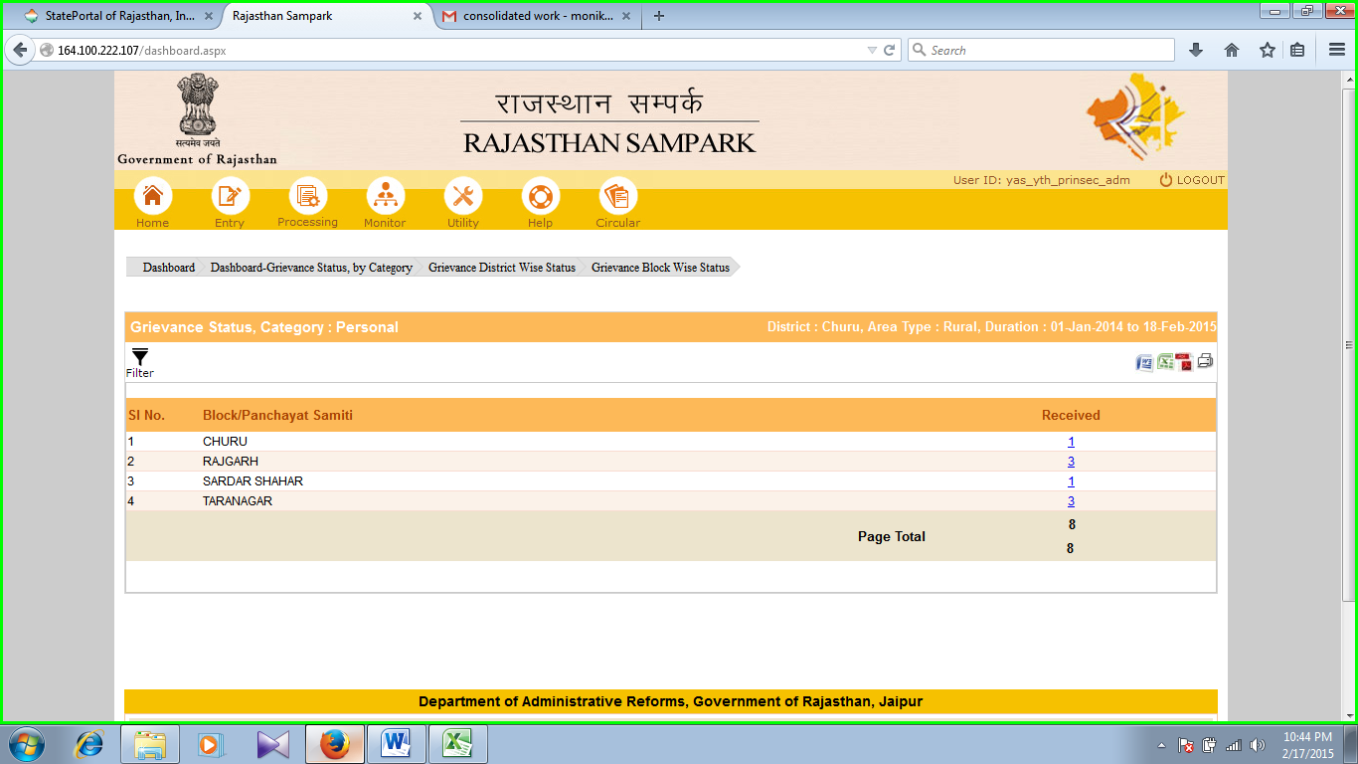

**Screenshot 56**

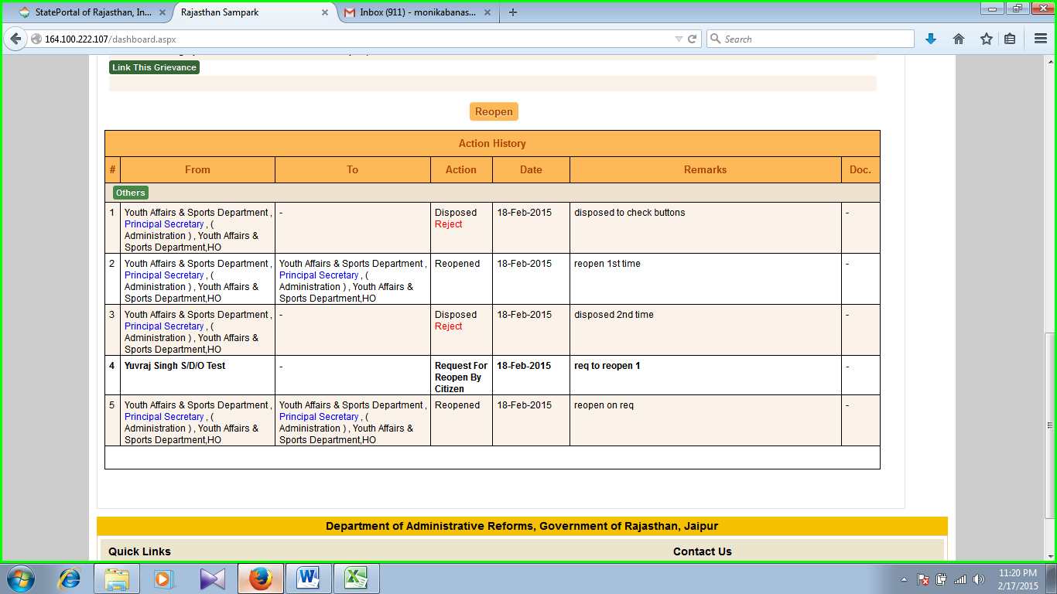

**Screenshot 57**

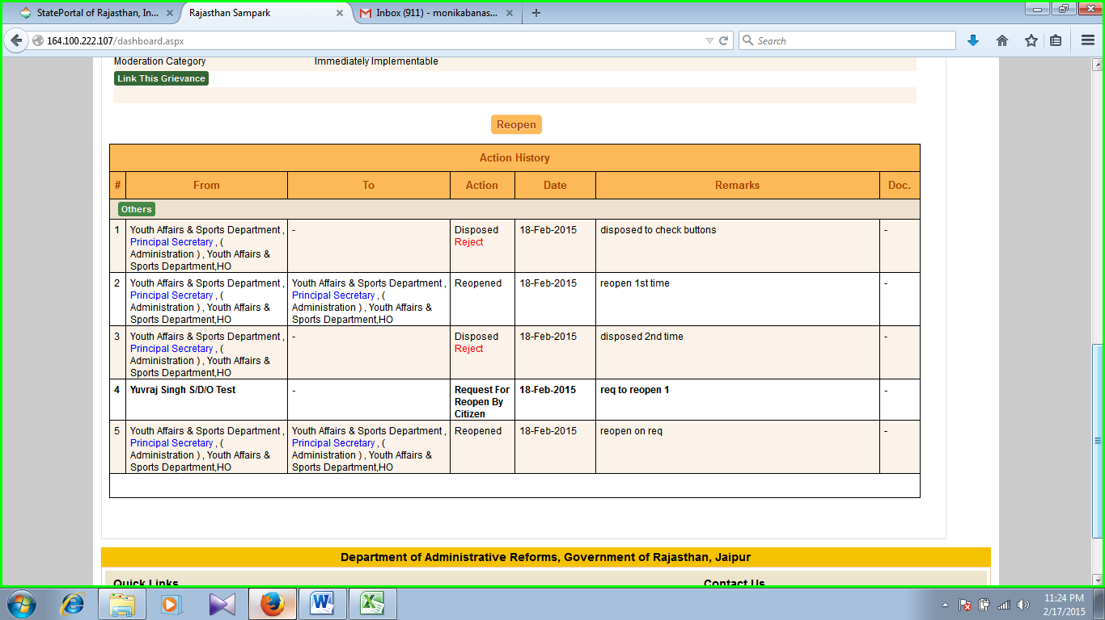**Screenshot 58**

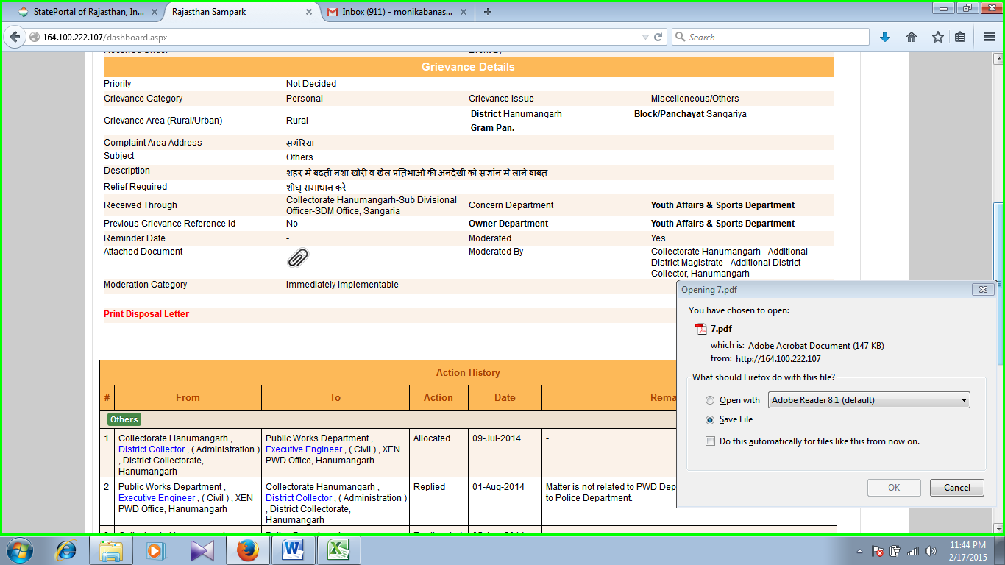

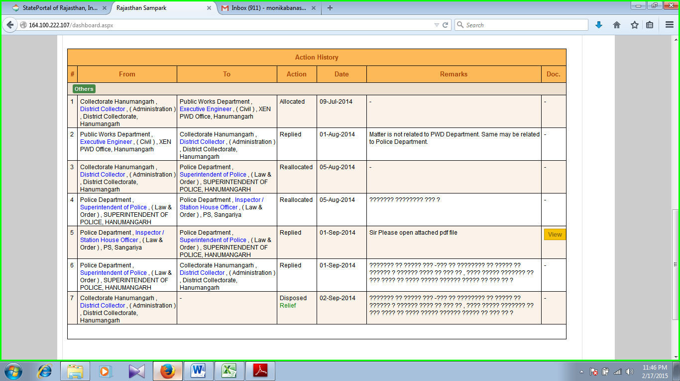

**Screenshot 59**

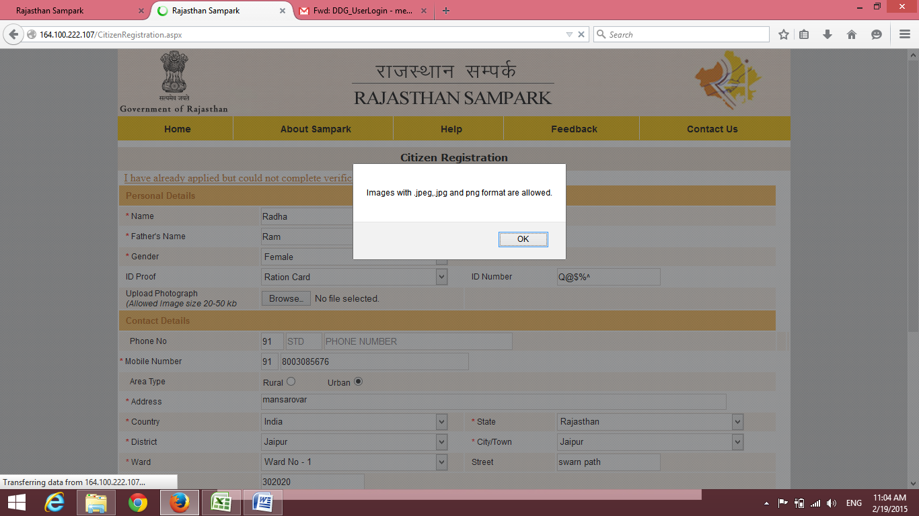**Screenshot 60**

**Screenshot 60**

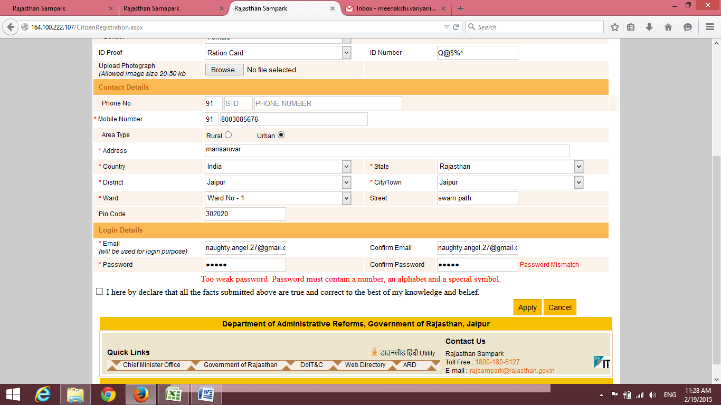

**Screenshot 61,62**

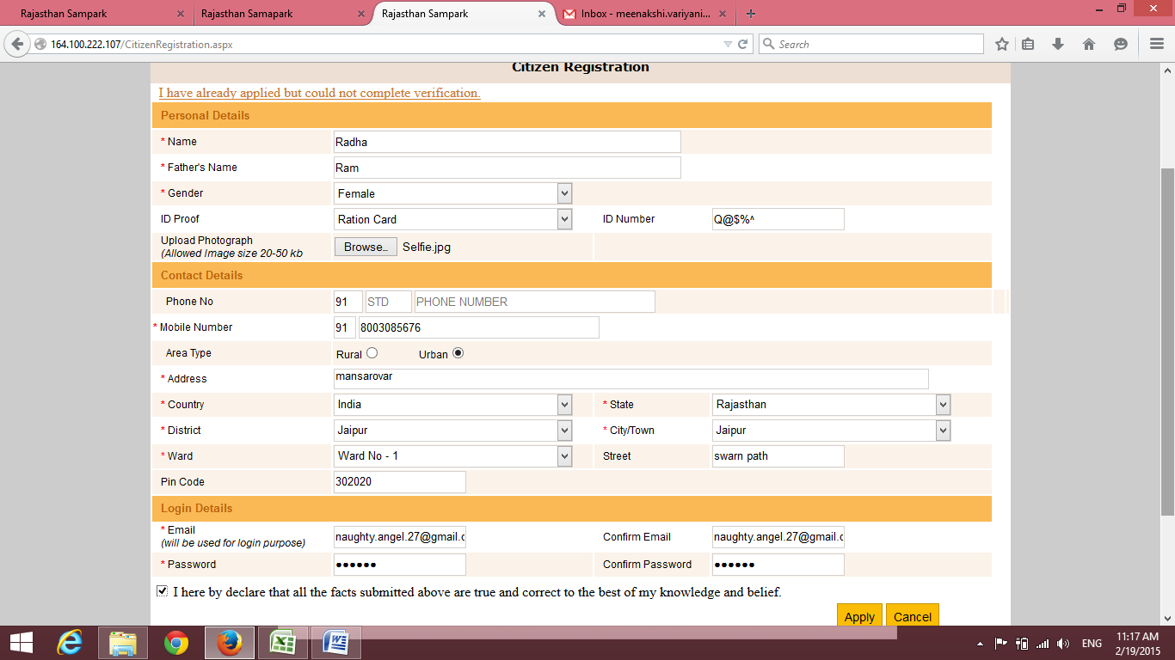

**Screenshot 63**

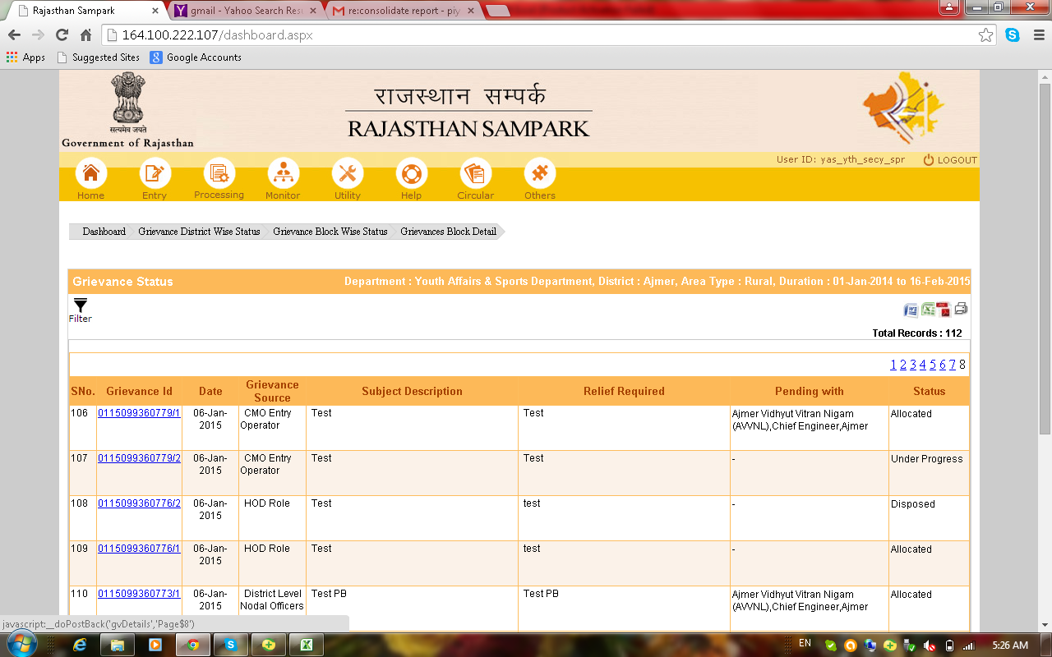

**Screenshot 64**

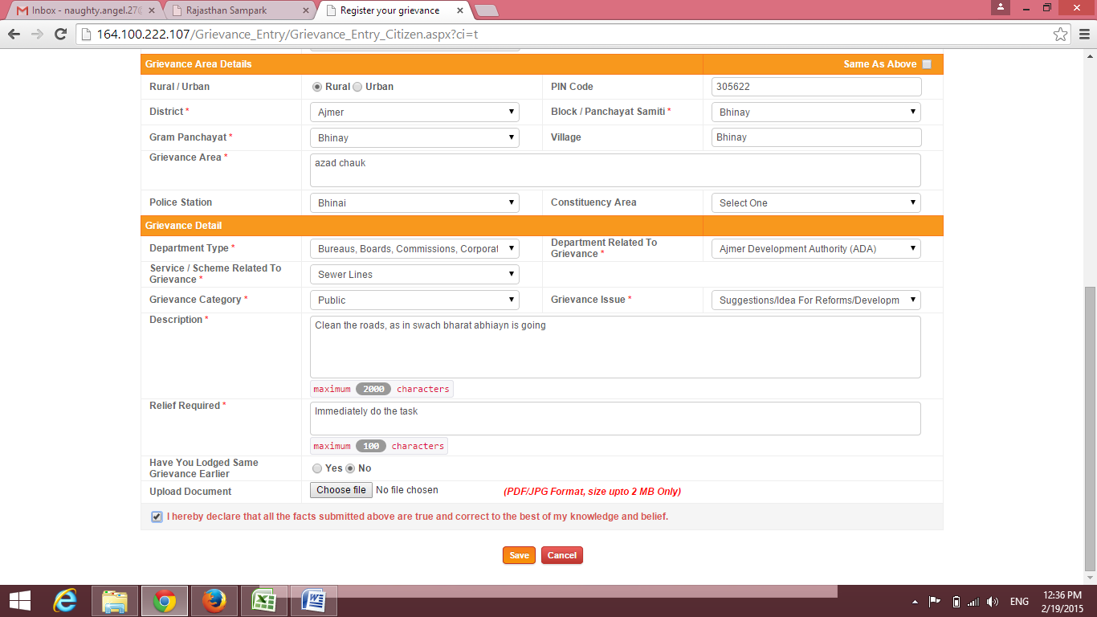

**Screenshot 65**

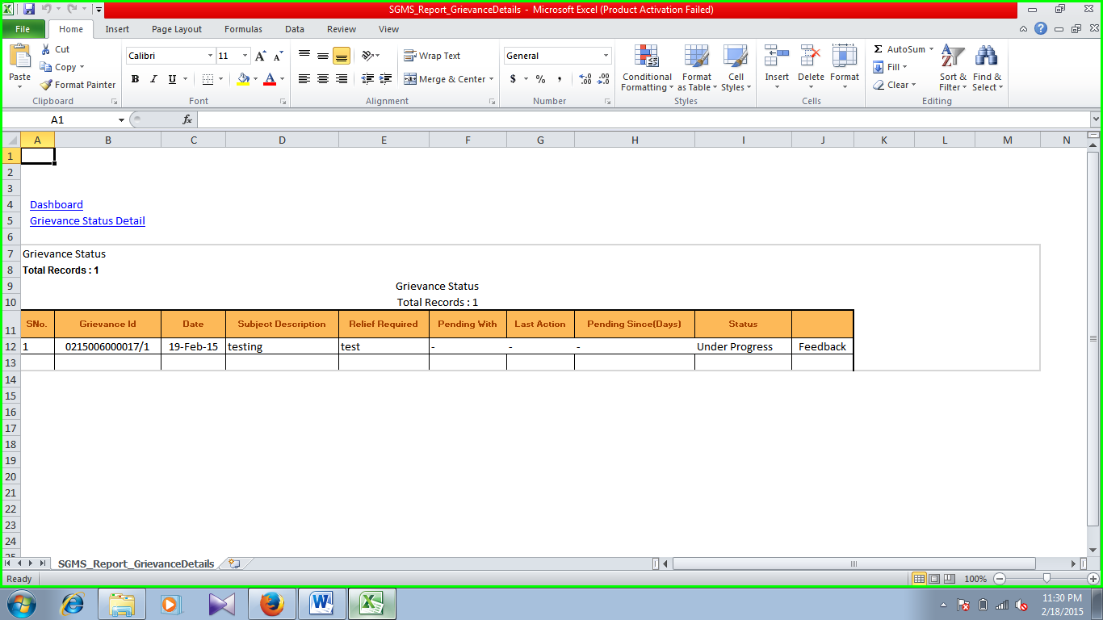

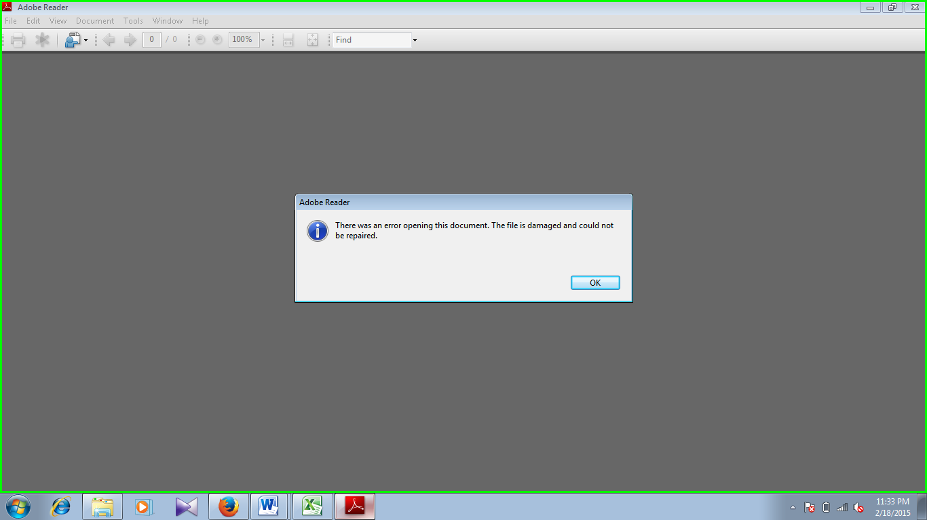

**Screenshot 66**

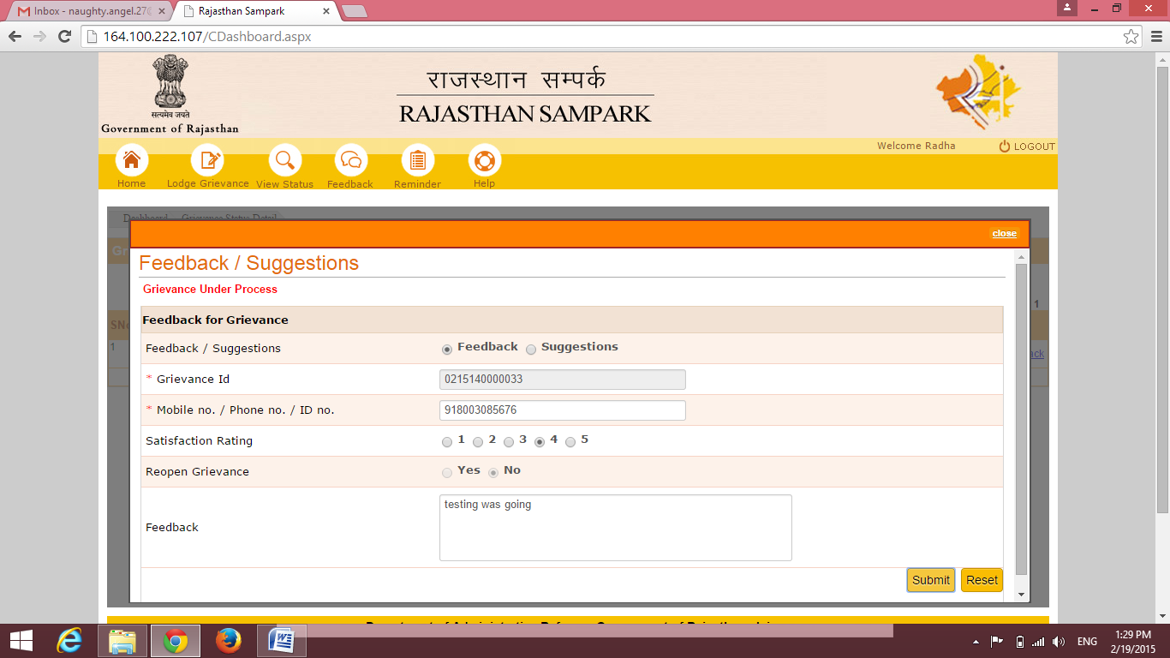

**Screenshot 67**

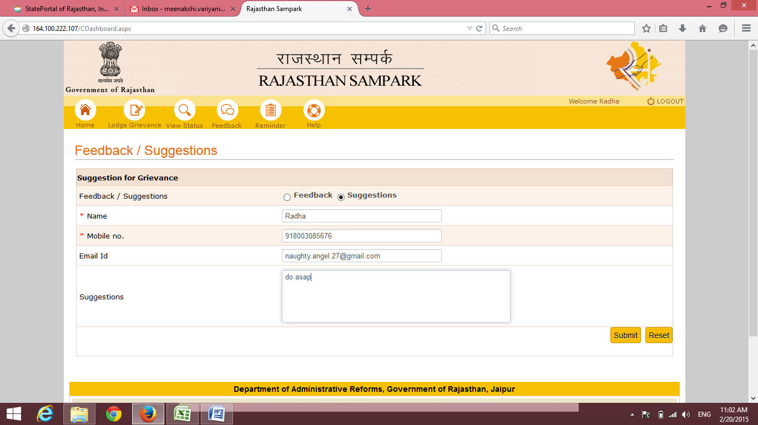

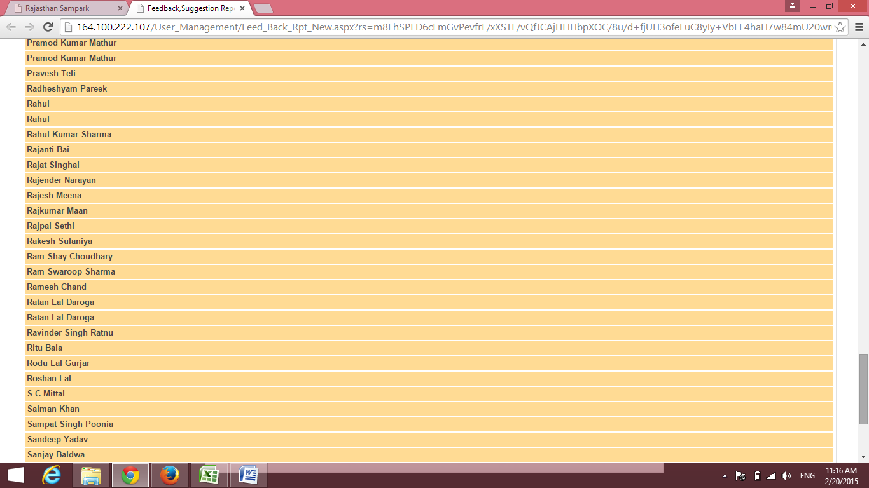

**Screenshot 68**

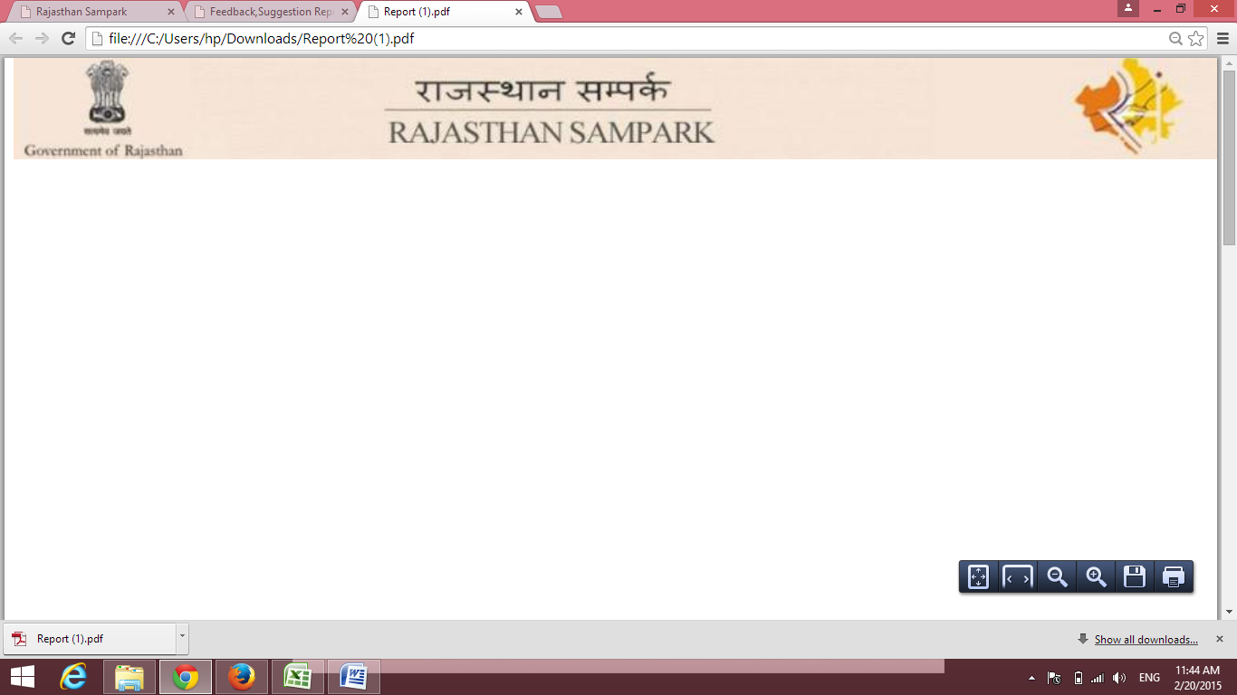

**Screenshot 69**

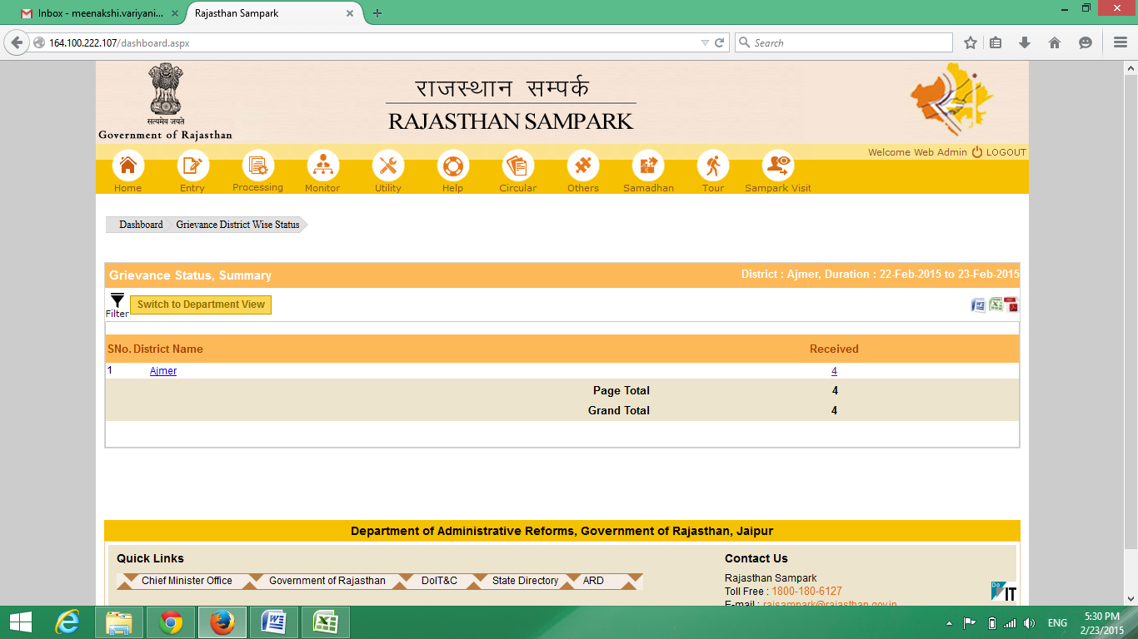

**Screenshot 70**

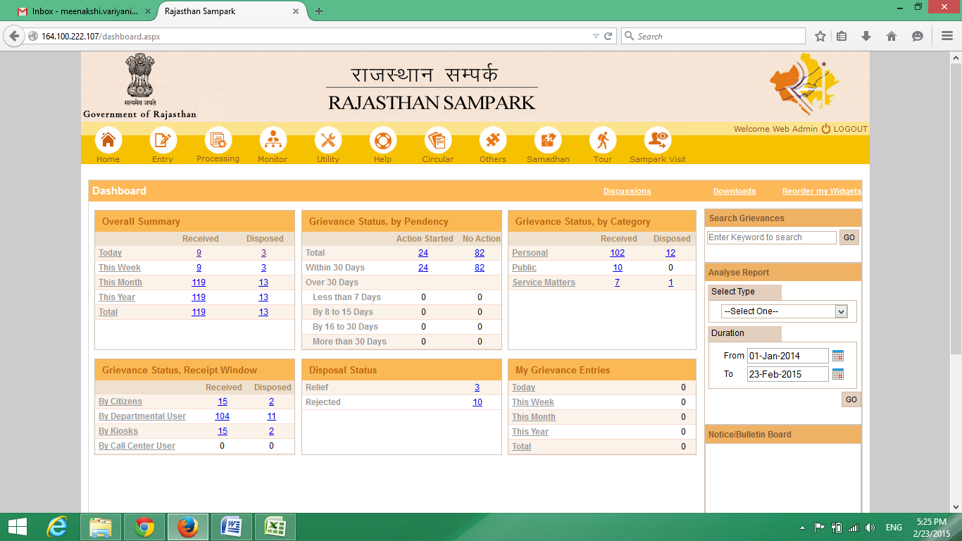

**Screenshot 71**

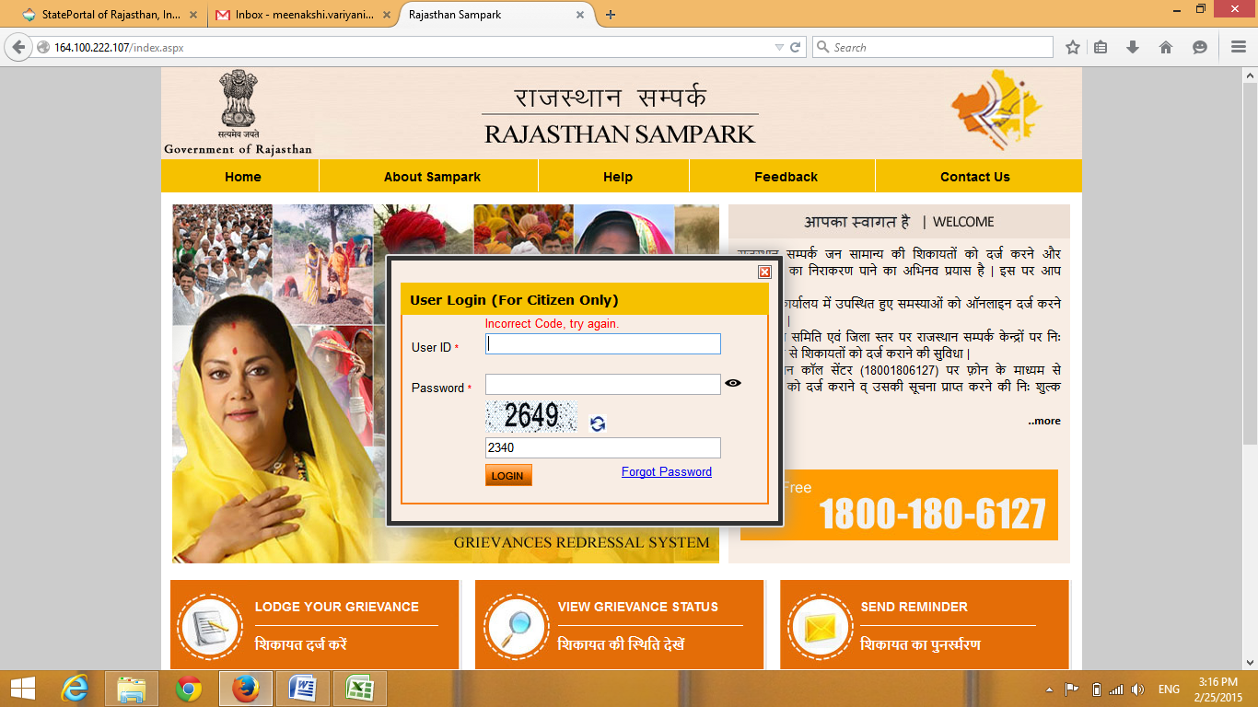

**Screenshot 72**

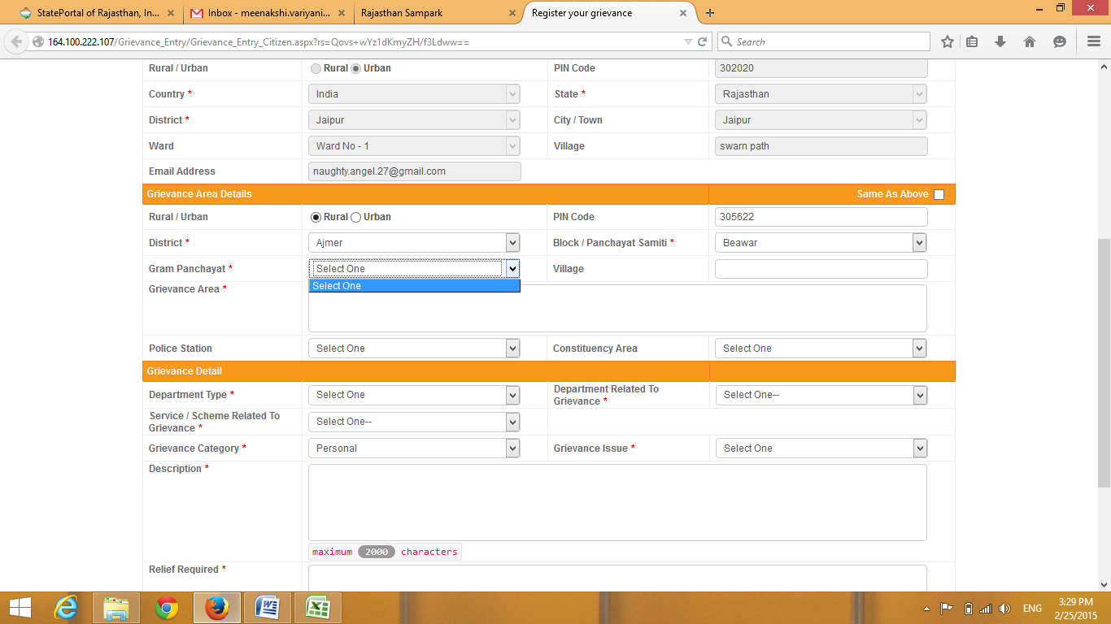

**Screenshot 73**

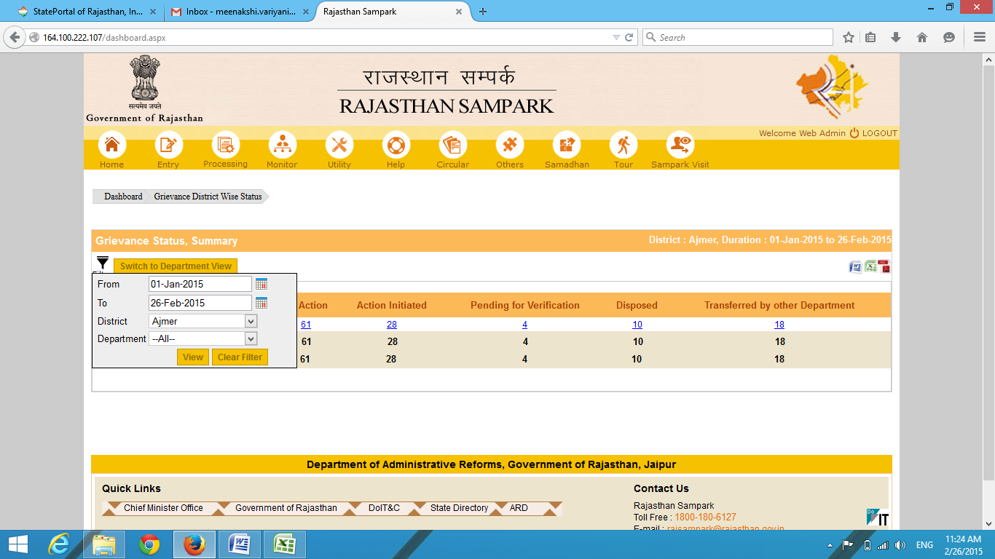

**Screenshot 74**

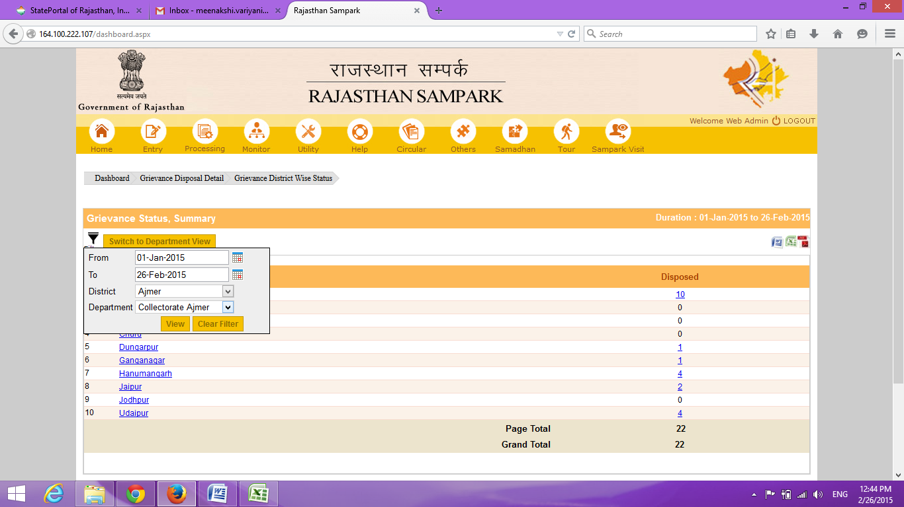

**Screenshot 75**

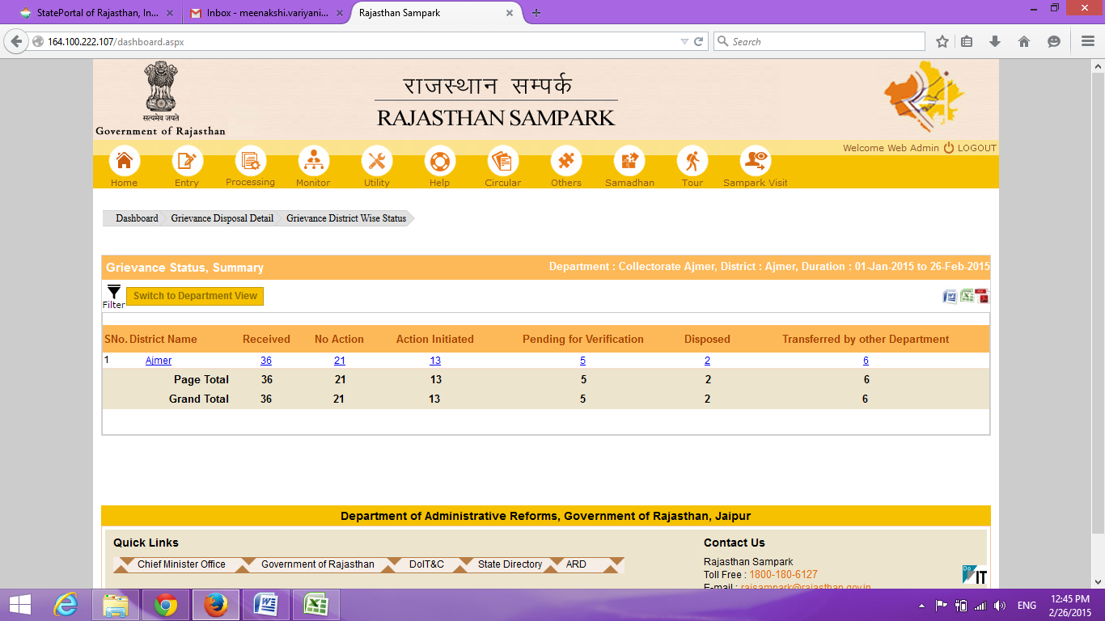

**Screenshot 76**

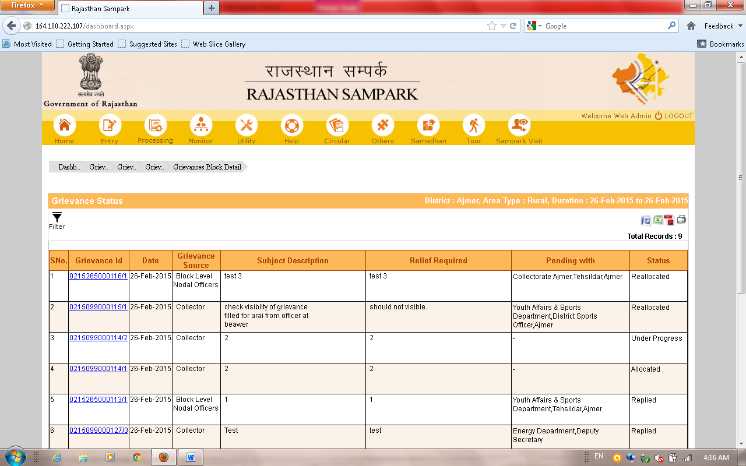

**Screenshot 77,78**



**Screenshot 79**



**Screenshot 80**



**Screenshot 81**



**Screenshot 82**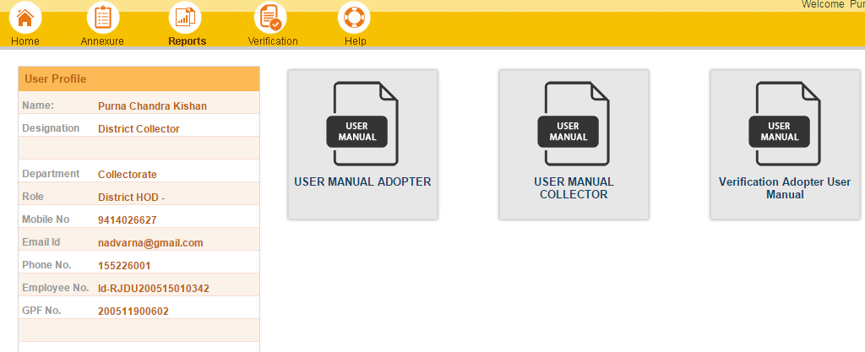

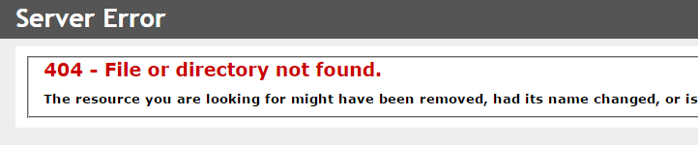

**Screenshot 83**

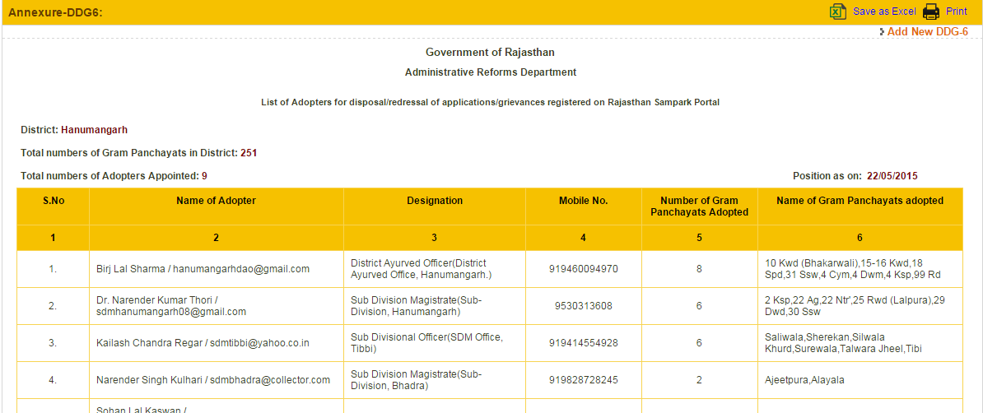

**Screenshot 84**

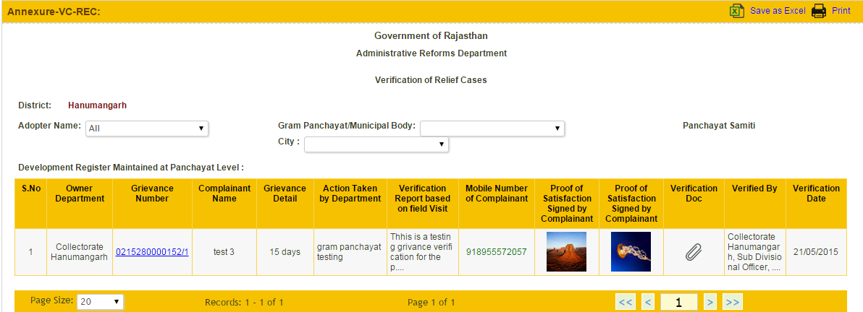

**Screenshot 85**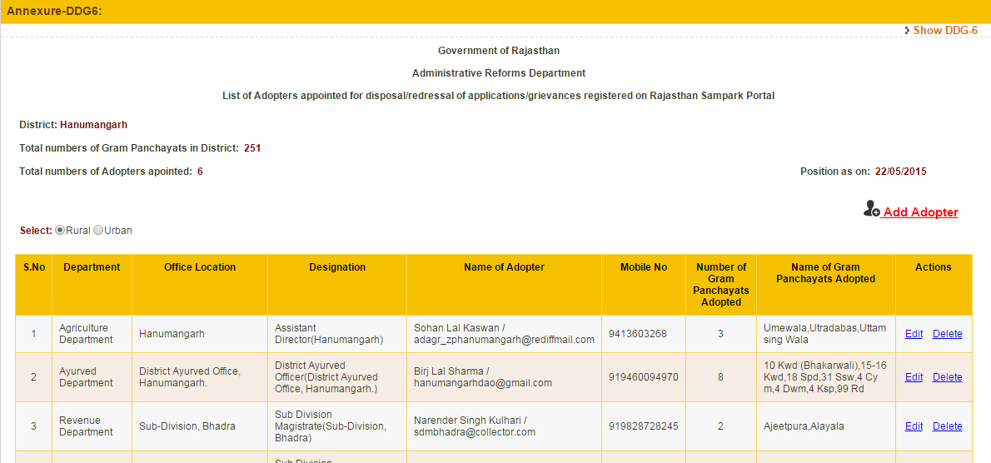

**Screenshot 86**



**Screenshot 87**

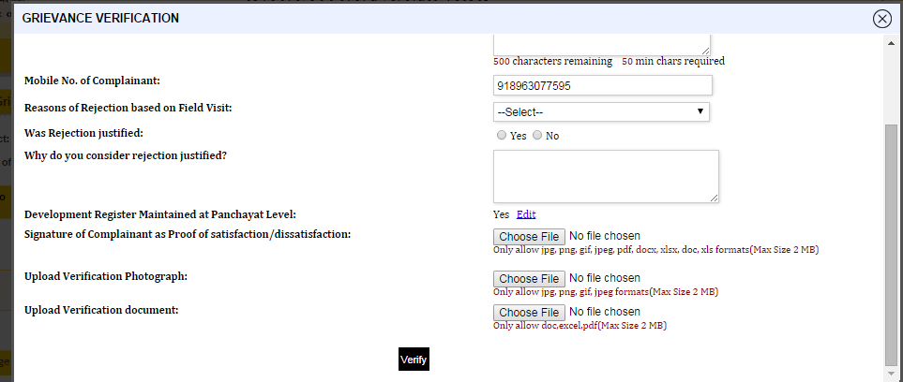

**Screenshot 88**

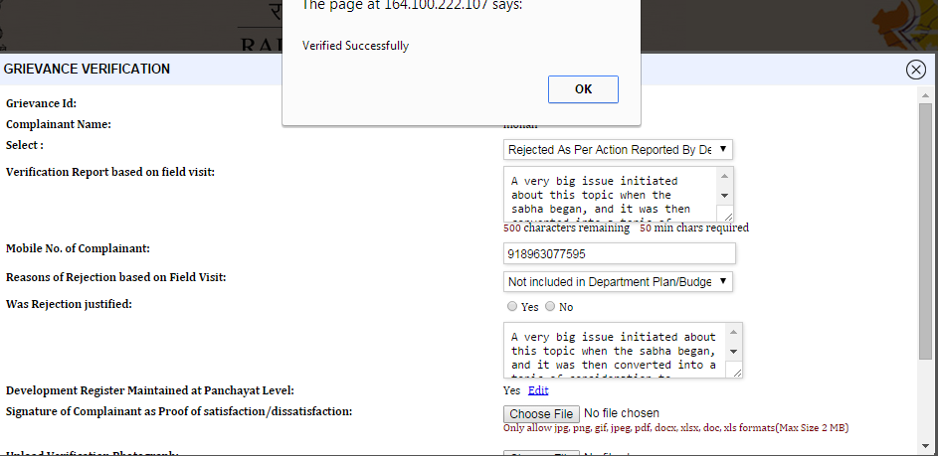

**Screenshot 89**

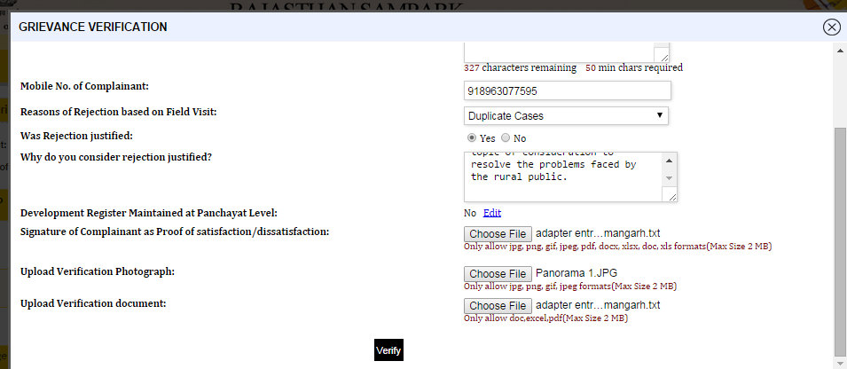

**Screenshot 90**





**Screenshot 91**



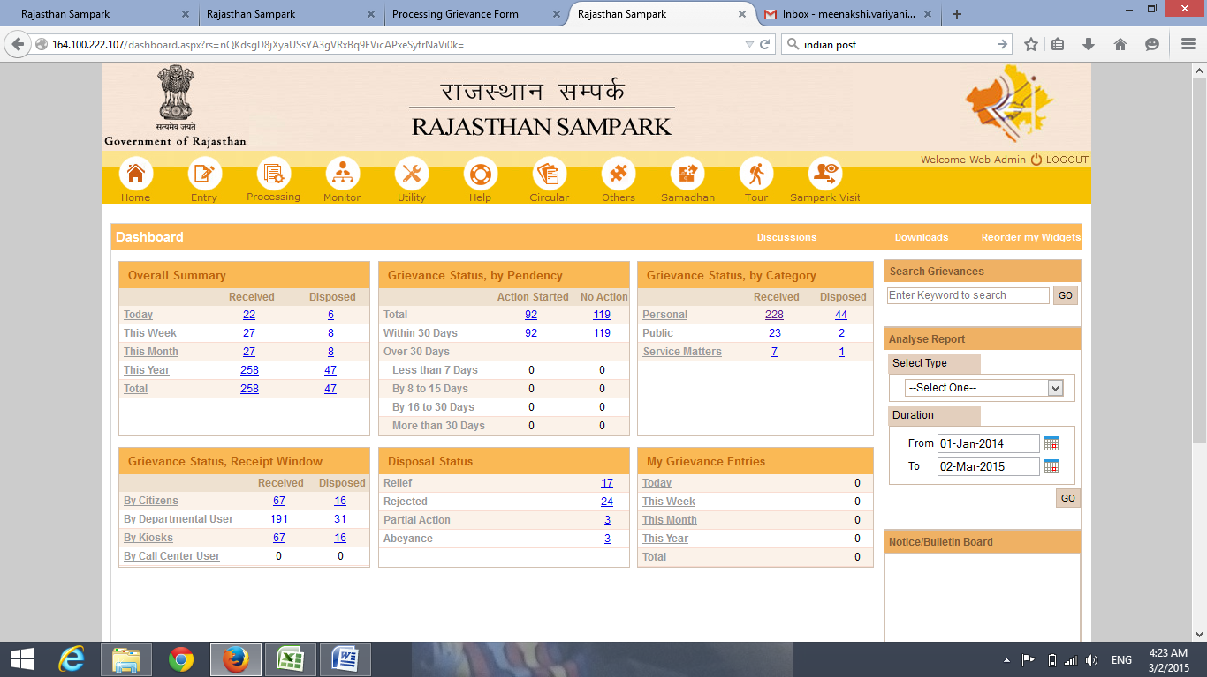

**Screenshot 92**

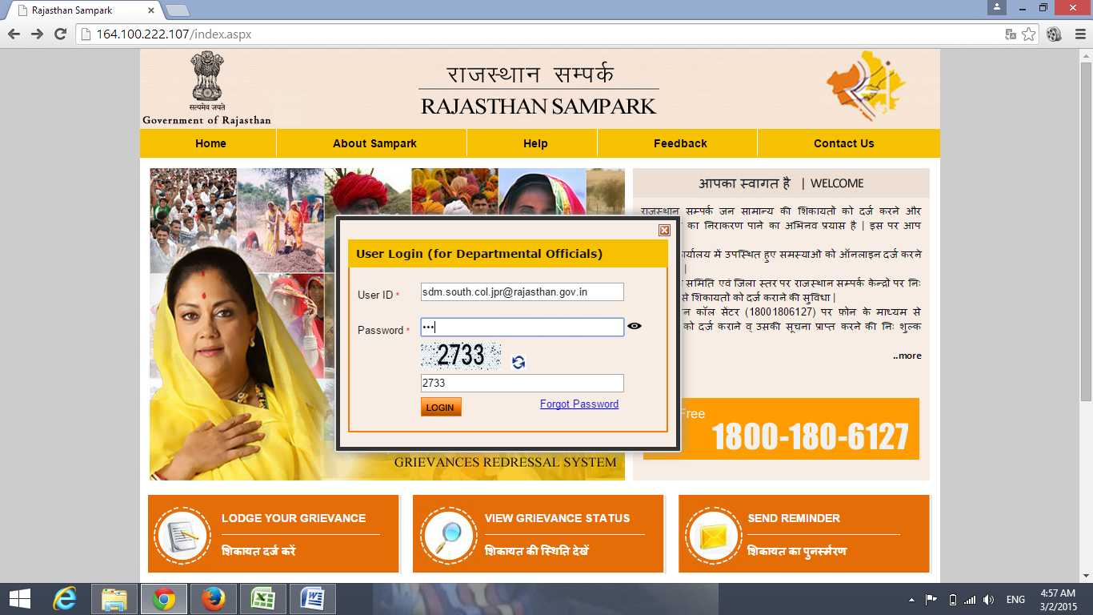



**Screenshot 93**

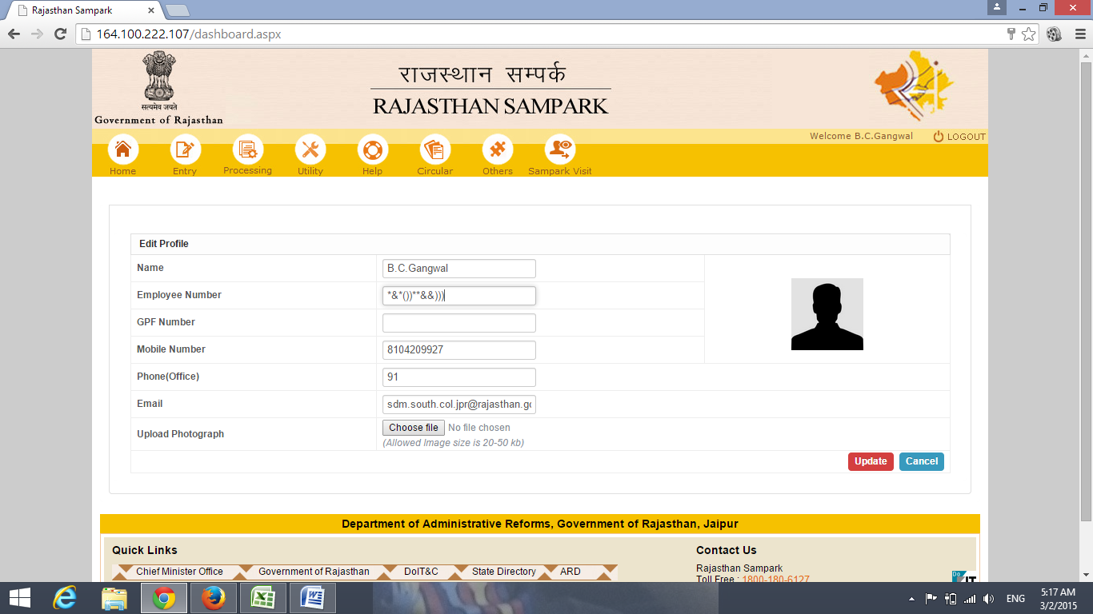

**Screenshot 94**

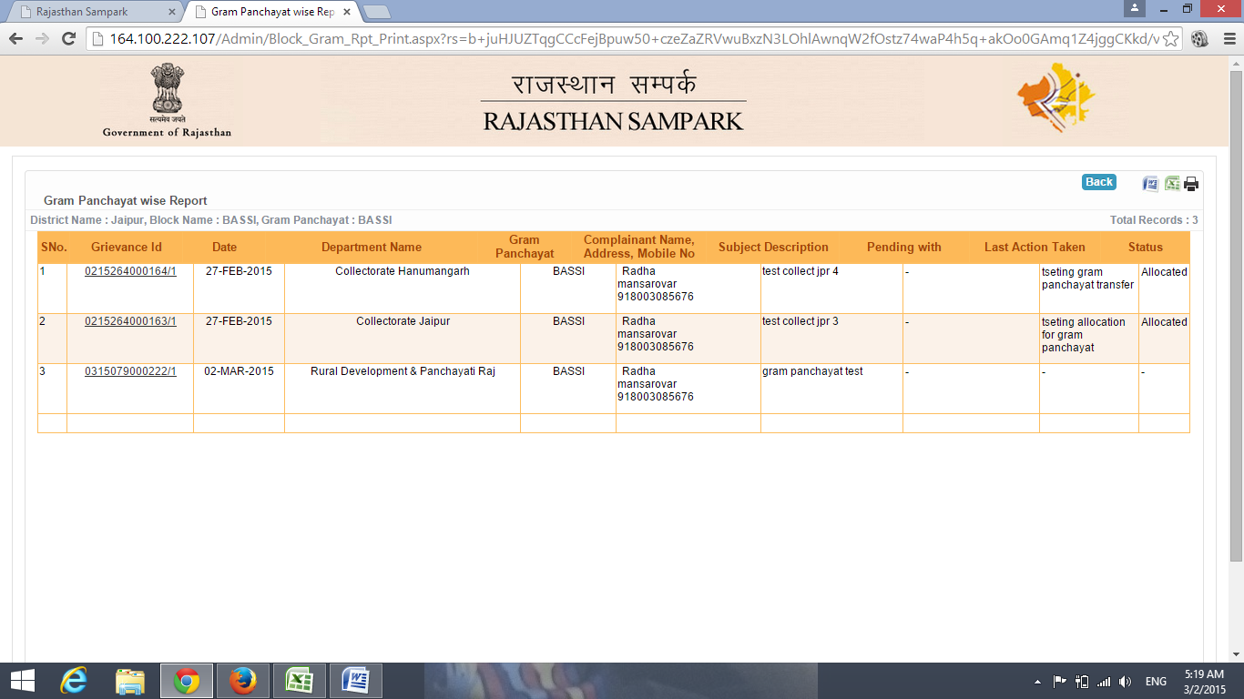

**Screenshot 95**



**Screenshot 96**



**Screenshot 97**



**Screenshot 98**

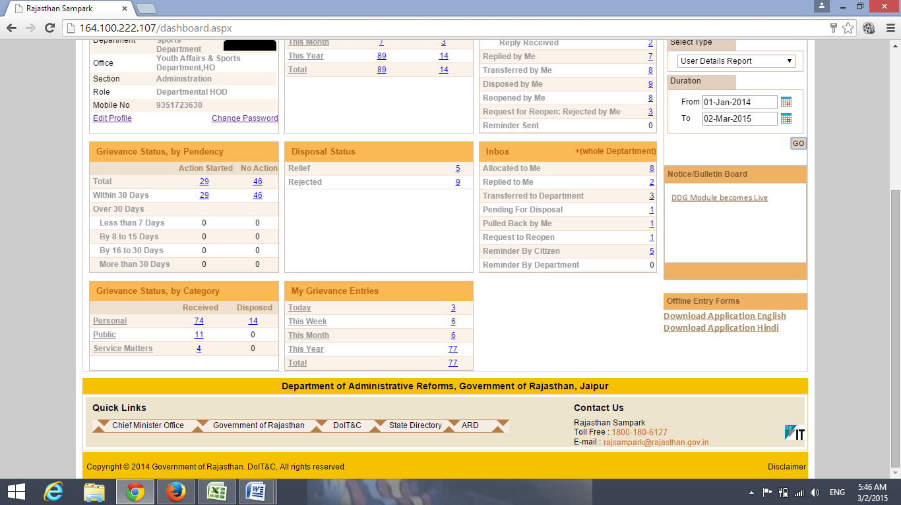

**Screenshot 99**

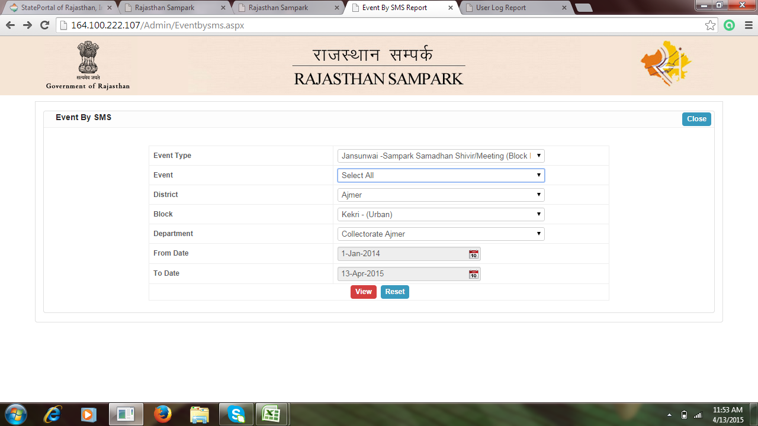

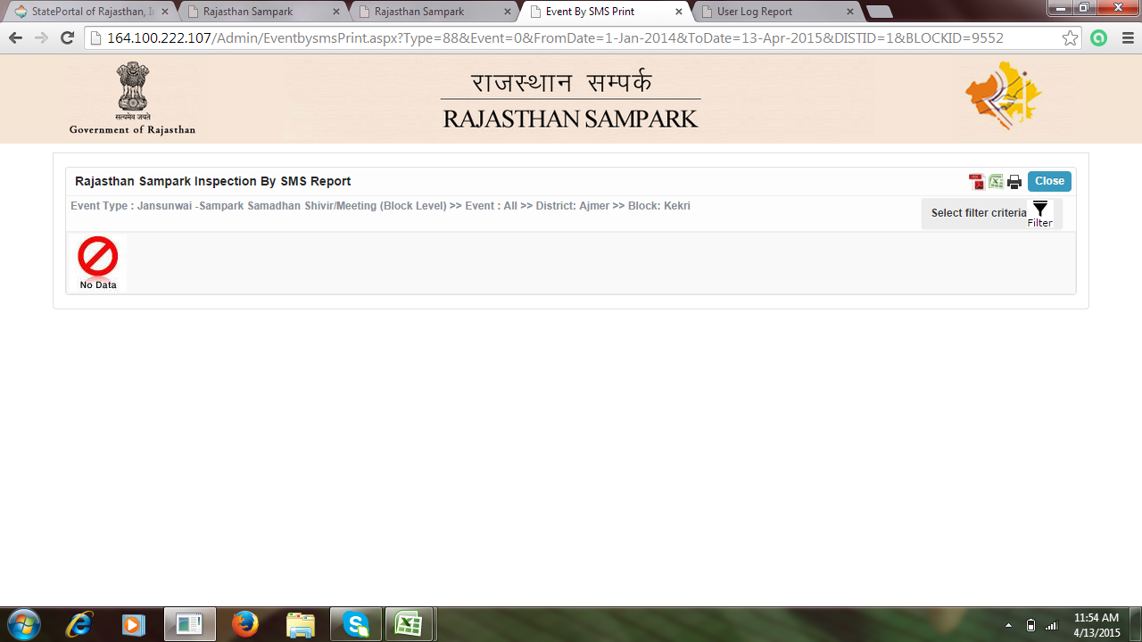

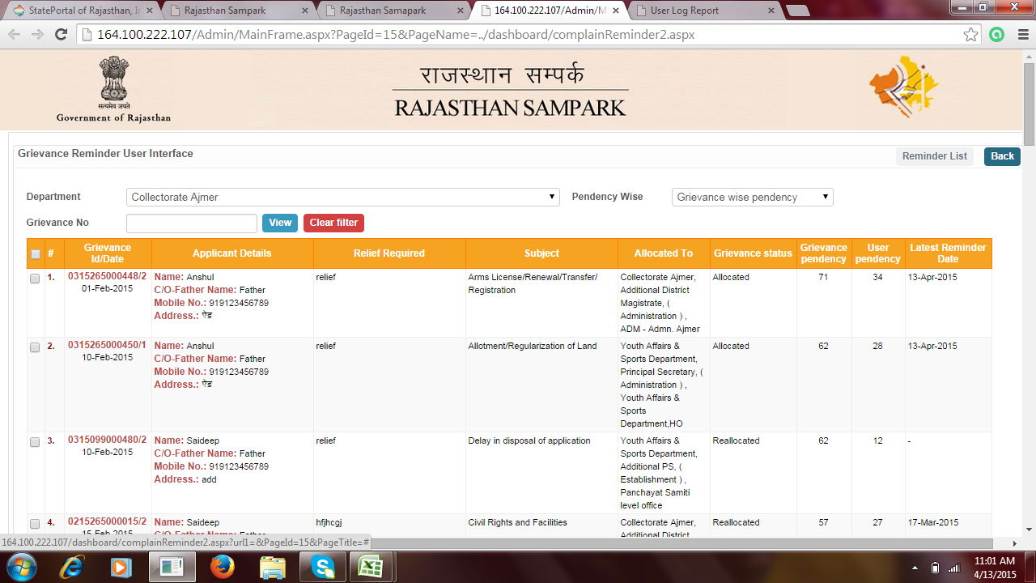**Screenshot 100**

# References:

1. https://msdn.microsoft.com/en-in/vstudio/hh341490.aspx

|  |  |
| --- | --- |
| |  | | --- | | 1. http://iwa-hwg.eclasses.org/courseP179/Description: https://mail.google.com/mail/images/cleardot.gif | |

1. http://www.tutorialspoint.com/sdlc/sdlc_iterative_model.htm
2. http://www.tmv.edu.in/pdf/Distance_education/BCA%20Books/BCA%20IV%20SEM/BCA-428%20Oracle.pdf
3. https://msdn.microsoft.com/en-us/library/vstudio/fx6bk1f4%28v=vs.100%29.aspx
4. http://www.sampark.rajasthan.gov.in/
5. http://www.google.com/url?q=http%3A%2F%2Fwww.slideshare.net%2Frahulkushwaha06%2Fcomputer-science-investigatory-project-class-12&sa=D&sntz=1&usg=AFQjCNGNcgQ0UdhFhLRFCHSUON_DasulFQ
6. http://doitc.rajasthan.gov.in/_layouts/15/Doitc/User/index.aspx?LangID=English